7 Memory-Boosting Foods
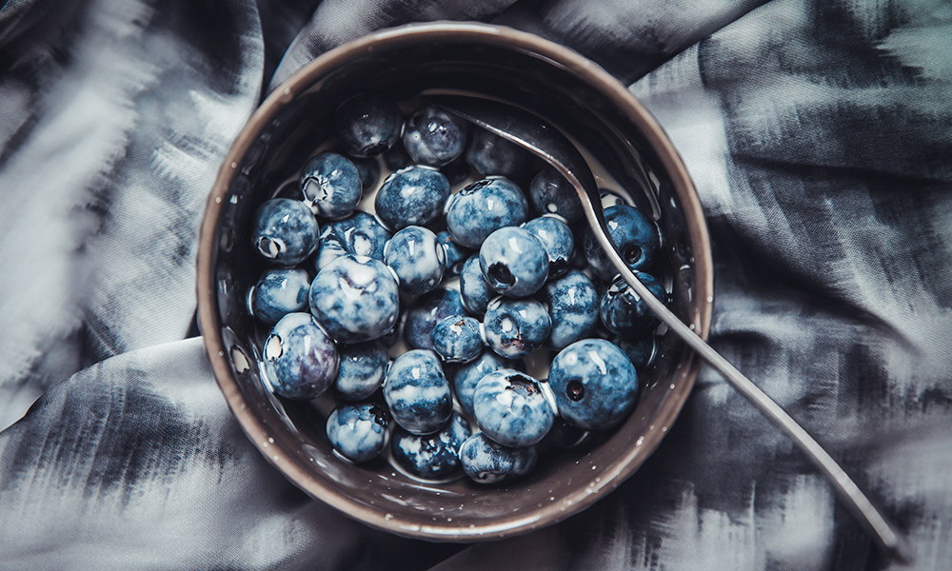
A well-balanced diet rich in fruit, veggies, whole grains and healthy fats (think: olive oil and nuts) isn’t just good for your heart, it’s also good for you.
Some foods are better at boosting your brain than others. Here are a few of our favourite foods for thought (literally!):

1. Leafy Greens
Leafy greens are high in folate, a B vitamin that helps your cells protect and repair their DNA. Folate also plays a key role in helping your body neutralize a harmful protein called homocysteine. High levels of homocysteine are linked to loss of cerebral grey matter and a decline in brain function. Thankfully there are lots of leafy greens to choose from. Romaine lettuce, spinach and collard greens are just a few.
For a new leafy-green favourite, try Spinach Salad with Shrimp and Balsamic Vinaigrette.

2. Walnuts
They’re not just brain-shaped, walnuts are good brain food. They contain healthy polyunsaturated fats, vitamin E and polyphenols. These nutrients help decrease inflammation, which can stress out the brain and other bodily systems. You don’t need to overload on walnuts to reap the benefits either. Eat them as a snack or in salads and sides.
For a great take on walnuts, try Creamy Grape Salad with Candied Walnuts.

3. Legumes
Like leafy greens, legumes are a good source of folic acid and they’re a good source of the other B vitamins, too. The B vitamins are important for brain health because they’re used to create neurotransmitters, the chemicals that help brain cells communicate with one another. Choose from a variety of legumes including beans, lentils, peas and peanuts.
For new ways to love legumes, try Very Green Lentil Soup or White Bean and Tomato Antipasti.

4. Olive Oil
Of all the oils on the market, olive oil certainly has the brightest health glow. Experts recommend it to help us fight heart disease, but did you know olive oil is also good for your brain? A randomized controlled trial of 447 adults found that those who received a supplement of olive oil and mixed nuts over a period of six years saw an improvement on their cognitive tests. It’s easy to get a daily dose of olive oil — make it your main fat for cooking!
For a delicious meal with olive oil, try Avocado Mint Pesto Pasta.

5. Fatty Fish
Fatty fish (think: salmon, herring, tuna, sardines and trout) are good sources of DHA, a type of omega-3 fat. DHA plays a special role in learning and memory — it gets incorporated into the cell membranes of neurons. A deficiency of DHA can lead to learning deficits, and it has been shown that low consumption of this essential fat is a risk factor for Alzheimer’s and other forms of dementia. Make fatty fish a regular part of your diet by eating two three-ounce servings of cooked fish every week.

6. Berries
Blueberries, raspberries and blackberries are rich in antioxidants, which can protect your brain from inflammation and oxidative damage. Load up on berries as a yogurt topping, blend berries into a fresh smoothie or sprinkle them onto your breakfast.
For a berry boost, try Almond Pumpkin Pancakes with Berries.

7. Green or Black Tea
Sipping a hot mug of tea isn’t just comforting, it can also keep you more mentally alert. A study following 957 elderly people found that those who drank tea regularly (about one to three cups per day) had a lower risk for neurocognitive disorders. Tea contains a host of antioxidants as well as caffeine, which help you feel more mentally alert.
For a new way to enjoy tea, try a Good Green Tea Smoothie.

