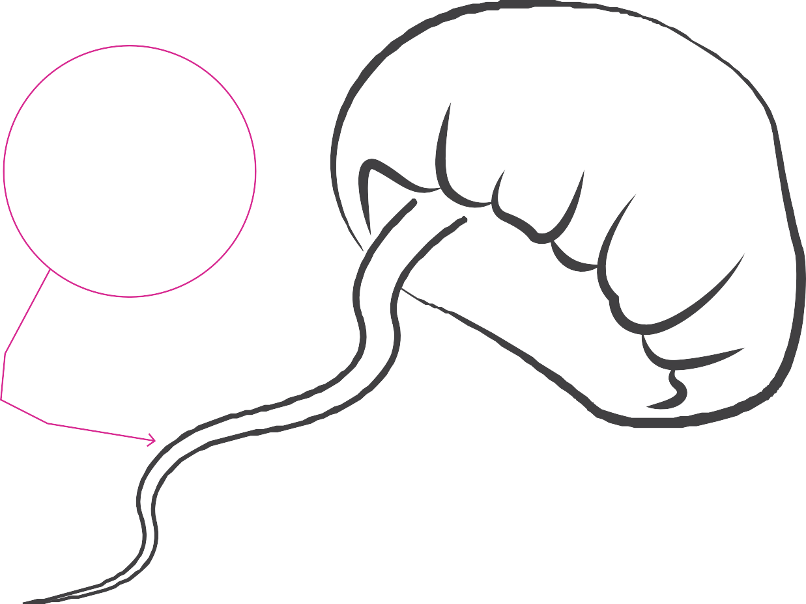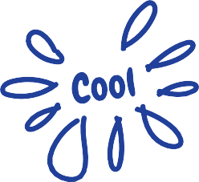TEST YOUR KNOWLEDGE
THE JELLYFISH CHALLENGE
Science

For each fact you remember add a tentacle and make a note to create your very own jellyfish!

We then want you to get ready for your visit by sharing with us any unanswered jellyfish questions you may have.

NAME CLASS

