Overnight Oats Three Ways

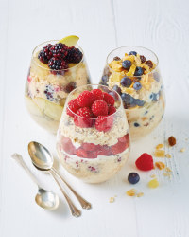

Ingredients
Blackberry and Apple (vegan)
42g Porridge Oats
70g Frozen or Fresh Blackberries
40g Apple Sauce
8g Chia Seeds
20ml Maple Syrup (or 20g Honey if not vegan)
160ml Unsweetened Almond Milk

Raspberry and Almond Butter (vegan)
42g Porridge Oats
70g Fresh or Frozen Raspberries
40g Almond Butter
8g Chia Seeds
20ml Maple Syrup (or 20g Honey if not vegan)
160ml Unsweetened Soya Milk

Blueberry and Tropical (vegan)
42g Porridge Oats
35g Fresh or Frozen Blueberries
35g Tropical Blend
Pinch of Ginger or Cinnamon
20ml Maple Syrup (or 20g Honey if not vegan)
150ml Unsweetened Almond Milk

Method
These keep well in the fridge for up to 5 days.
Mix all the ingredients together, put into a jar or glass, cover and refrigerate overnight (or at least 4 hours).
Add the toppings on the day you’re going to eat.

Oat, Almond and Fruit Breakfast Balls

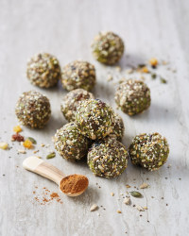

Ingredients
135g Porridge Oats
80g Dried Mixed Fruit
100g Set Honey
100g Almond Butter
½ tsp Ground Ginger
½ tsp Ground Cinnamon
1 tsp Vanilla Essence
10g Wheatgrass Powder
10g Chia Seeds
35ml Coconut Water

Method
Put all the ingredients except the coconut water into a bowl and mix well.
Add the coconut water and mix to a sticky ball.
Divide the mixture in 12 and roll into balls.
Put on a tray to refrigerate until hard.

Very Berry Smoothie

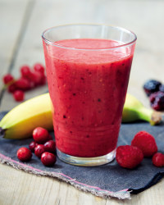

Ingredients
130g Four Seasons Frozen Summer Fruits, defrosted
1 Banana
100ml Cranberry Juice
15ml The Pantry Lemon Juice

Method
Chop up all of the fruit, then place in a blender with all the other ingredients.
Blend until smooth and serve immediately.

Mango, Pineapple and Kale Smoothie

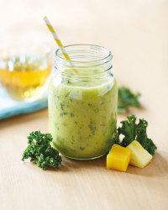

Ingredients
200g Mango Chunks
200g Pineapple Chunks
30g Curly Kale
200ml Rio D’Oro Apple juice

Method
Chop the kale finely.
Put all the ingredients into a food processor and pulse till well blended and serve.
Breakfast.

Breakfast kick-starts your metabolism, helping you burn calories throughout the day. It also gives you the energy you need to get things done and helps you focus at work or at school. Those are just a few reasons why it's the most important meal of the day.

Boiled egg with soldiers

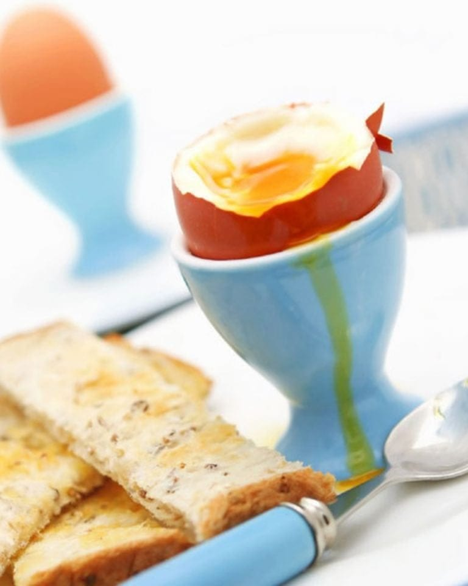

1 medium free-range egg
1 wholemeal bread slice
Small piece of softened butter, for spreading
- Half-fill a small saucepan with water. Put on the hob over a medium heat and bring to the boil. Once boiling, gently lower the egg into the saucepan using a long-handled, slotted spoon. As soon as the water comes back to the boil, set the timer for 4 minutes. This will give you a lovely soft-boiled egg with a runny yolk, which is perfect for dipping your toast soldiers into. If you want the yolk to be slightly firmer, boil the egg for 5 minutes. If you want a hard-boiled egg with a firm yolk you will need to boil it for 7 minutes.

- When the egg is done, carefully lift it out of the pan with a slotted spoon. Put it into an egg cup.

- Pop the bread into the toaster and toast until golden brown. Put it on a chopping board and spread it with butter, then cut it into long strips to dip into the egg. Serve the egg with salt and pepper pots.

