Paper Quilling
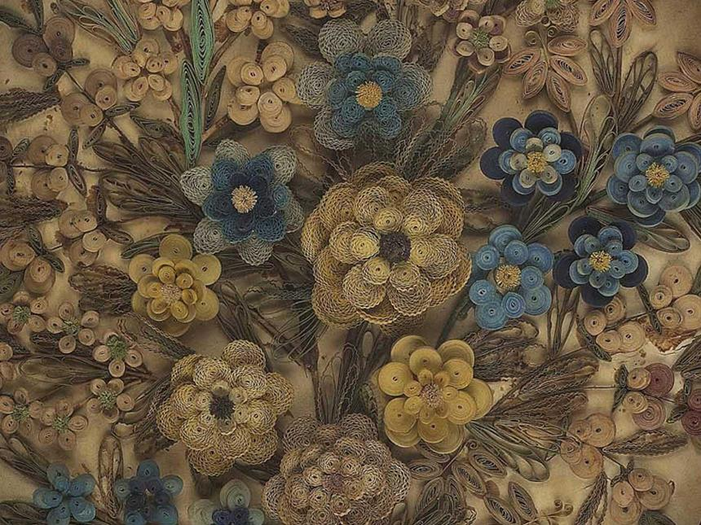

Learn how to quill paper with materials from home
The decorative art of paper quilling has been around since the 15th century, possibly longer and crafted by people all around the world!
Quilling involves rolling, twisting, and bending thin strips of colourful paper into shapes to make detailed designs, just like the flowers and leaves in the framed artwork above.
Materials
You will need:
- a pencil
- strips of paper, about 1/2 inch wide and at least 8 inches long
- a plain piece of paper
- a glue stick

Step One

Draw a shape on a piece of paper.

Step Two.
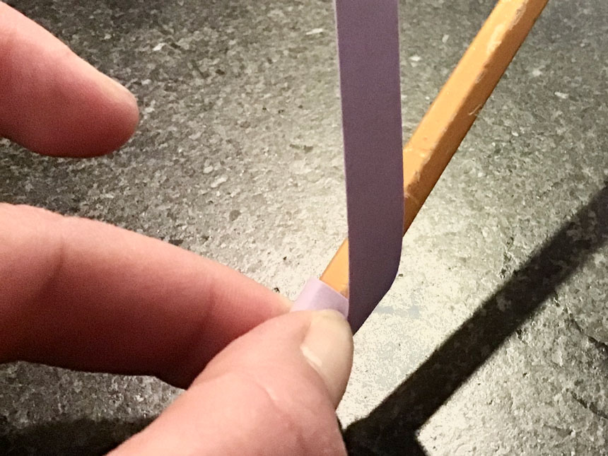
Wrap a strip of paper tightly around the pencil.

Step Three.
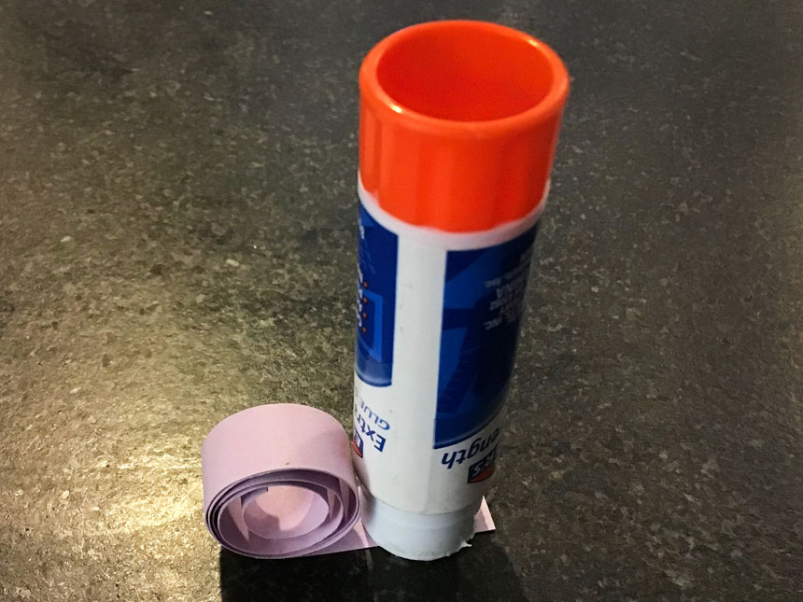

Slide the paper roll off the pencil and put glue on the inside end of the roll.

Step Four
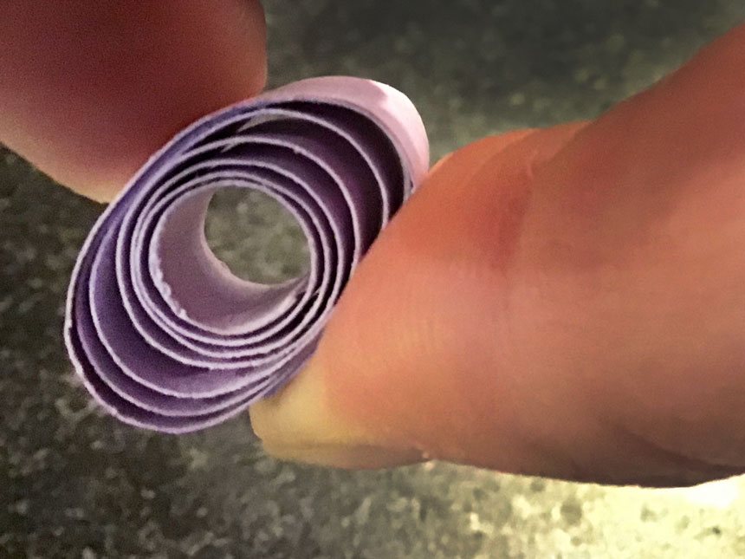
Press the end of the paper down gently so the roll keeps its shape. Keep pressing until the roll stays together.

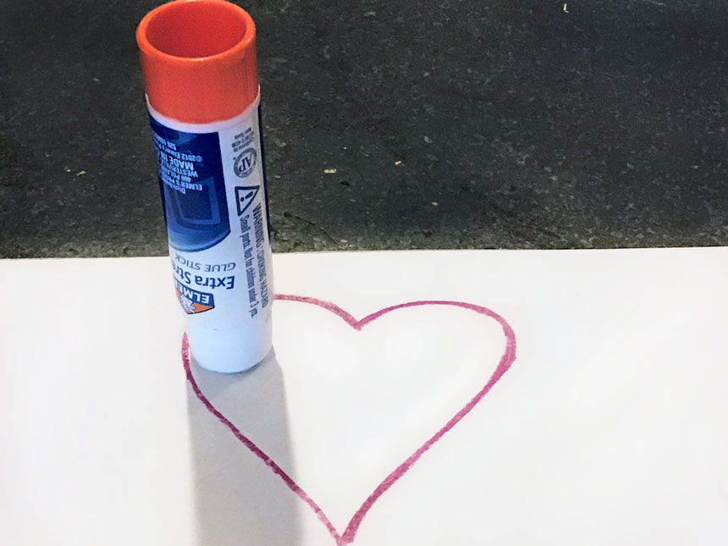
Step Five

Put glue where you want the roll to go on the shape that you drew.

Step Six
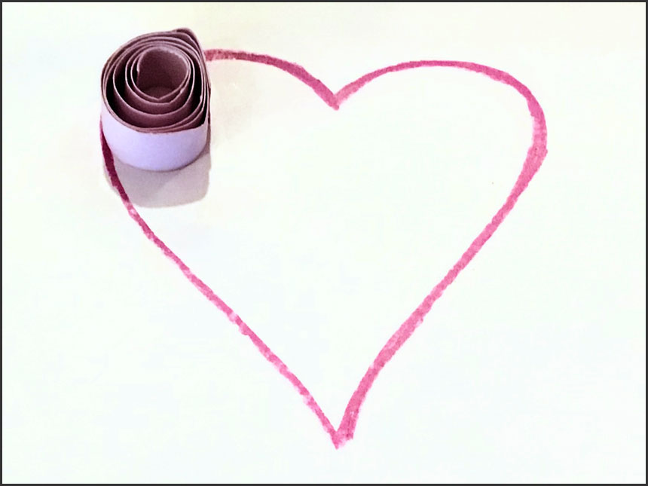

Press the rolled paper onto your design.

Step Seven
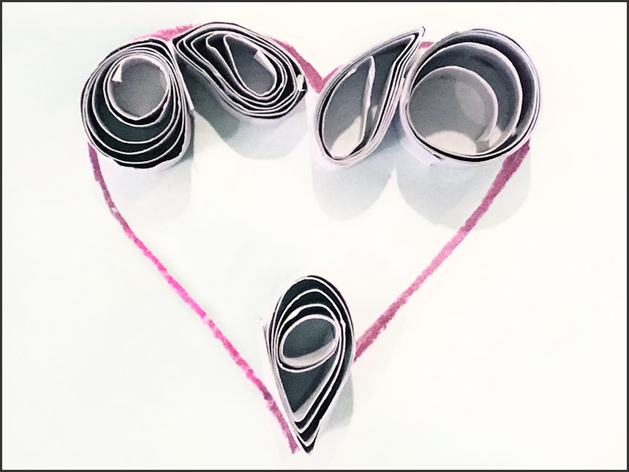
Make more paper rolls to fill in your drawing. Try making shapes by pinching or pushing on the sides of the rolled paper.

Step Eight

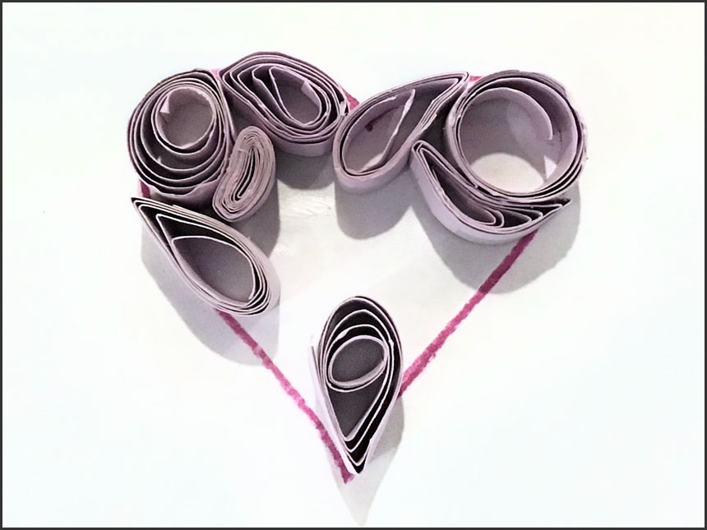
Keep adding! What designs can you make?

