The Plague

Learning Objectives
PuPils should learn:
About aspects of life in a medieval town.
About the nature and impact of bubonic plague at two key points in history.
How people in the Middle Ages viewed the plague.
How people in the Middle Ages thought they could cure the plague.
How to make deductions based on evidence.

Dungeon Links
The Plague is a key topic which features throughout the Dungeon.

Using the Pupil Worksheets
The Dungeons’ worksheets are designed to give your pupils an idea of the magnitude of the plague, focusing on two key points in history when Great Britain was gripped by the plague; 1348 and 1665.
PuPil Worksheet 1 sets the scene for pupils in 1348. Activities ask them to consider the horrible symptoms of the illness.
PuPil Worksheet 2 asks pupils to consider some of the crazy cures and plague preventatives used by people in the 14th Century and to write
a letter of advice to a friend in a town stricken by the plague.
PuPil Worksheet 3 introduces the plague of 1665.
PuPil Worksheet 4 is a sheet of cards for photocopying. In their groups, pupils must sort the cards into causes and effects of the plague. Following this, ask them to sort their cards into long and short-term effects.

Discussion Points
Why did the plague spread so quickly in both 1348 and 1665?
What can we learn about medieval beliefs from the different explanations people provided for the plague?
Why was there so little understanding about medicine and health in the 14th Century?
Were there any positive outcomes of the 1348 plague?

Extension Activities
Ask pupils to write a set of quiz questions on the subject of the plague in the style of ‘Who Wants to be a Millionaire?’ The class can then run the quiz.
Ask pupils to imagine how plague events might have unfolded if various circumstances had been different (i.e. what would have happened if…people didn’t believe in God, people knew about germs, the microscope had been invented etc.)
Ask pupils to write a diary, imagining that they are a goldsmith living in London during the plague of 1348. They should produce entries for a number of dates and events, for example:
2nd October 1348 – The plague begins to spread through the city.
10th April 1349 – Your neighbour contracts the plague.
1st June 1349 – Celebrations for the end of the plague.

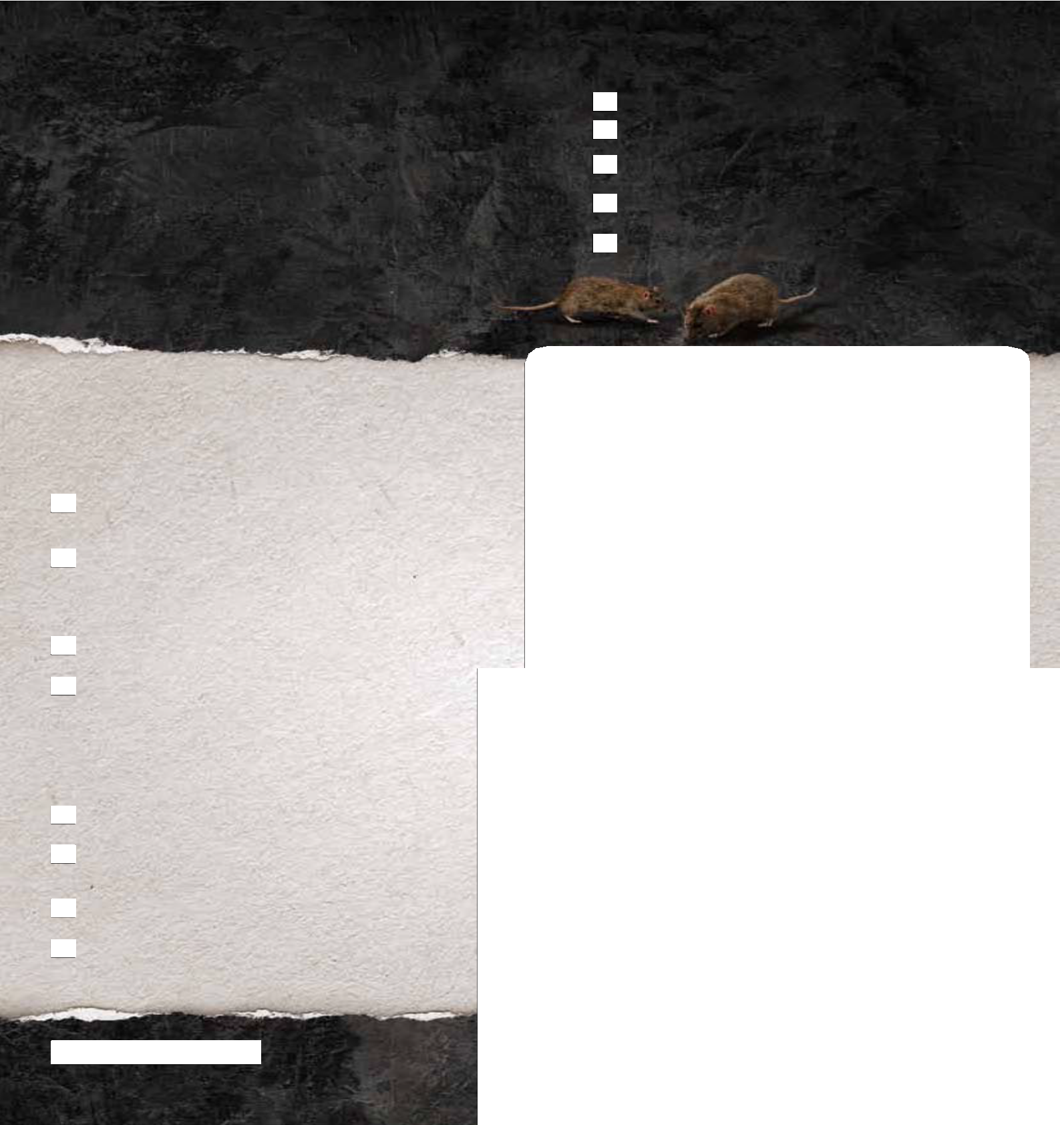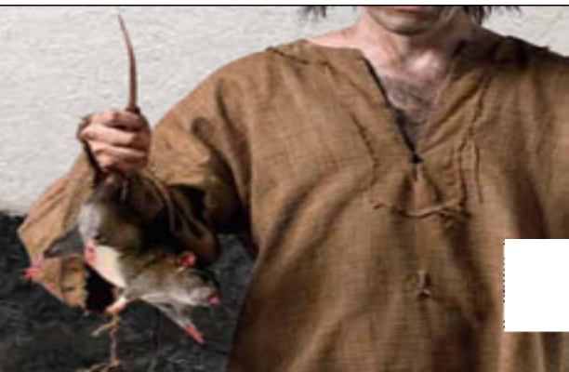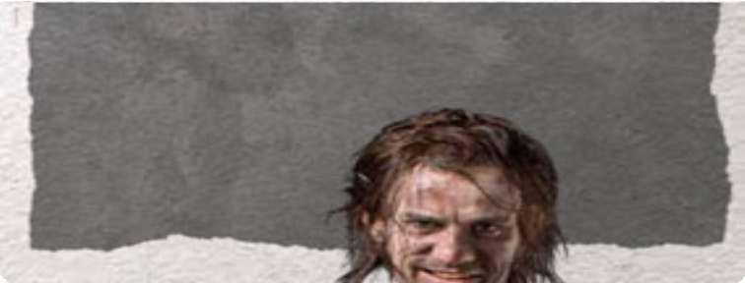TEACHER NOTES
ansWers: Pupil Worksheet 1: Activity 1 – c, g, b, f, e, a, d Pupil Worksheet 2: Activity 2 a) – i, iv, v, vii b) iv, v, vi

thedungeons.com

Scary symptoms
First came a bad cold, then vomiting and fever, and finally repulsive swellings in the armpit and groin, oozing blood and pus. By the time death arrived, most people were grateful for it.

The Plague
The dreaded plague was thought to begin in 1330s China. The plague was spread by rats that had fleas which carried the virus. When the rats died, their fleas moved on to humans, and their bites caused bubonic plague.
The plague reached Britain in August 1348, carried by the crew of a small boat that came ashore near Weymouth in Dorset. Three months later, it reached London.
By the time the plague finally died away in 1350, up to 2 million people had lost their lives in the most horrible way.

Activity 1

the plague was not a pleasant experience! Put this list of gruesome symptoms into the order that you think a sufferer would have experienced them.
- Internal bleeding
- Arms and legs become sore
- Headache, chills and a fever
- Death
- Swellings split open, oozing blood and pus
- Swellings on neck and limbs
- Nausea and vomiting

Did you know?
The bubonic plague was so-called because of the disgusting pus-filled boils or ‘buboes’ that appeared on sufferers.

  - 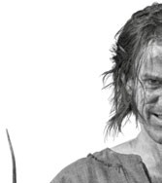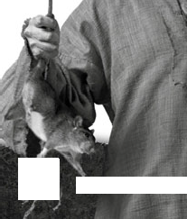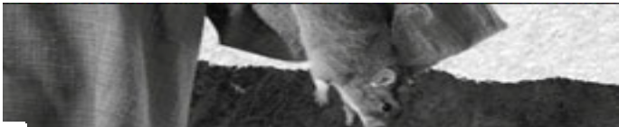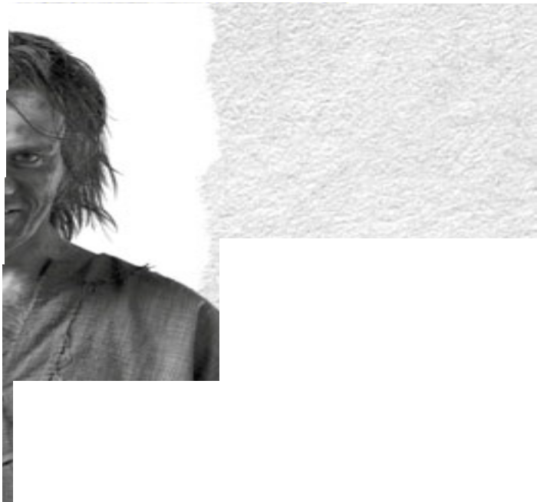PUPIL WORKSHEETS The Plague

thedungeons.com

Did you know?
There are still around 2,000 incidences of the plague every year, however
in most situations it can be cured by antibiotics. Further research is being carried out to stop its spread.

Activity 2
People in the 14th Century didn’t know much about what caused sickness and how to treat it.

Which four of the following do you think were used as ‘cures’ during the plague of 1348 – 1350?
Putting the tail feathers of a live chicken onto the boils.
i.
i Rubbing antiseptic cream onto the boils.
ii.

Which three of the following do you think were used to ‘prevent’ the plague?
Taking aspirin.
i.
i Sterilising everything in the house. ii Eating a balanced diet.
ii.
iii.
i
v.
Smoking tobacco.
. Smelling sweet herbs or flowers.
v
Praying.
vi.

ii v.
iii.
iv.
v.

vi vii
vi.
vii.
Drinking lots of water.
Slicing the boils open and burning them with a red-hot poker.
Bathing in your own urine.
Eating plenty of fruit and vegetables.
Applying a live frog or toad to the buboes.
vi Praying.

Activity 3

imagine you are a doctor living in london at the time of the plague (1348 – 1350).
Write a reply to this letter from John smith, a friend living in a nearby village. remember that a medieval doctor would not give the same kind of advice as a modern day doctor.

  - PUPIL WORKSHEETS: The Plague

thedungeons.com

1665 - The Plague strikes again!
In 1665, the horror returned. London was filthy, stinking and overcrowded and as the temperature rose throughout the spring and summer, the plague went from strength to strength.

London at the time of the plague wasn’t a pretty place. It didn’t matter if you were rich or poor, the plague would still come knocking at your door. Even if only one member of your family had the plague, a red cross would be painted on your door and your whole family would be quarantined in your house. Perhaps you’d like a new job? The ‘Plague Body Carrier’ was employed to dispose of the corpses in plague pits. Your chances of survival weren’t very high though...even escaping wasn’t an option- it was forbidden by law, and by the time the plague of 1665 ended, nearly 100,000 lives had been lost.

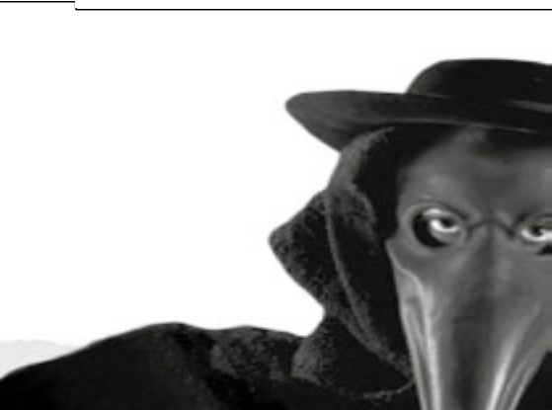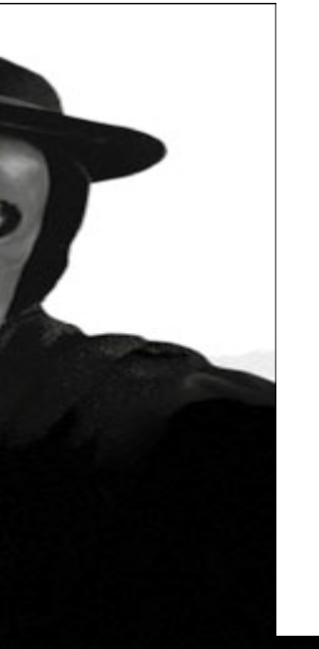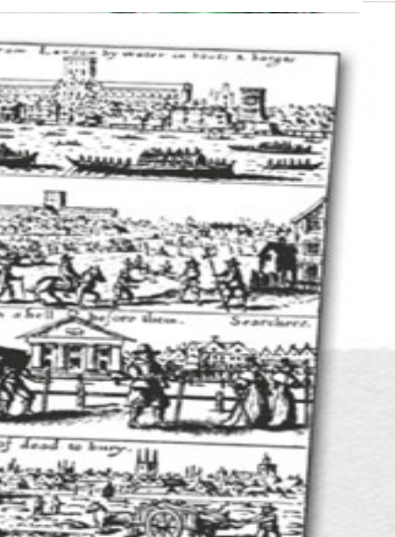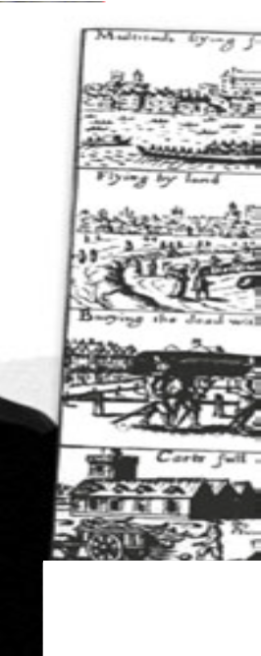The children’s rhyme ‘Ring a Ring of Roses’ was about the plague.
The ‘roses’ were the round red rashes that appeared on the victim’s skin. The ‘posies’ were sweet-smelling flowers that people held to their noses as they believed it would stop them from catching the disease. The sneezes were an early symptom of the disease, and ‘we all fall down’ was the sudden death that usually followed.

  - PUPIL WORKSHEETS: Plague

Did you know?
Many people believe the Great Fire of London put an end to the epidemic. In fact, it had greatly subsided by then.

thedungeons.com

Lack of medicine. | People travelling from town to town within Britain. | Animals dying.
Ignorance of doctors. | Increased taxes with fewer people to pay them. | Lack of sanitation.
Boats travelling from country to country. | Churches closing as many priests died after visiting the sick. | Population decrease.
Changes in farming. Lords kept animals instead of growing crops as they required fewer workers  to look after them. | Dirty, crowded living conditions. | Crops rotting in fields.
Death. | Fleas passed the disease from rats to humans. | Bad smelling air.
Stealing from empty shops and houses. | Dirty streets full of rubbish and excrement. | Labour shortage resulting in workers being able to demand higher wages from lords.
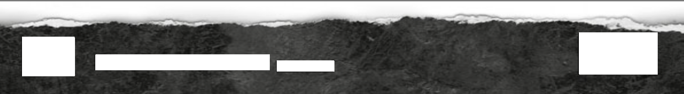
4
PUPIL WORKSHEETS: The Plague
thedungeons.com

