Marker Monoprints
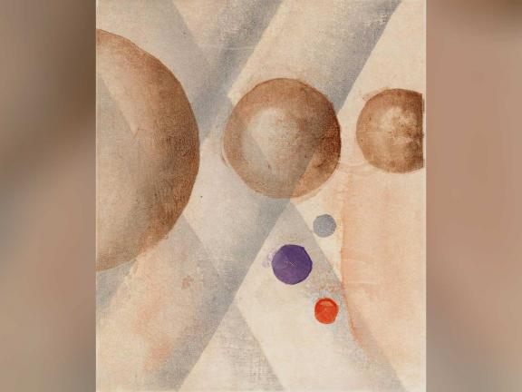

Learn how to make a monoprint with materials from home.
Printmaking allows artists to create multiple original copies of their work which is similar to making a print on a copy machine. But with mono printing, the image can only be made one time.
Each work of art is unique! Many different materials can be used as the base for making mono prints, such as metal, wood, and even Styrofoam. Artists can add designs with paint, ink, and collage. Afterward the surface is wiped clean and ready to be used all over again.
Onchi Kōshirō, the artist who made the print above, used colourful ink to paint circles and stripes on a wood block.
start by gathering all the materials below.
Materials
You will need:
- a large plate
- water
- print foam or a clean Styrofoam food tray
- washable markers
- white paper
- coloured paper
- glue stick
- paper towel or a sponge

Step One.
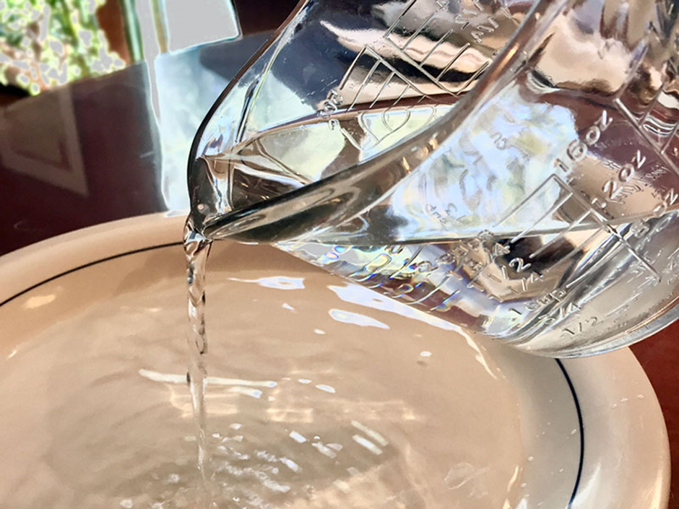

Pour just a little bit of water onto a plate.

Step Two
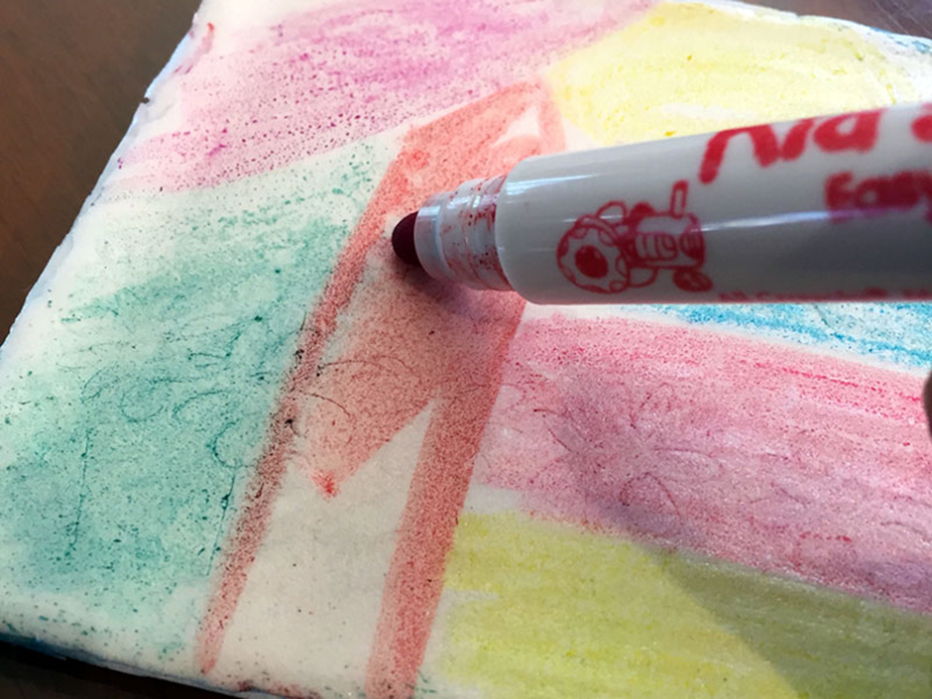

Use washable markers to draw designs or a picture onto the Styrofoam, being careful not to press the marker down too hard. You can make anything you like!

Step Three
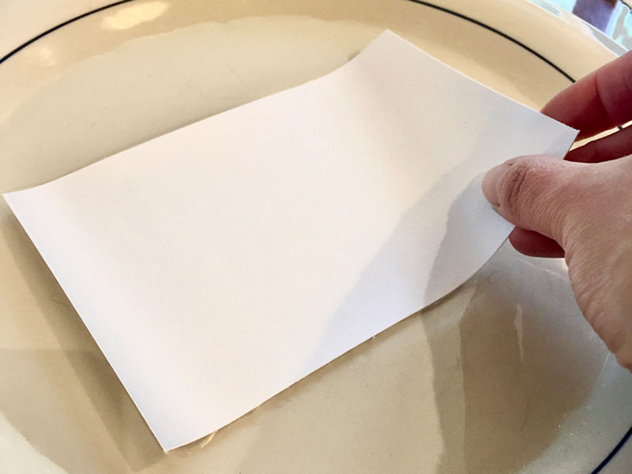

Wet one side of the white paper by dipping it into the water.

Step Four
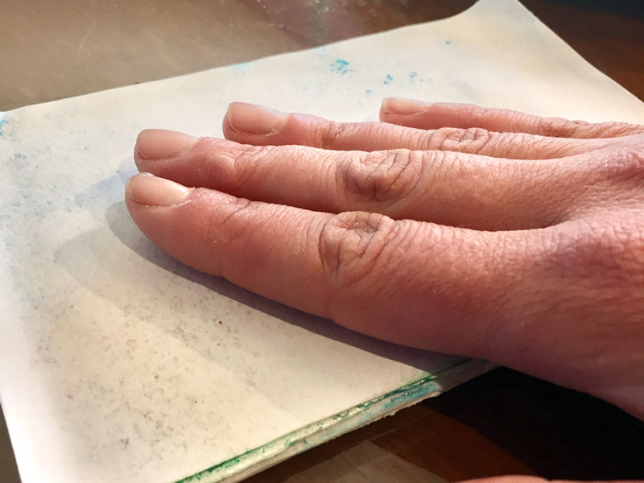

With the wet side facing down, carefully place the paper on top of the Styrofoam.

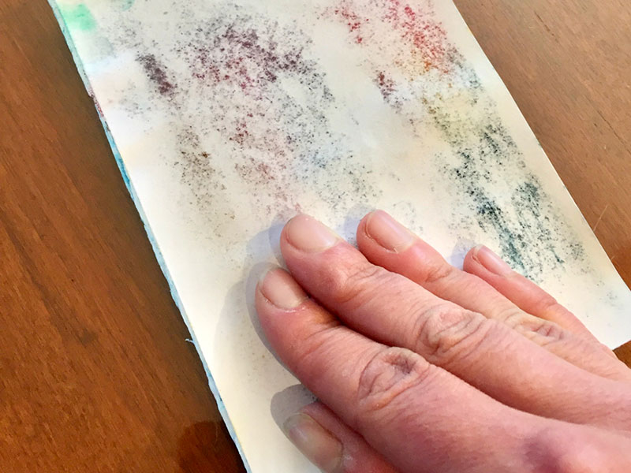
Step Five

Gently press the paper onto the Styrofoam with your fingers, making sure to press the whole surface.

Step Six
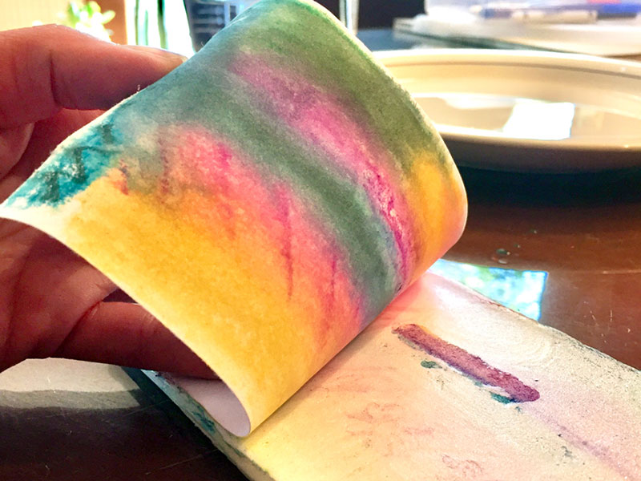

Peel back the paper and take a look at what you made!

Step Seven
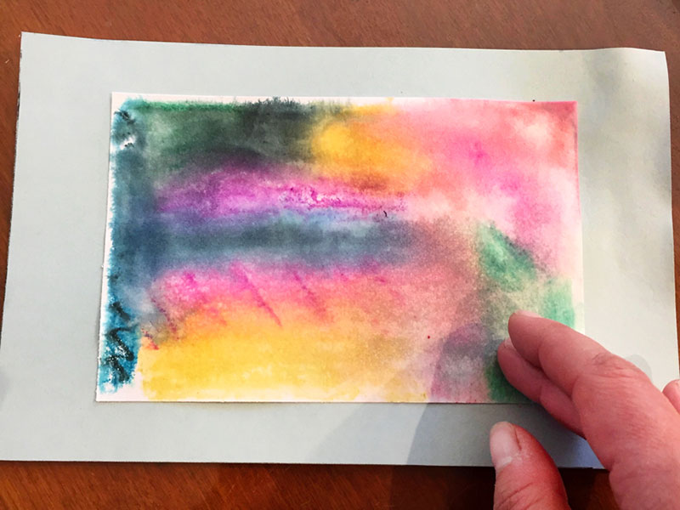

If you’d like, you can frame your print by gluing it onto another piece of paper.

Step Eight
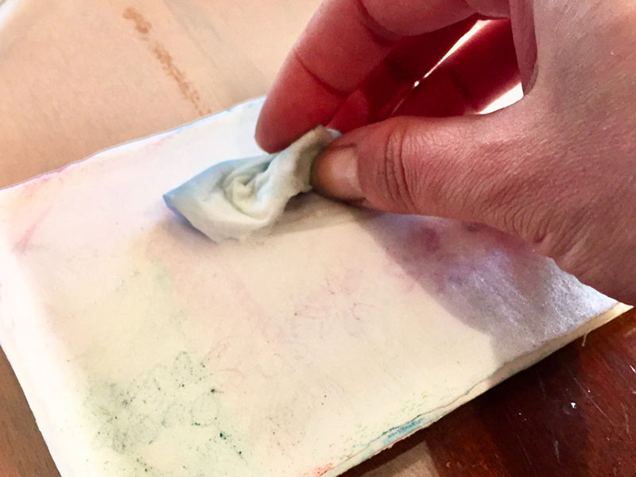

Use a paper towel or sponge dipped in water to wash the marker off the Styrofoam. Once it’s dry you can start again!

