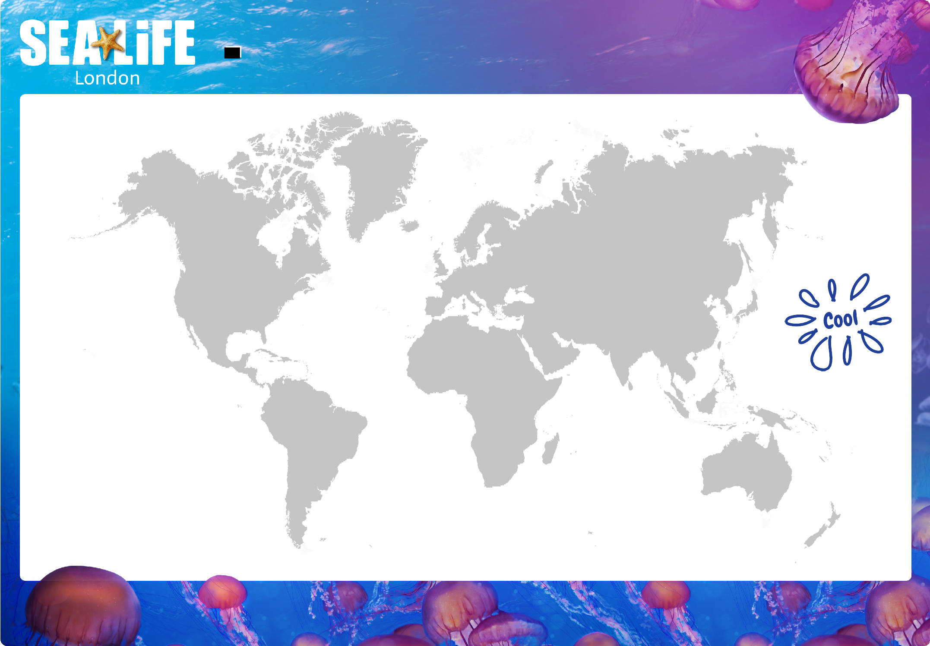
WHERE IN THE WORLD
Geography

Time to work as a team and share your jellyfish fact file with your friends to create a detailed map of where in the world you would locate various Jellyfish species.

