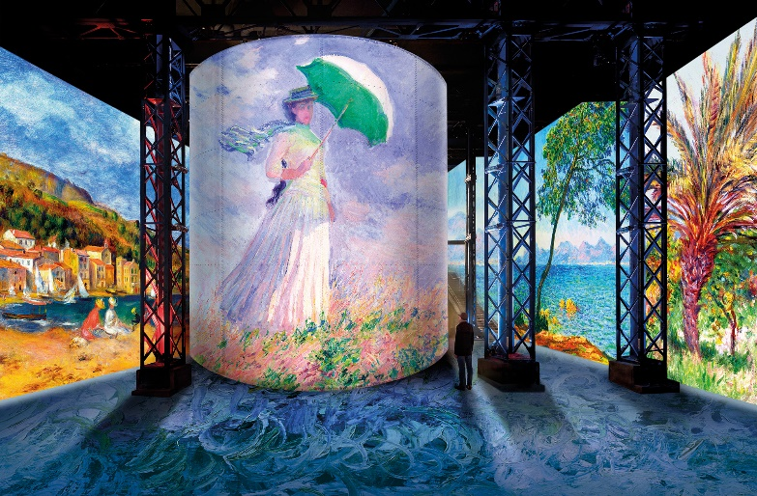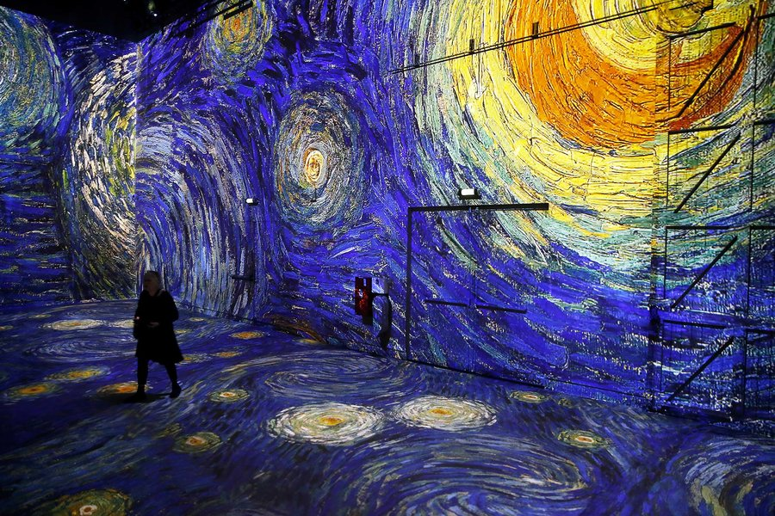

A New Museum Exhibit Lets You Walk into Vincent Van Gogh’s Masterpieces and Monet Renoir…Chagall.

Workshop of light is in Paris and lets you walk into a painting.

Have a look at the gallery of work that is being displayed.

What is your favourite Piece and why?

What is the meaning behind the painting, what was the artist trying to express?

Have a go at designing your own exhibit

[**www.atelier-lumieres.com**](http://www.atelier-lumieres.com)

Workshop Of Light.

The Atelier des Lumieres