Kew Gardens

Welcome to Royal Botanic Gardens, Kew

Unlock the amazing power of plants and fungi. Visit our world-leading botanic gardens and discover our science and conservation work.

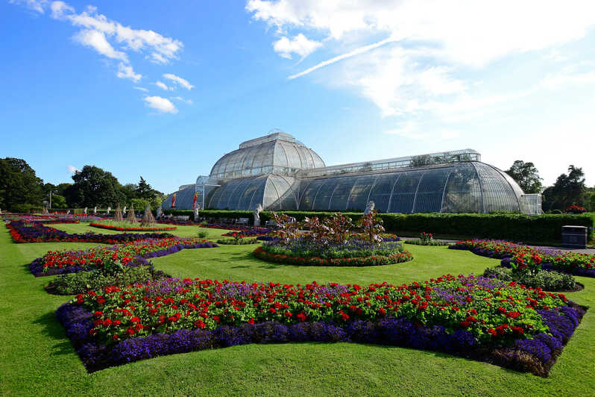

Expand your knowledge on plant and fungal science from the world's best experts.

[www.kew.org/about-us/virtual-kew-wakehurst](http://www.kew.org/about-us/virtual-kew-wakehurst)

Have

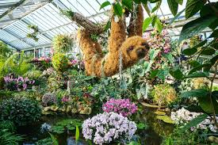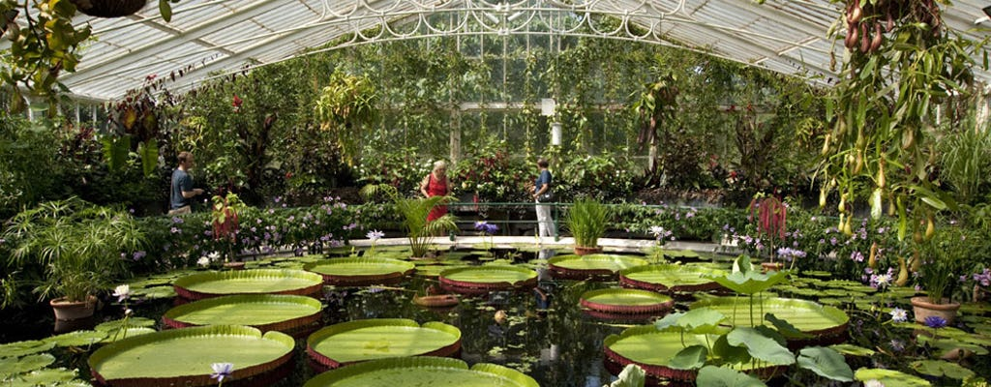

[www.kew.org/about-us/virtual-kew-wakehurst/unearthed-kew-podcast](http://www.kew.org/about-us/virtual-kew-wakehurst/unearthed-kew-podcast)

Have a browse through the podcasts and discover interesting facts and information about what happens at Kew Gardens.