Touchstone Online

Touchstone is a display featuring a single photograph. Visitors are inviting to respond to the photograph, through writing and drawing. This programme links with The Photographer’s Gallery wider educational emphasis on visual literacy.

Maxime Matthys-2091-The Ministry of Privacy, 2019

What do you see? Write a small description on the image. What do you like about the image and how would adapt this idea to your own?

Biography.

Maxime Matthys is a visual artist working and living between Rennes and Paris. He is developing an artistic practice using mainly photography, performance, videography and installation. His work focuses on the way technologies are affecting our daily life and our shifting our perception of reality. While exploring new forms if narrative, he keeps documenting the important issues that are shaping our future.

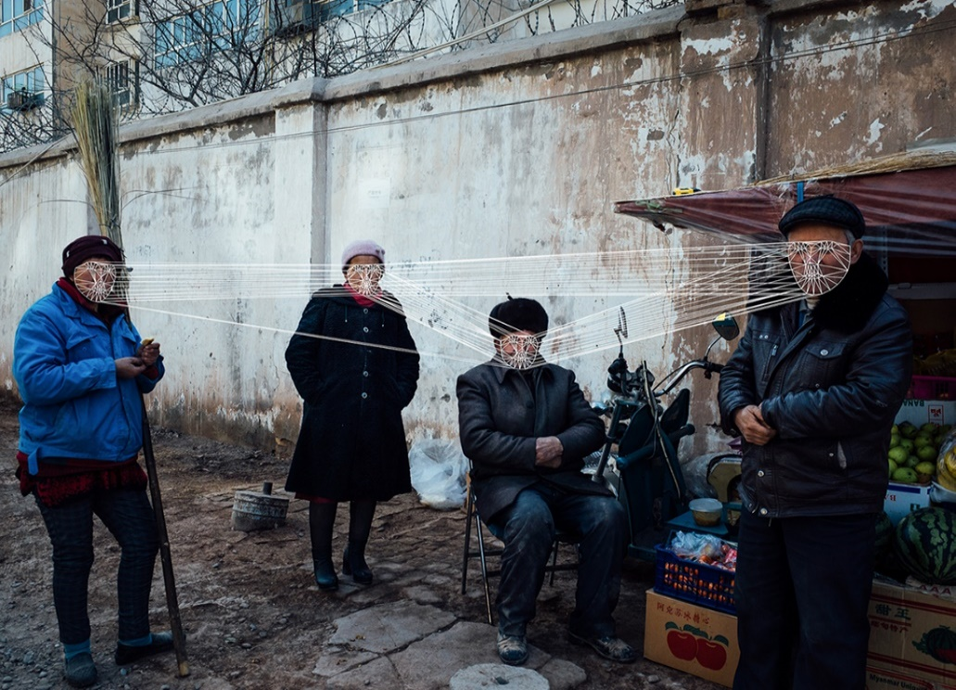

The Series 2091, The Ministry of Privacy is exploring the mechanism of facial recognition technologies used by China to monitor and oppress minorities in Xinjiang.

To do so, I developed a facial recognition software with the help of an IT engineer, which I used while photographing the daily life of the inhabitants in Xinjiang. Once shot, I uploaded the pictures in the software, which recognized and drew the respective biometric facial information’s directly on the faces of the people appearing on the original photographs, allowing us to see how facial recognition works and is used as a tool of oppression by the government. The society of control depicted in Orwell’s dystopia 1984 is indeed slowly becoming a reality, not only in authoritarian countries such as China, but also in the ‘democratic countries’. Herein France, for example, the government has increased spending on drones to watch overt the citizen during the current health crisis.