Kew Gardens

If you can't get to the gardens, let us bring the gardens to you.

Travel to the tropics, the desert and the mountains without leaving the house with our seasonal footage and a sneak peek at our glasshouses across Kew and Wakehurst.

These links will take you to our [YouTube channel,](https://www.youtube.com/channel/UCNa8wJk6VYIRK78JuDSRnTQ?view_as=subscriber) where there's more to explore.

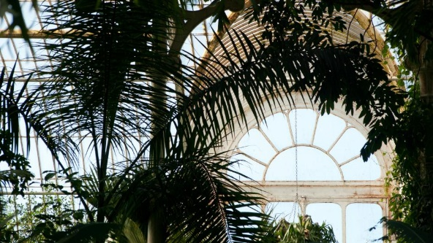

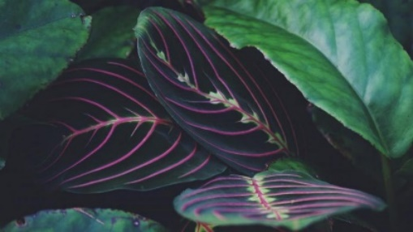

# **Learning at home**

Learn about plant and fungal science from home with our resources.

[www.kew.org/learning/learning-at-home](http://www.kew.org/learning/learning-at-home)