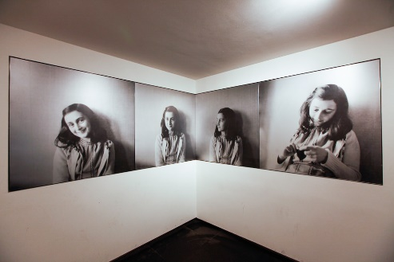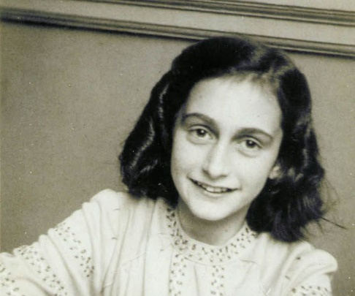

Who was Anne Frank?

Anne Frank hid in 1942 from the Nazi’s during the occupation of the Netherlands. Two years later she was discovered. In 1945 she died in the Bergen-Belsen concentration camp.

Click on the link below to be taken to Anne Frank Museum and find out more information on Anne Frank life.

[www.annefrank.org/en/anne-frank/who-was-anne-frank](http://www.annefrank.org/en/anne-frank/who-was-anne-frank)

Why did Anne Frank and her family go into hiding?

What comes to mind when you think of WW2 and the Holocaust.

How do you think Anne Frank diary changed the world?

Write your own short story, if you were living in the secret annex, what would you write about.

Have a look in the LRC or request a copy of Anne Frank diary to read.

Anne Frank House