Which Political Party Best Represents Your Views?

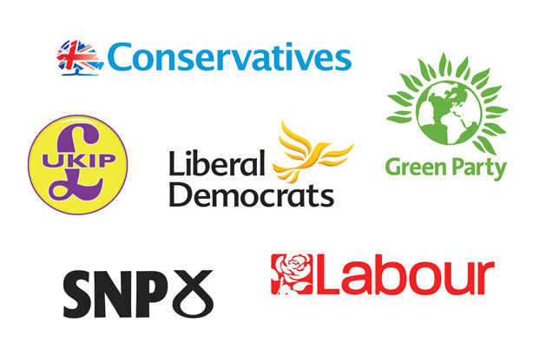

In England you can vote from the age of 18 but figuring out who to vote for can be confusing.
Your vote helps to decide the government that is elected and the policies they implement, including those on education, healthcare, criminal justice and the economy.
It is vital that you know which political party best represents your views and values. The quiz below will help you to discover which UK party is for you and help you to find out more about important political issues!

https://uk.isidewith.com/political-quiz

