Creative Activity
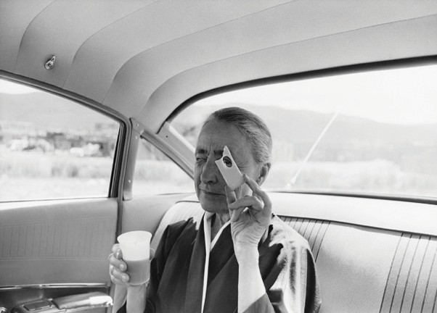
PHOTOGRAPHY: VIEWFINDER
Most cameras have a viewfinder—a small square of glass that you look through to compose or focus the subject of what will be included in the photograph.
The viewfinder makes a frame for your photo, and helps you decide where you want your main subject to be—at the center, or the bottom, or elsewhere in the picture.
Cut the center circle out of the camera image below, then

Tony Vaccaro. Georgia O’Keeffe with the Cheese, 1960. Gelatin silver print, 145/8 x 183/8 in. Georgia O’Keeffe Museum. Museum Purchase. © Tony Vaccaro. [2007.3.27]
look through your paper viewfinder to create different com- positions in the world around you.

