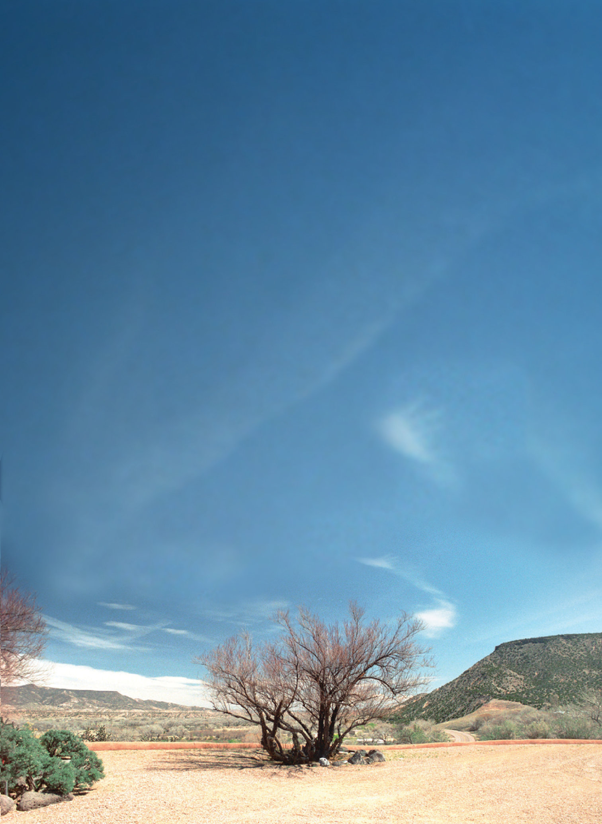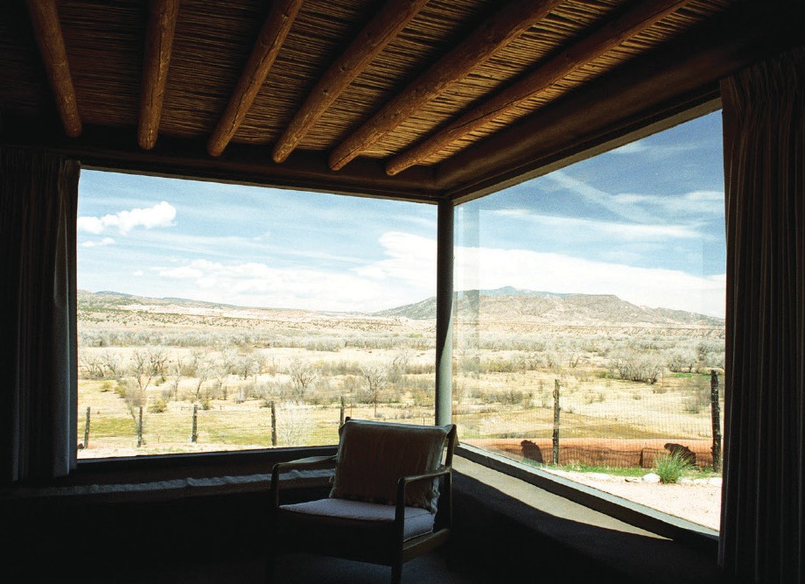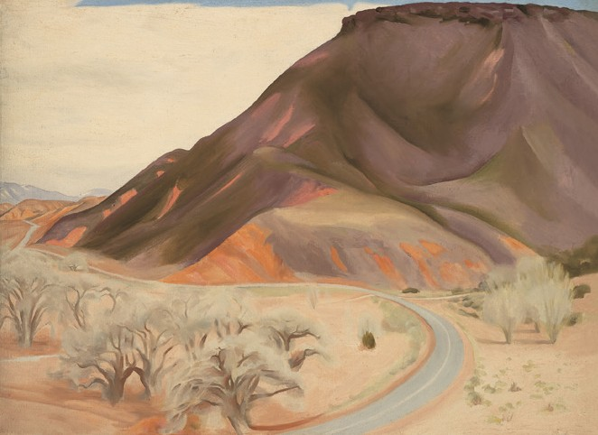Creative Activity

WHAT’S OUTSIDE YOUR WINDOW?
Georgia O’Keeffe was inspired by the beauty of the New Mexico desert. From her bedroom window in Abiquiu, she could see the vast sky above, hills and trees below, and a road stretching into the distance. She enjoyed this view so much that she completed many paintings, drawings, and even photographs of the mesa and the road to the east.
Familiar places can be great as sources for artistic inspiration!
What do you see when you look out your window?

View from O’Keeffe’s bedroom looking north, 2007. Photograph by Herbert Lotz, © Georgia O’Keeffe Museum.
Georgia O’Keeffe, Mesa and Road East, 1952. Oil on canvas, 26 x 36 in. Georgia O’Keeffe Museum. Gift of The Georgia O’Keeffe Foundation (2006.05.234). © Georgia O’Keeffe Museum

