Homemade Potato Chips Made In The Microwave.
When using a regular plate, just be sure to coat the bottom of the plate with oil so they don’t stick. Also regular plates get VERY hot in the microwave, so just be careful when you take the plate out.
To make homemade potato chips in the microwave all you need to do is slice a potato into thin slices, spray a plate with oil, lay the potato slices on a plate in a single layer, season them and then microwave them for about 4 minutes. Really, that’s all there is to it!
I definitely recommend using a mandolin to slice the potato. The key to these potato chips working is that they are sliced very, very thin. Using a regular knife does not get them thin enough to make good microwave potato chips.
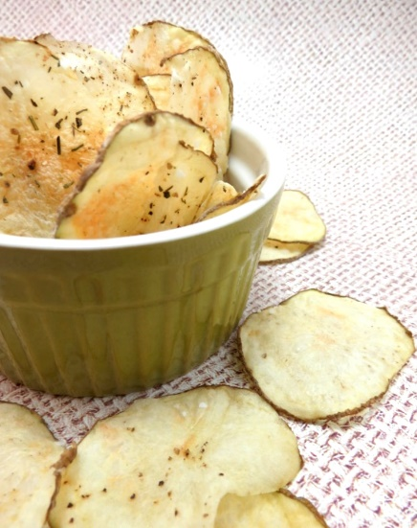
Something else to consider – go light on your seasoning, especially the salt. A little seasoning goes a very long way with these chips and you don’t want it to be overpowering.
It should only take about 4 minutes in the microwave for each plate, but you may want to start with 3 minutes and see how yours are turning out. I also found that microwaving them on a regular plate took slightly longer and it helped to take them out halfway through, peel them off the plate and lay them back down. That gives the bottom the chance to circulate some air and get nice and crispy.
To store the chips for later, place them in a zip lock bag in your pantry. They stay good for a week at least, but to be honest they don’t usually last more than a day or two before we eat them all.

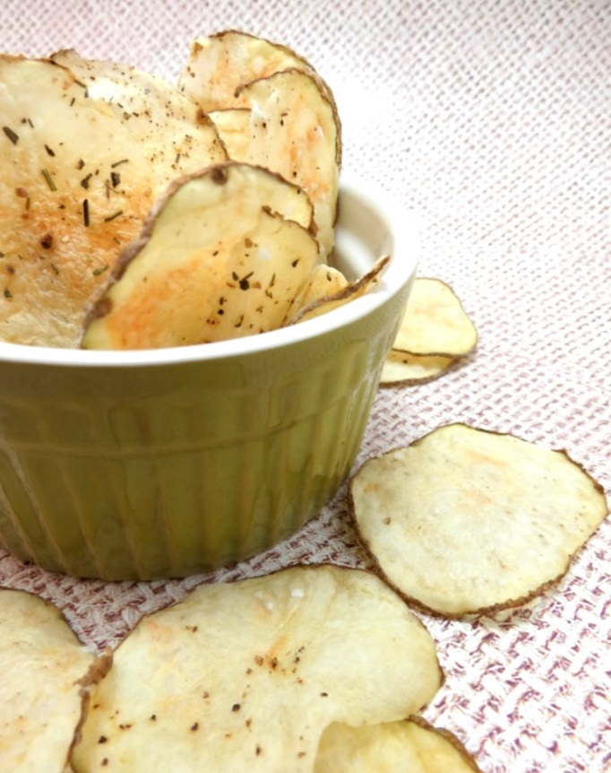
Frozen Fruity Yoghurt Bites.

With just a few ingredients and minimal equipment, this recipe couldn’t be easier to make, and the yoghurt bites make a great healthy dessert, snack or even a fun breakfast idea!
As always, this recipe can be adjusted to suit your tastes and needs – swap fresh fruit for alternatives of your choice (strawberries or blackberries would work nicely) or try dried fruits, or switch to soya yoghurt or similar if you’d like to make it dairy free.
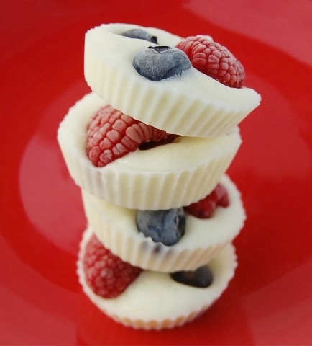

Reusable silicone muffin cups for this project as they are sturdy and eco-friendly, but you could also use paper cupcake cases if you have some. you’d like to use up. It might be fun to experiment with different shaped silicone cups if you have them.

Ingredients
- 200g Yoghurt of your choice
- Handful of fresh raspberries
- Handful of fresh blueberries
Method
Gather together your ingredients. Lay out approximately 12 cupcake cases or silicone muffin cups on a small baking sheet or tray (this will need to fit in your freezer, so it may be worth checking it for size before you start).
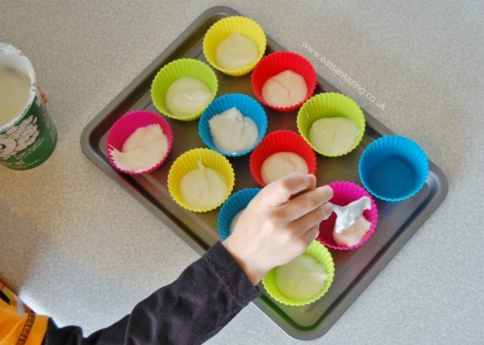
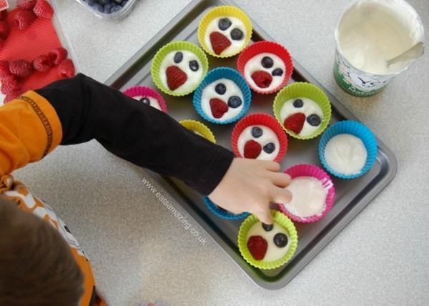
Using a spoon, dollop some yoghurt into the bottom of each cake case until all the yoghurt has gone.
Pop a few pieces of fruit into each cup, pressing them down into the yoghurt with the tip of your finger.
Place the cups (still on the baking tray) into the freezer and leave to freeze for a couple of hours until they have set and are solid.
Once frozen through, remove from the cases and serve (or bag up and pop straight back in the freezer to eat later).
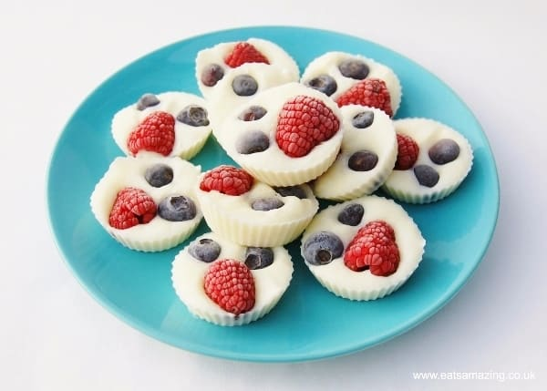
These are great to munch on straight out of the freezer as a healthy snack or dessert, or for a fresh idea for breakfast you could throw a few into a bowl of granola or cereal, yum!
Rainbow Fruit And Yoghurt Parfait.
Ingredients
Strawberry
Clementine’s
Mangos
Kiwis
Blueberries
Greek yoghurt
Granola

Instructions.
- In a glass layer yoghurt, fruit and granola
- Enjoy!

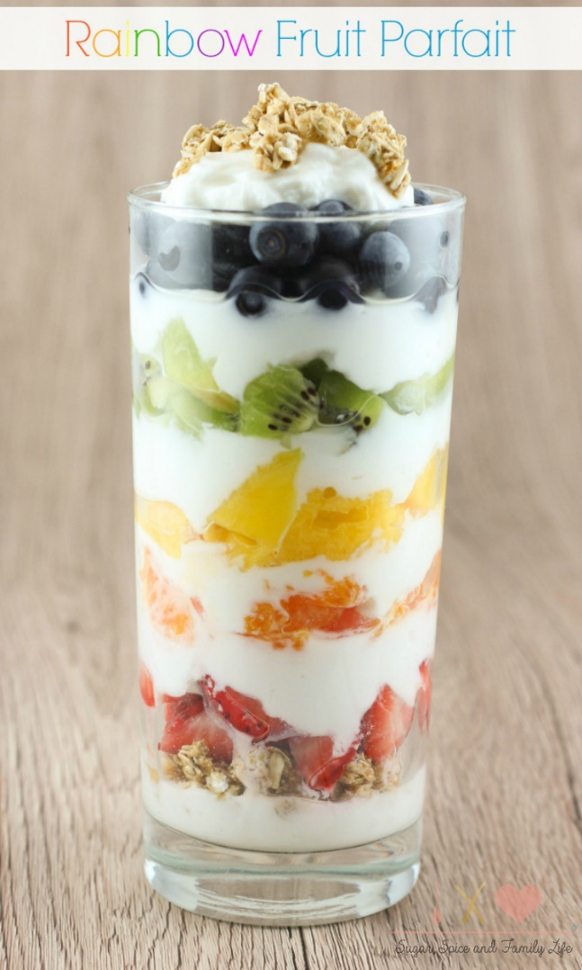

Banana Granola Bars (no-bake, vegan gluten-free)

These banana granola bars are super easy to make, are no-bake and can be made vegan and gluten-free!
Servings: 10 -12

Ingredients
- 2 large overripe bananas (240 grams total, without peel)
- 1 cup (92 grams) rolled oats (Use GF oats, if needed)
- 1/2 cup crunchy cereal granola or nuts
- 2 tbsp pure maple syrup or any other sweetener you use, if using a granulated sweetener add 2 tbsp liquid such as almond milk
- 2 tbsp (28 grams) natural peanut butter or other nut or seed butter
- 2 tbsp semi-sweet chocolate chips (make sure to use vegan, if desired)
- 2 tbsp dried cranberries or other dried fruit
- 2 - 4 tsp unsweetened cocoa powder

Instructions
- Line a muffin pan with paper liners, or use a silicone muffin pan for easy removal.
- Mash the bananas. Add wet ingredients and cocoa powder and mix well. Add all other ingredients, mix well then press into prepared muffin tin.
- Freeze at least 60 minutes before enjoying.



