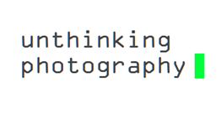
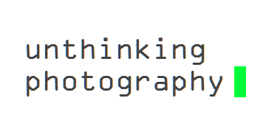
Photographer’s Gallery.
Unthinking Photography is an online resource that explores photography's increasingly automated, networked life, an online platform for mapping and responding to photography’s role in contemporary culture.
The title of the platform indicates a departure from Victor Burgin’s 1982 book ‘Thinking Photography’ and acts as an invitation to reconsider the ways we perceive photography today.
Alongside the gallery’s Media Wall programme and through commissioned writing and visual essays, and the imgexhaust tumblr, an aggregate of emerging themes and curation of online resources, the Unthinking Photography online space explores the aesthetics and politics of photographic culture today as well as what it means to make photographs in an age of big data, social networking and automated processes.
https://unthinking.photography/
Click on the link and have a look at some of the articles. They are some good reads, hopefully can help with ideas and artists.





