Henri Cartier-Bresson
From the images of Man Audio-visual Series, The Decisive moment: Henri Cartier-Bresson, 1973
The most difficult thing for me is a portrait. It’s a question mark you put on someone. Trying to say, “Who is it? What does it amount to? What is the significance of that face?” The difference between a portrait and a snapshot is that in the portrait, the person has agreed to be photographed.
I like to take pictures of people in their environment, the animals in its habitats. It is fascinating coming into people’s homes, looking at them. But you have to be like a cat, not disturb. On tiptoes, always on tiptoes. It’s like biologist and his microscope. When you study the thing, it doesn’t react the same way as when it is not being studied and you have to try and put your camera between the skin of a person and his shirt, which is not an easy thing.
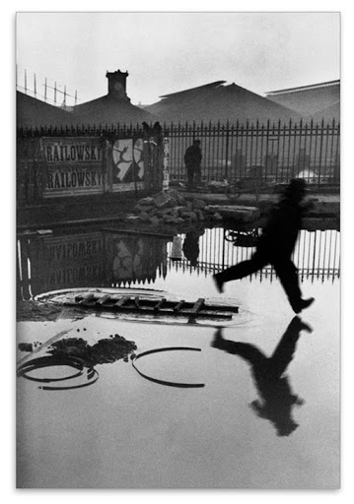

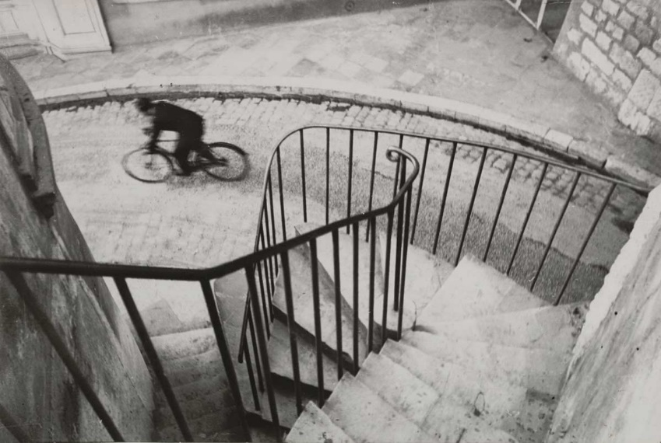
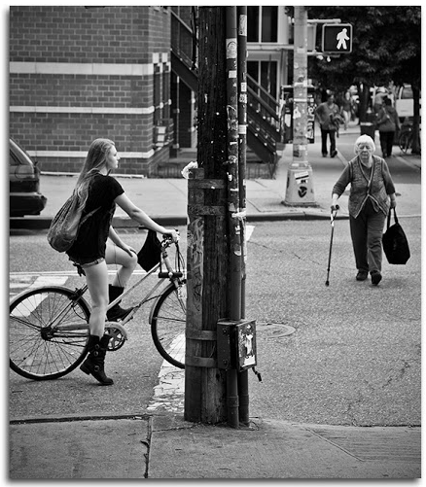

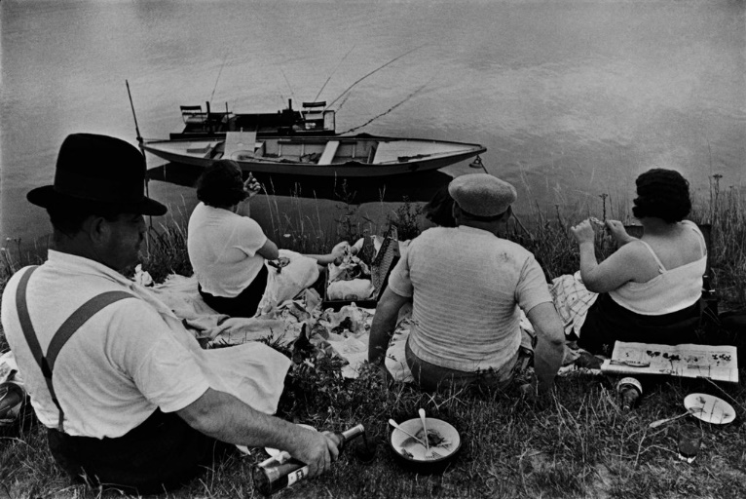

Have a think about Henri Cartier-Bresson is saying.
What do you think when you take photographs? Try to apply the questions to your own images and see what out comes you get.

