National Theatre
Drama Online offers users a unique opportunity to read and watch a play in the same digital space.
Approaching plays through different versions or media can transform learning.

Click the link below to go to the plays.
www.dramaonlinelibrary.com/custom-browse?docid=nationalTheatreCollection

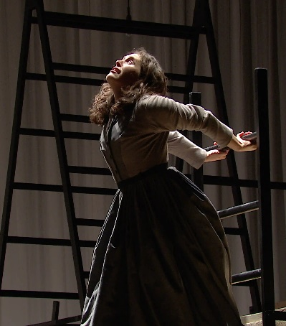
Born into a life of struggle, the spirited Jane Eyre tackles life's obstacles head-on as she seeks to pursue her own path in the world. Faced with poverty, injustice and a bitter betrayal, the trailblazing Jane follows her heart to fight for freedom and fulfilment on her own terms.

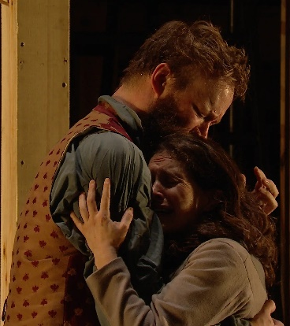

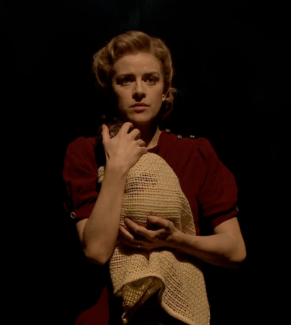
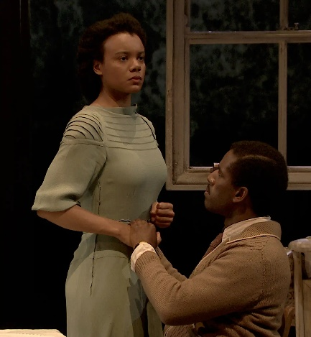
To access the videos please contact Mrs Wood through the cultural capital email for the username and password.
KS3cc@marlborough.herts.sch.uk

Adapted for the stage by Helen Edmundson, Small Island follows three intricately connected stories. Hortense yearns for a new life away from rural Jamaica, Gilbert dreams of becoming a lawyer, and Queenie longs to escape her Lincolnshire roots. Hope and humanity meet stubborn reality as the play traces the tangled history of Jamaica and the UK

