Drama Online offers users a unique opportunity to read and watch a play in the same digital space.
Approaching plays through different versions or media can transform learning.
Once you have watched the plays, have a go at designing your own set design and write a paragraph on your favourite scene and why.

Click the link below to go to the plays.
www.dramaonlinelibrary.com/custom-browse?docid=nationalTheatreCollection

National Theatre
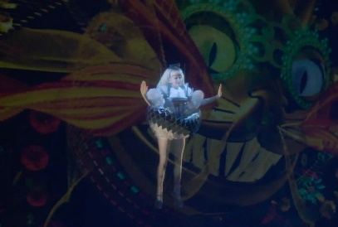
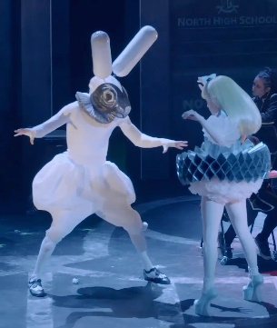
Fired from his skiffle band, Francis Henshall becomes minder to Roscoe Crabbe, a small time East End hood, now in Brighton to collect £6,000 from his fiancée’s dad. But Roscoe is really his sister Rachel posing as her own dead brother, who’s been killed by her boyfriend Stanley Stubbers.
Holed up at The Cricketers’ Arms, the permanently ravenous Francis spots the chance of an extra meal ticket and takes a second job with one Stanley Stubbers, who is hiding from the police and waiting to be re-united with Rachel. To prevent discovery, Francis must keep his two guvnors apart. Simple.

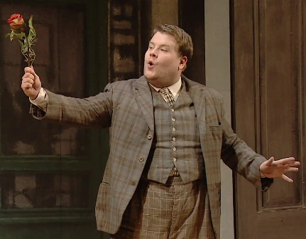
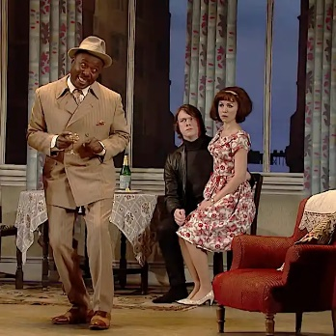
A new musical inspired by Lewis Carroll’s iconic story, wonder.land is a coming-of-age adventure that explores the blurred boundaries between our online and offline lives. Combining live theatre and digital technology in dazzling new ways, wonder.land is brought to life on stage by an extraordinary creative team.
To access the videos please contact Mrs Wood through the cultural capital email for the username and password.
KS3cc@marlborough.herts.sch.uk

