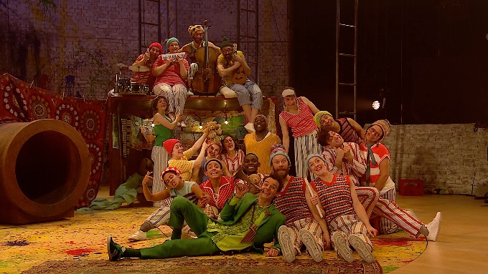
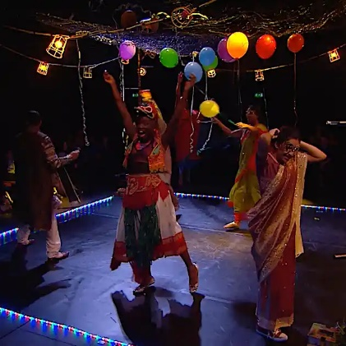
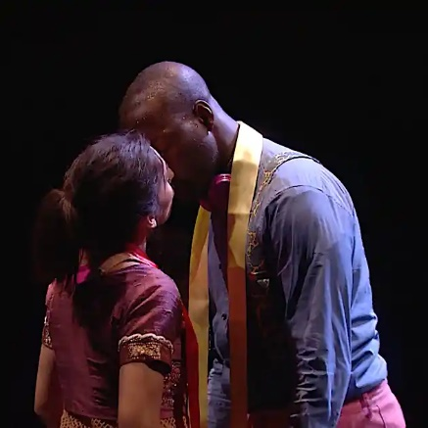
This contemporary production sees a company of eight tell the most famous love story of all time, set against a vivid urban backdrop bursting with excitement, colour, dance and song.
A swift, contemporary celebration of Shakespeare’s masterpiece, Bijan Sheibani’s thrilling production brings Romeo and Juliet to life for a new generation.
All children grow up, except one.
When Peter Pan loses his shadow, headstrong Wendy helps him reattach it. In return, she is invited to Neverland, where Tinker Bell the fairy, Tiger Lily and the vengeful Captain Hook await. A riot of music, magic and make-believe ensues.

Drama Online offers users a unique opportunity to read and watch a play in the same digital space.
Approaching plays through different versions or media can transform learning.
Once you have watched the plays, have a go at designing your own set design and write a paragraph on your favourite scene and why.

Click the link below to go to the plays.
www.dramaonlinelibrary.com/custom-browse?docid=nationalTheatreCollection

To access the videos please contact Mrs Wood through the cultural capital email for the username and password.
KS3cc@marlborough.herts.sch.uk
National Theatre

