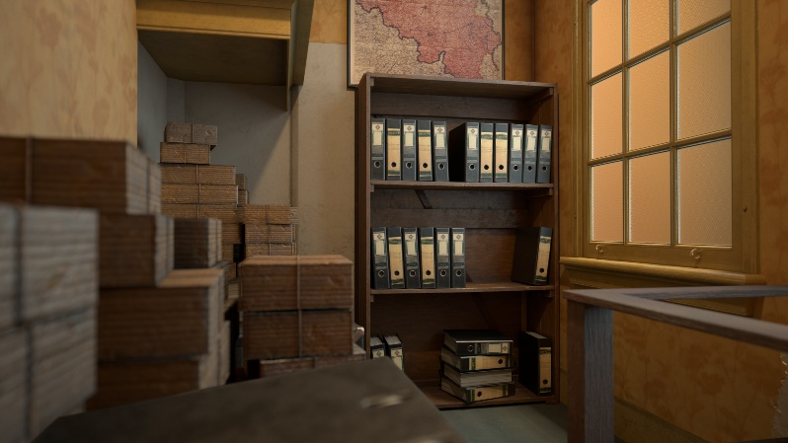
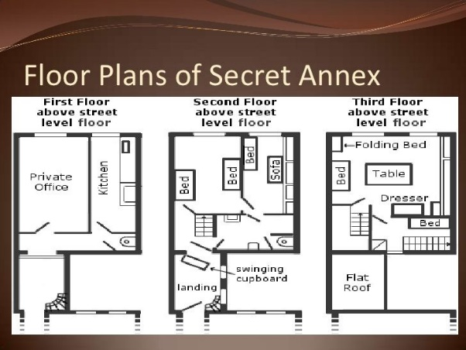
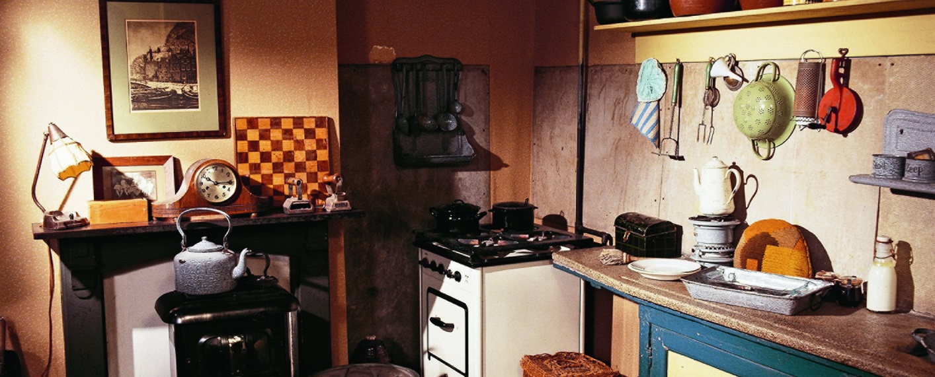
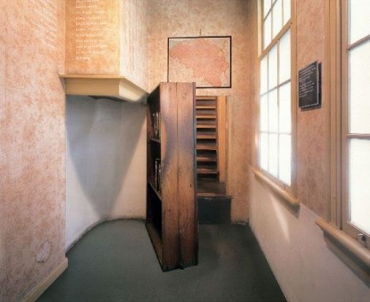
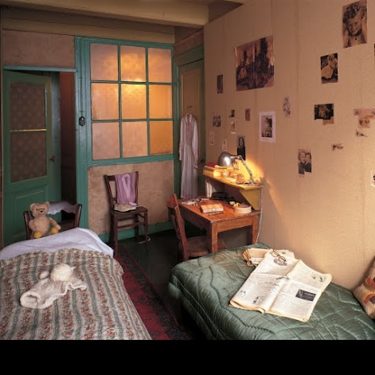
Take a look around and discover the Secret Annex where Anne Frank hid for more than 2 years during WWII and where she wrote her diary
In July 1942, the frank family went into hiding. The Van pels family followed a week later. The two families already knew each other.
Hermann Van Pels worked for Otto’s company. Four months later, they were joined by an eighth person, Fritz Pfeffer, an acquaintance of the Frank family.
www.annefrank.org/en/anne-frank/secret-annex
Write a small description on the Annex, what do you think it would be like to live there. What is the one item you would take with you?

The Secret Annex

