Anne Frank Activity

Complete the activities below after watching the video from the link
http://edu.annefrank.org/annefrankintroductorylesson/filmclip2.html
When Finished the activities, write a small description on who were the important people and events from Anne Frank’s life.
What do you think Anne Frank would have done with her life if she survived? What career would she had followed?

Think of 6 words that have something to do with World War 2.

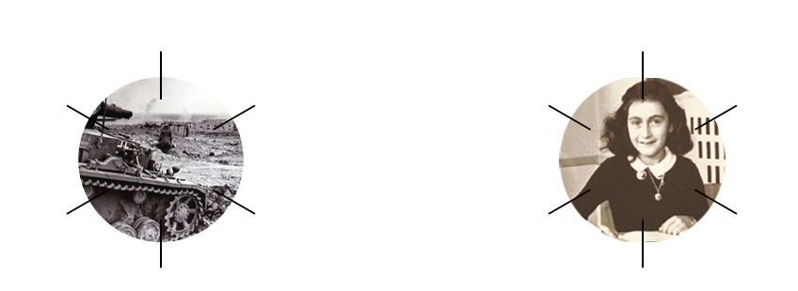

Think of 6 words that have something to do with Anne Frank

Place these events in the correct order.

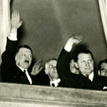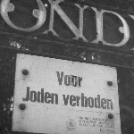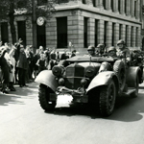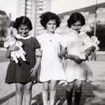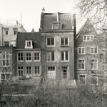

Put the events in the correct order.

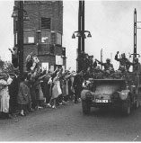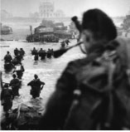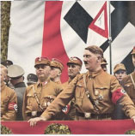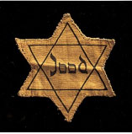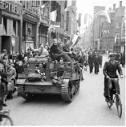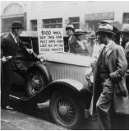

Put the events in the correct order

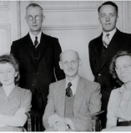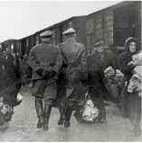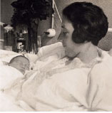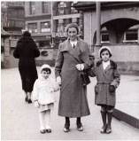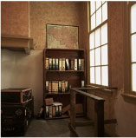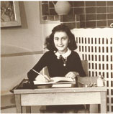

The timeline is complete. Above the line are the events from history. Below the line are important events from Anne Frank’s story

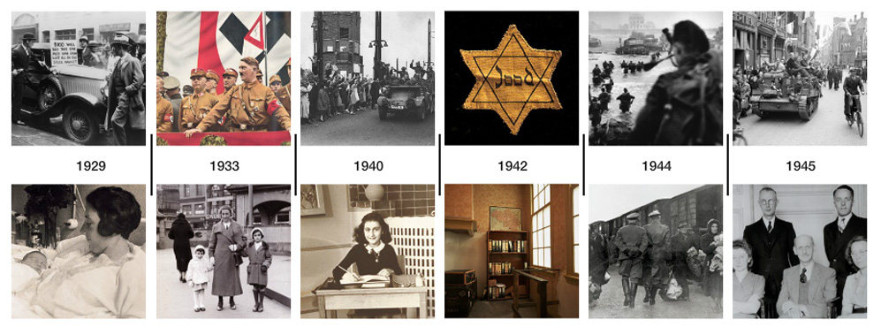

WHO IS WHO?
Put the photos of the 8 people in hiding on the right and the 4 helpers on the left.

HELPERS | THE PEOPLE IN HIDING

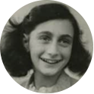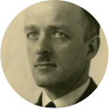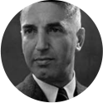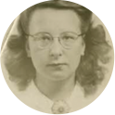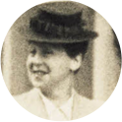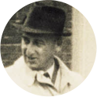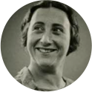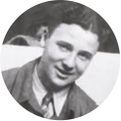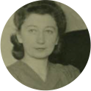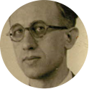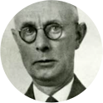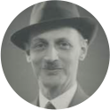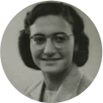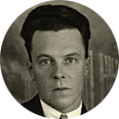

THE PEOPLE IN HIDING
Which description matches which one of the people in hiding? Match the descriptions to the photos of the people in hiding. Place the photo to the correct description.

..received a diary for her 13th birthday.

In November 1942...was the last to join the others in hiding

...had a business with Anne’s father dealing in spices.

...fell in love with Anne and was the only one to have his own room in the Secret Annex.

...received a call-up from the Nazis to go to a work camp in Germany.

Peter’s mother, ..., cooked most of the meals in the Secret Annex

..asked the 4 employees if they would help them while in hiding

..was Otto Frank’s wife and Anne and Margot’s mother.

ANTI JEWISH LAWS
The Nazis took a total of more than one hundred measures against Jews. There are only seven listed above. Place the images on the timeline.

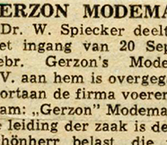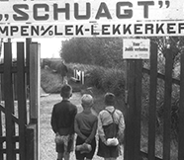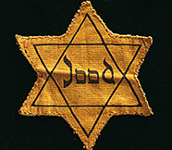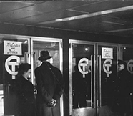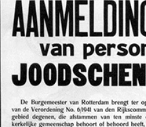
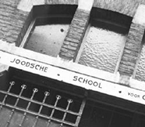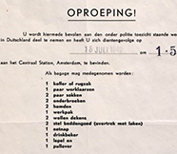
1941 January
1941 January
1941 March
1941 September
1941 September
1942 May
1942 July

