The Classical World Meets The 21st Century

You might not immediately associate Classics with computers but video game developers are constantly drawing on the history, culture and lifestyles of the ancient world when they design their fantasy worlds. One brilliant example of this is Assassin’s Creed Odyssey which is set in the years 431-422 BCE.

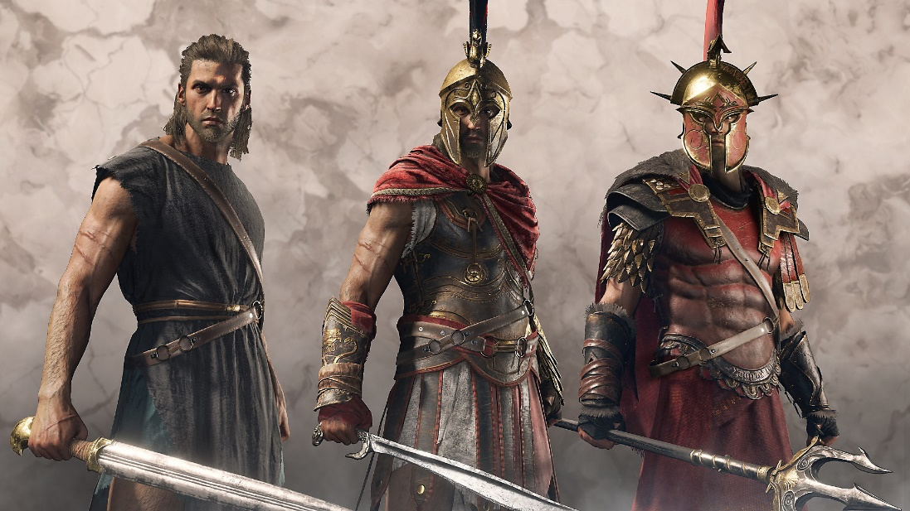

The Faculty of Classics at the University of Oxford have produced a series of four YouTube videos showing in-game footage of Assassin’s Creed Odyssey with commentary on how accurate the game is, relevant historical context, and the information regarding the inspiration behind the game’s setting, appearance and mythology.
The videos mentioned above can be found here: https://www.youtube.com/playlist?list=PLN_RX1AjtckBdnEBLlcukbe41TmOd9y5p
You can simply watch the above videos or you can complete an extension task of writing a short (half a page of A4) recap of something fascinating that you learned from the videos. Return this to Miss McCluskey (KS4CC@marlborough.herts.sch.uk) for a house point.
If you write a small review of another video game (or TV show) that draws on elements of the ancient world and return it to Miss McCluskey you will receive a pinkie!

