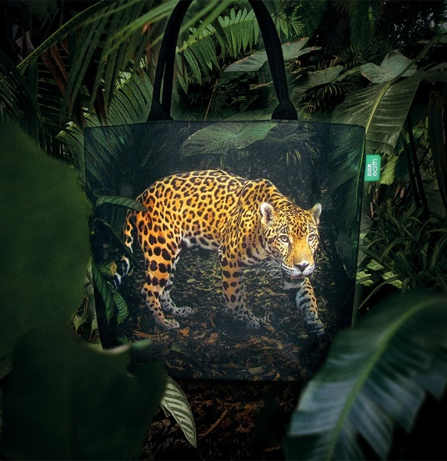
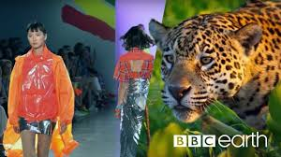
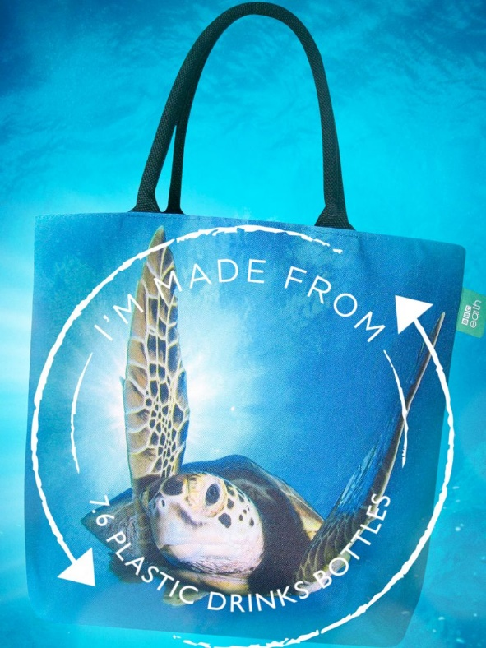
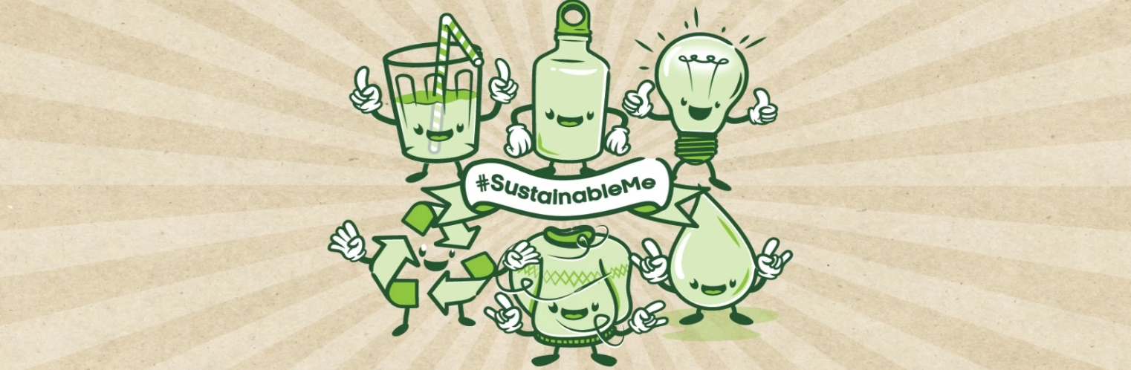
Can fashion be sustainable? Watch the all the videos clips by clicking the link below.
Design your own sustainable fashion item or clothing and write about why you chose it and how it will benefit the environment.
What else do you think that we can do to help the environment with everyday objects. Think about how we can recycle them instead of throwing them away.
www.bbcearth.com/sustainable-me

#Sustainable Me

