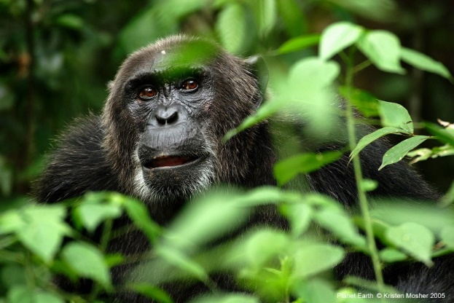
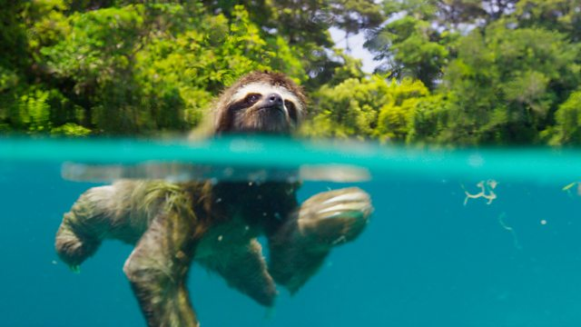
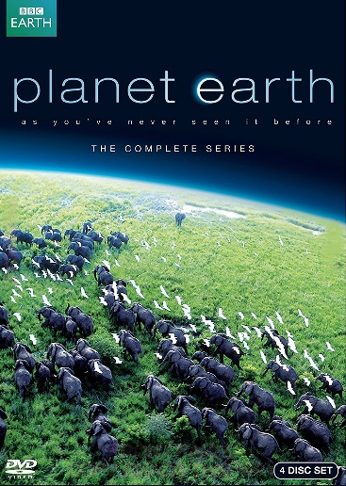
Watch planet earth on BBC iplayer. Follow the link below.
www.bbc.co.uk/iplayer/episodes/b006mywy/planet-earth
Scale majestic mountains explore waterways and caves, starlit deserts and spectacular ice-worlds. See awe-inspiring landscapes from all across the globe and incredible footage of the rarely spotted, almost mythical creatures that live in these habitats.
Be prepared to be overwhelmed by the beauty of Planet Earth.
Follow the link below to find out about planet earth

www.bbcearth.com/planet

Planet Earth

