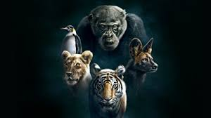
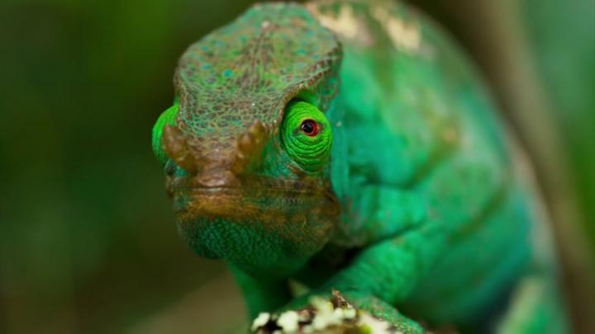
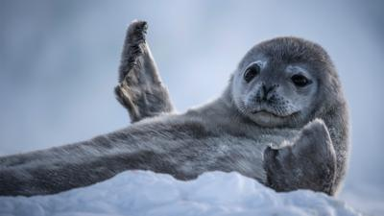
Have a go at some of the quizzes from the link below.
At the end of each quiz you take make a note of what you are and what quizzes you have done.
Design a poster on what you got. Does the answer relate to you?
If you could be an animal what would you be a why?
www.bbcearth.com/blog?tag=Quiz

Quiz: How utterly orangutan are you?

Quiz: Which playful animal are you?

Quiz: What kind of dog are you?

Quiz: What laughing animal are you?

Quiz: Which sleepy animal are you?

BBC Planet Earth Quizzes.

