How to Make a Zine
Materials: One piece of paper that is at least 8 ½” x 11”, Drawing/Writing Materials – markers, pens, colour pencils, crayons, etc. Optional Collage Materials – magazines, scissors, glue sticks, etc.
Instructions:
1. Start with a piece of paper that is rectangle and at least 8 ½” x 11”. Fold your sheet of paper in half lengthwise.
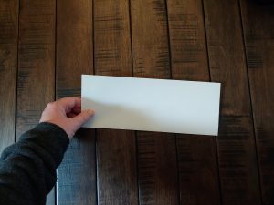
2. Now fold it in half width-wise.
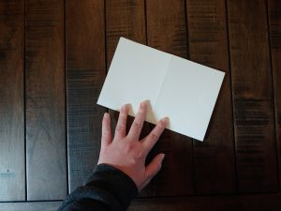
3. Fold it again width wise so that now you have folded it into quarters.
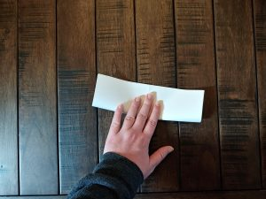
4. When you open your paper it should have 8 sections.
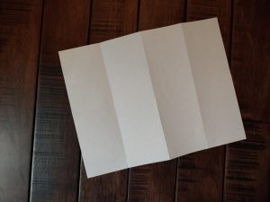
5. Fold your paper in half width-wise. Tear or cut halfway across the middle from the fold.
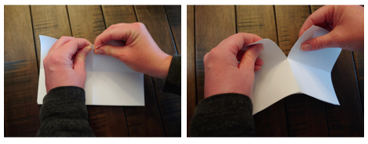
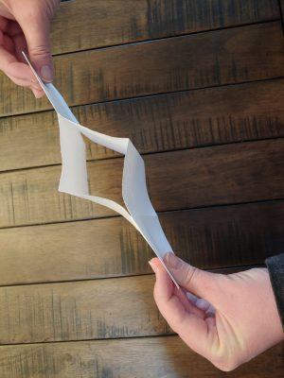
6. When you open your paper it should have a slit in the middle.

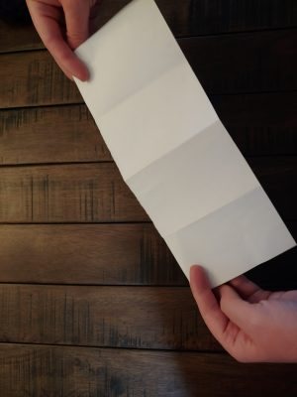
7. Fold your paper lengthwise (along the crease that has the slit).
8. Hold the paper at either end, then push the ends in toward each other. The sections should fold into each other to form an eight-page booklet.
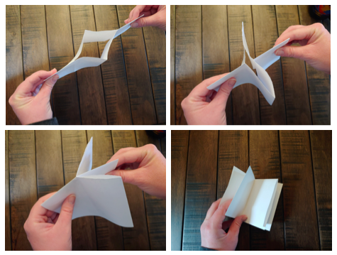
9. Design your zine. Your zine could be a journal, diary or comic book. Think of a beginning, middle and end. Use images or words or both! Sketch or write your ideas on separate sheets of paper before committing to the book.
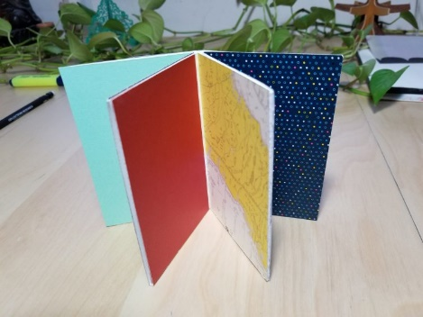
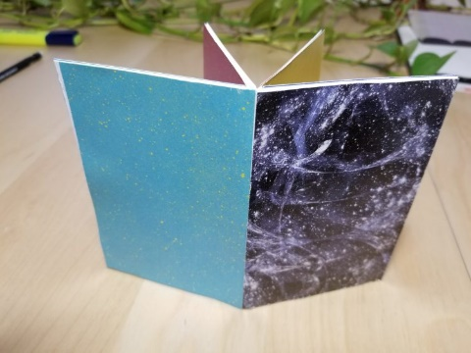
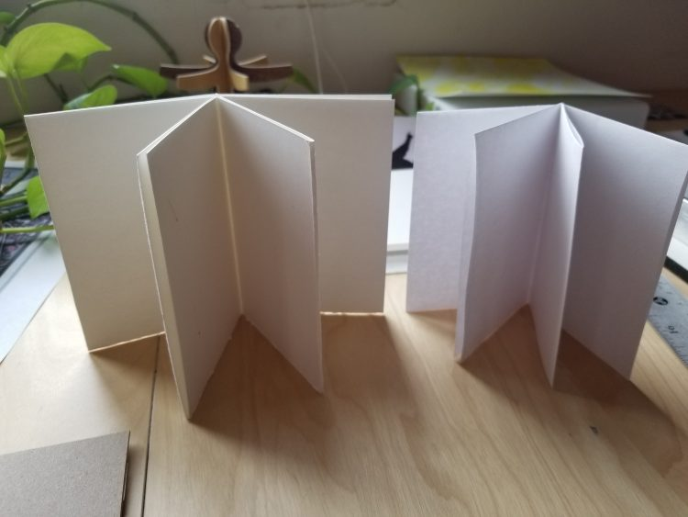
Need inspiration? Check out the following examples.

