Georgia O’Keeffe
Museum
Five virtual exhibits walk you through the inspiration behind Georgia O’Keeffe’s greatest works, from modernism to watercolours.
She is affectionately dubbed the “Mother of American Modernism,” and these pieces truly take our breath away.

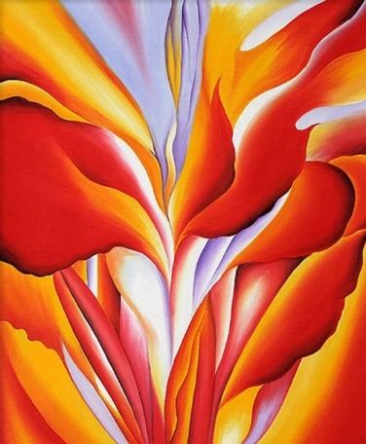
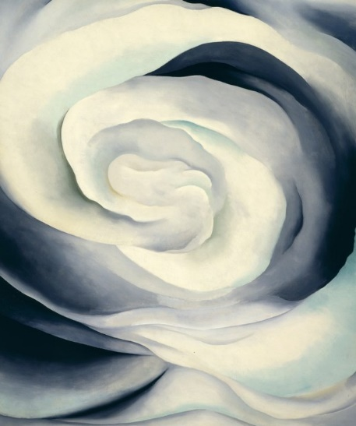
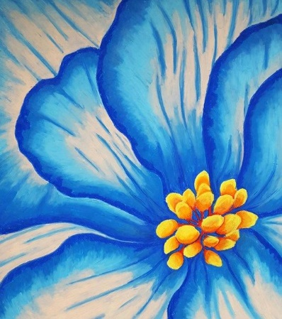
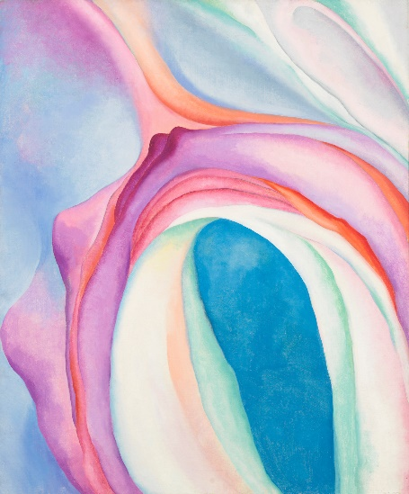
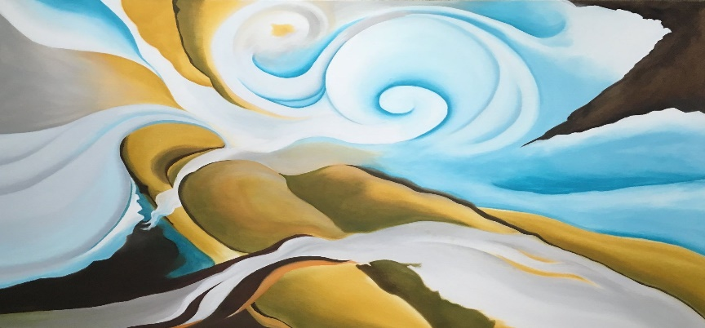
One of the most significant artists of the 20th century, Georgia O’Keeffe (1887-1986) was devoted to creating imagery that expressed what she called “the wideness and wonder of the world as I live in it.” The Georgia O'Keeffe Museum preserves, presents, and advances the artistic legacy of Georgia O’Keeffe through the Museum's art and archival collections as well as the artist's historic homes in Abiquiú, New Mexico.

Have a look at Georgia O’Keeffe website. Have a go at some of the activities. www.okeeffemuseum.org/about-georgia-okeeffe

