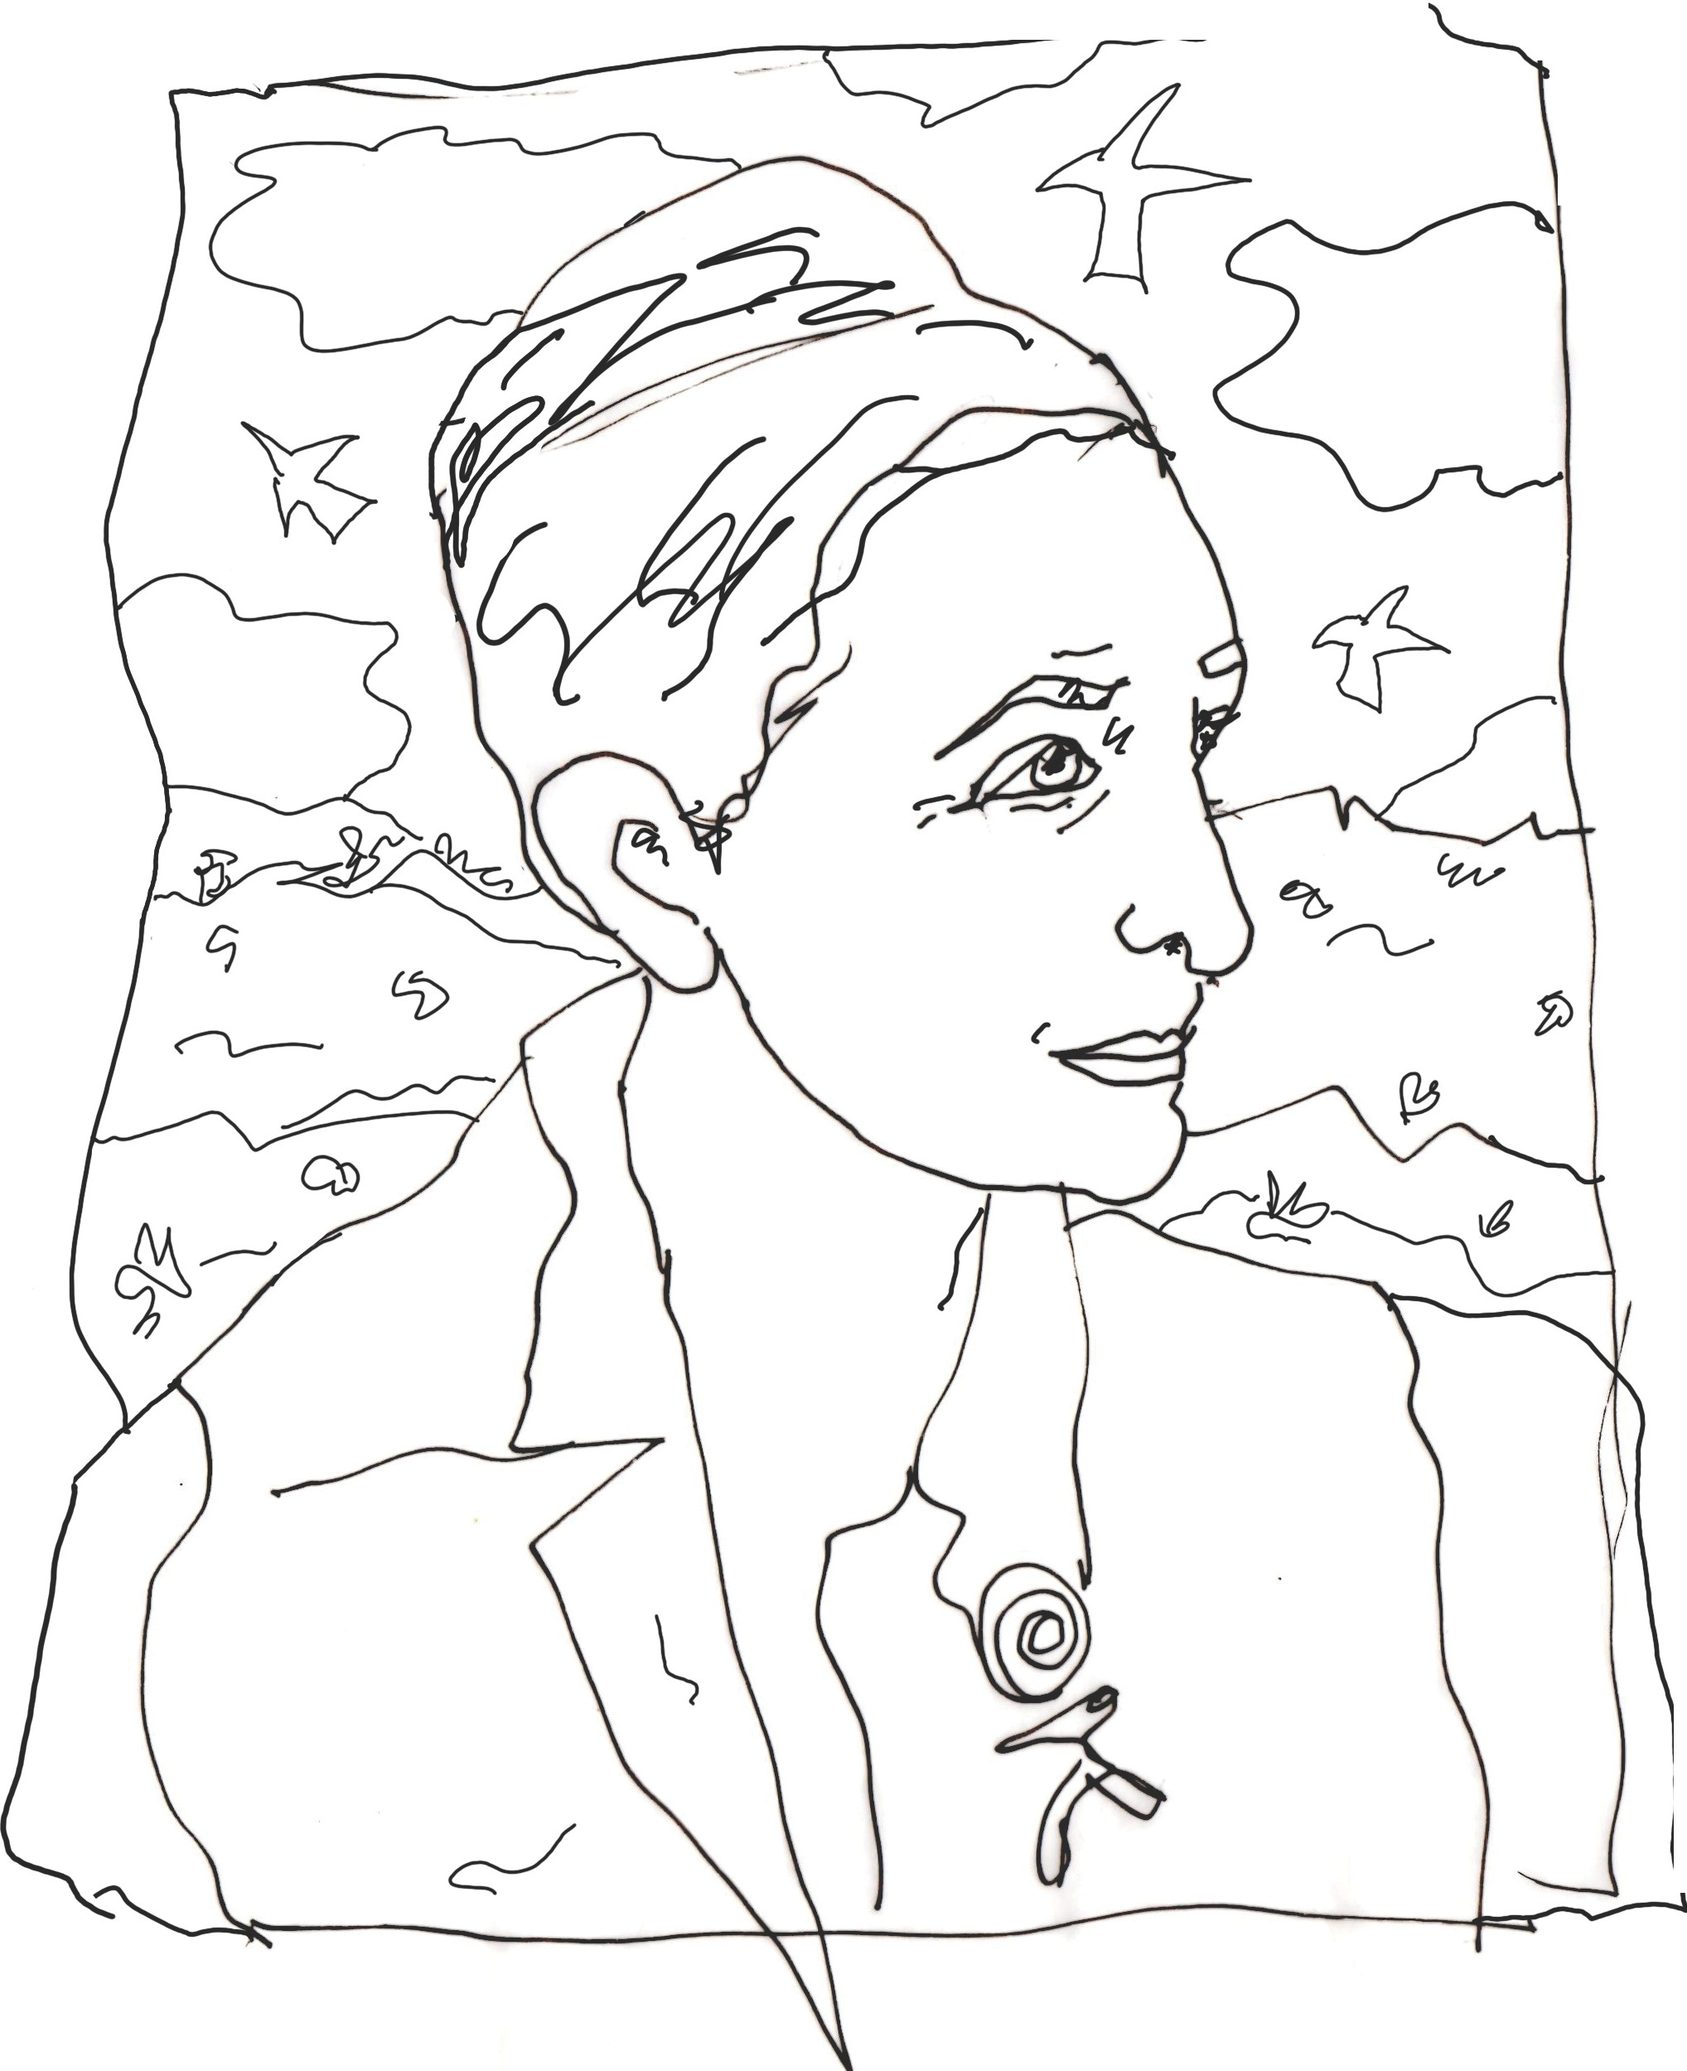

Georgia O'Keeffe Museum

