Creative Activity
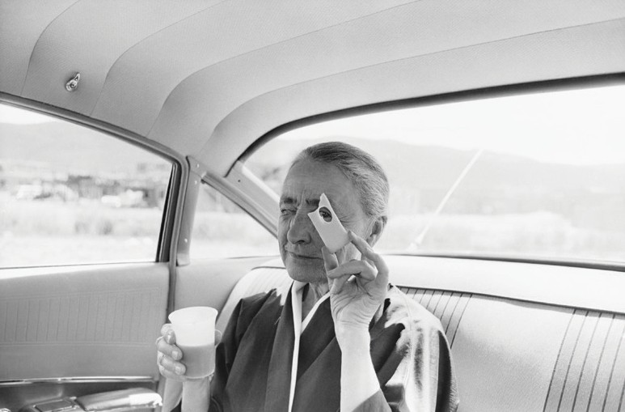
VIEWFINDER
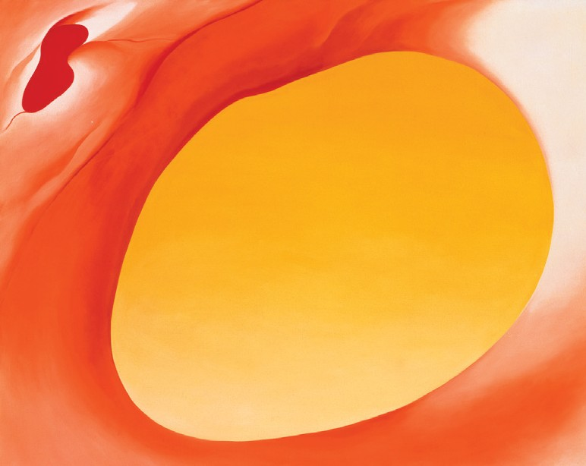
A viewfinder is a tool that some artists look through to compose, and in many cases to focus, a picture. It makes possible the close examination of a potential composition from various viewpoints, and can be used for portraits, figures, landscapes, or any other subjects. In this photograph, do you think Georgia O’Keeffe is using a slice of Swiss cheese as a viewfinder while enjoying a picnic?

CREATE YOUR OWN COMPOSITION USING A VIEWFINDER
First, cut out the viewfinder below. Next, create your very own window for viewing by cutting along the dotted lines. Look through your viewfinder to select what you will focus on for a subject. Use a separate piece of paper to carefully record what you see. Finish your creation any way you like, using pencils, pastels, or even paint!

Tony Vaccaro, Georgia O’Keeffe with the Cheese, 1960. Gelatin silver print. Georgia O’Keeffe Museum. © Tony Vaccaro 2007.3.027. Georgia O’Keeffe, Pelvis Series, Red with Yellow, 1945. Oil on canvas, 361/8 x 481/8. Extended loan, private collection. © Georgia O’Keeffe Museum.



