RULE OF THIRDS
The rule of thirds is a guideline commonly used in painting, photography, and design. The rule of thirds means that the subject isn’t centered; rather, the main focal point can be to one side or at the top or bottom of the image. It’s a tool to help artists draw the viewer’s eye into the composition, rather than just glancing at the center.
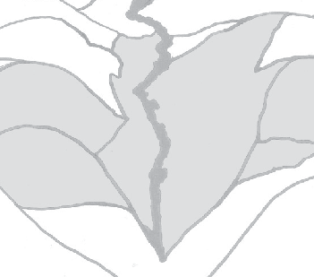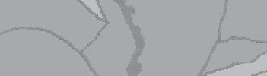Georgia O’Keeffe was aware of this principle, which can be seen in the artwork at left. Lines overlaid on an outline of the painting show how she organized the composition.

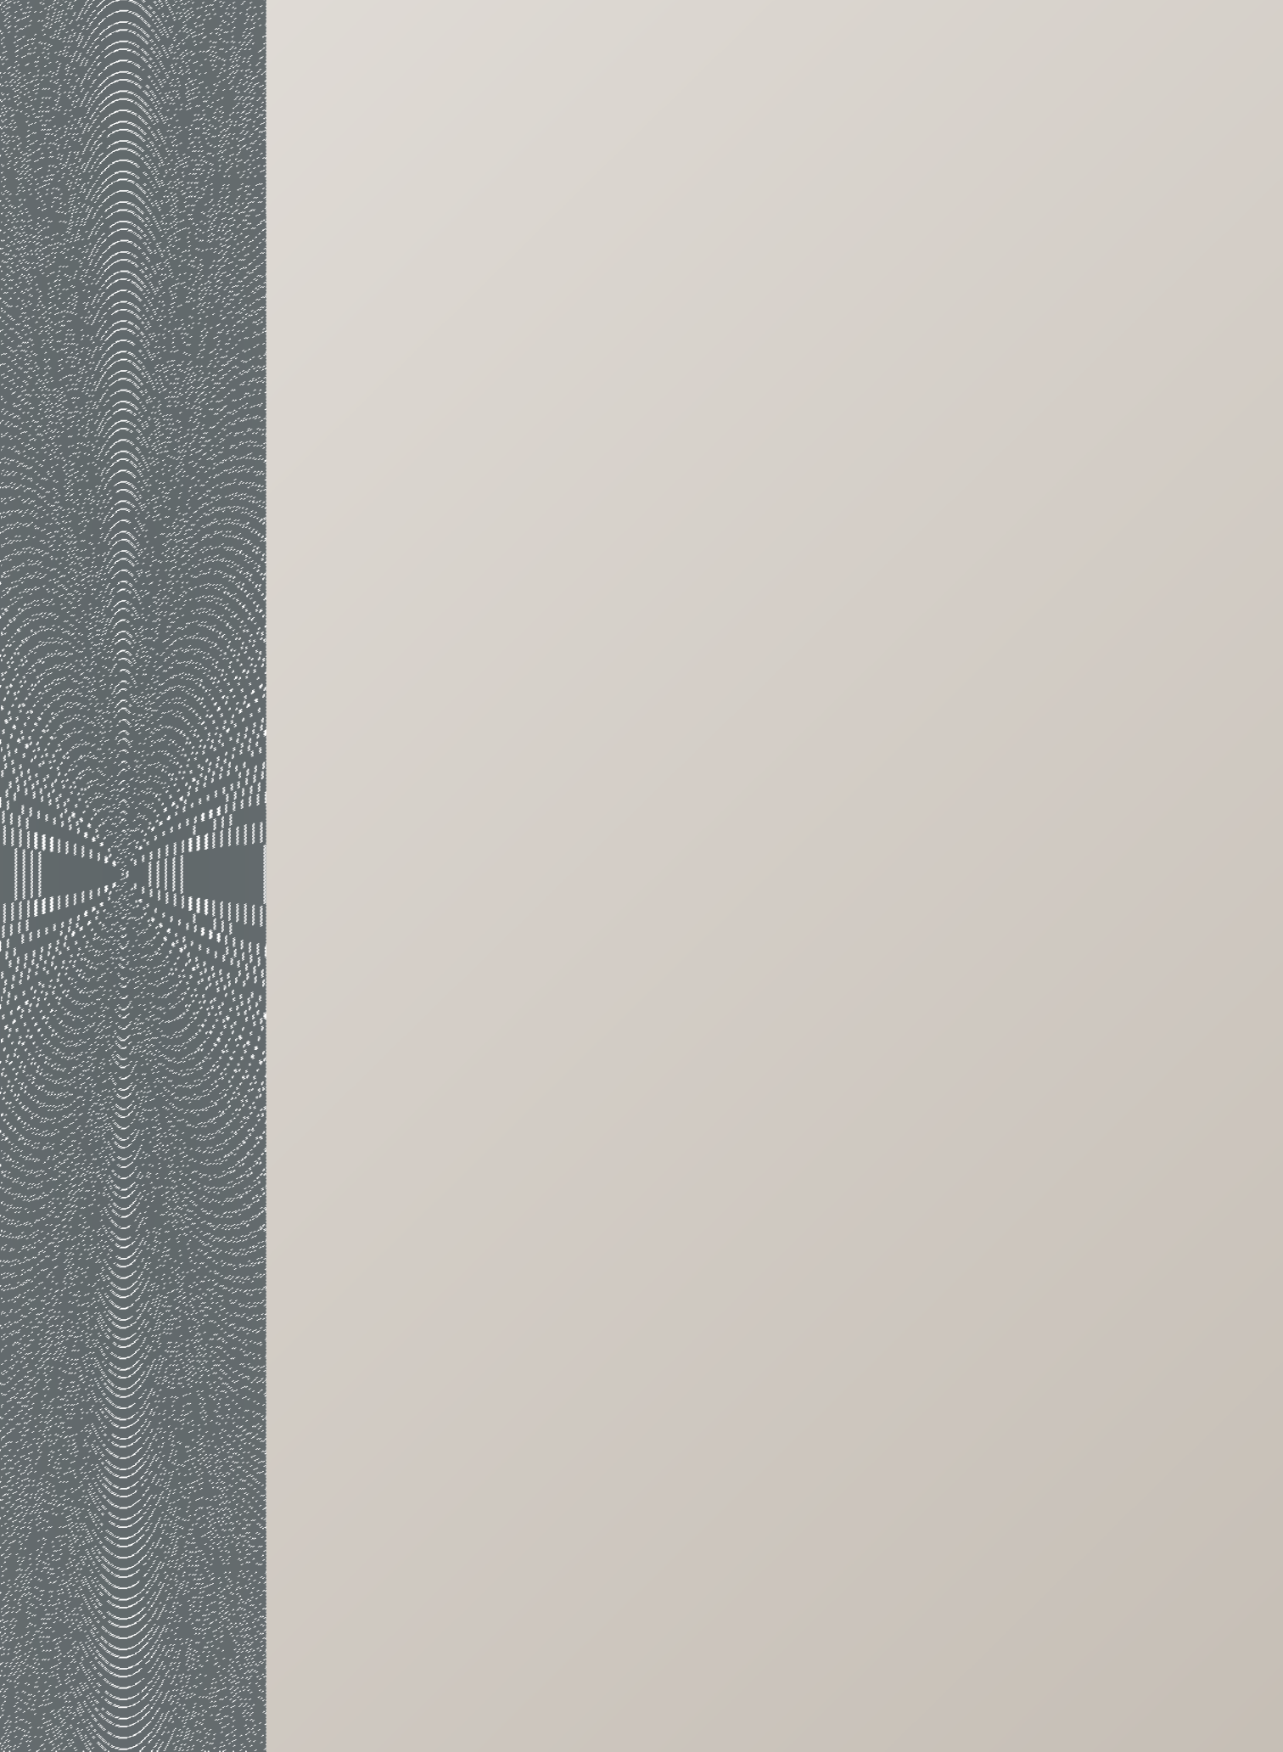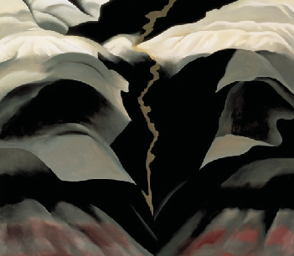
Creative Activity

TOP: Georgia O’Keeffe. Black Place III, 1944. Oil on canvas, 36 x 40 in. Georgia O’Keeffe Museum. Gift of The Burnett Foundation. © 1987, Private Collection.
LET’S TRY IT!
On your sheet of paper or canvas, draw four equally spaced lines, as below. This breaks the space into three horizontal and three vertical sections. The four points where the lines meet are visual “hot spots”— good areas to position things you want the viewer
to focus on.
When the grid is ready, draw your own unique landscape inspired by O’Keeffe’s love of nature.

