Creative Activity

PIONEER OF PROCESS
Georgia O’Keeffe didn’t always paint flowers. Like many artists, O’Keeffe experimented with different techniques in order to find her own unique style. The three images at left illustrate her explorations of pointillism, cubism, and monochromaticism.

Pointillism – small, distinct dots of color applied in patterns to form an image
Georgia O’Keeffe, Untitled (Horse), 1914. Oil on cardboard, 121/2 x 111/2 in.
Gift of The Georgia O’Keeffe Foundation.
© Georgia O’Keeffe Museum.

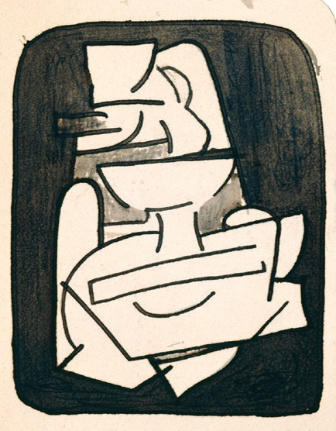
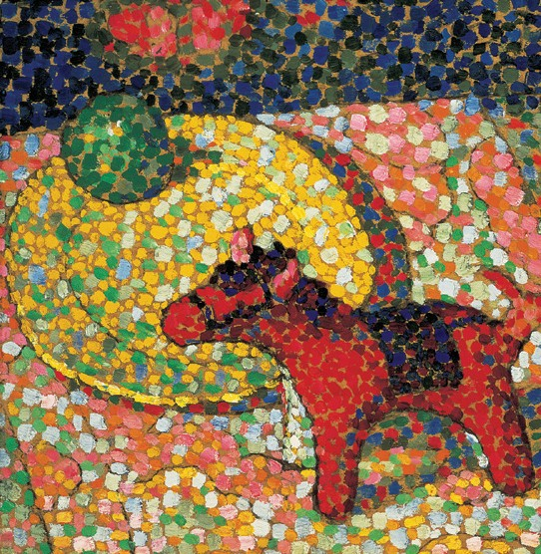
Cubism – the representation of forms with geometric shapes
Georgia O’Keeffe, Untitled (Still-Life), 1916/ 1917. Black ink on paper, 31/2 x 21/2 in.
Gift of The Georgia O’Keeffe Foundation.
© Georgia O’Keeffe Museum.

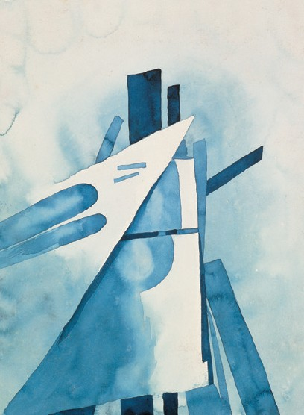
Monochromaticism – the quality of having one color
Georgia O’Keeffe, Blue Shapes, 1919. Watercolor on paper, 12 x 87/8 in.
Georgia O’Keeffe Museum. Gift of The Burnett Foundation.
© 1987, Private Collection.
Below the images are brief definitions of these terms. In the spaces below, draw a subject of your choice using these three techniques.
Georgia O’Keeffe was also known to make small drawings and sketches—please use these as practice for larger works!

Pointillism
Monochromaticism
Cubism

