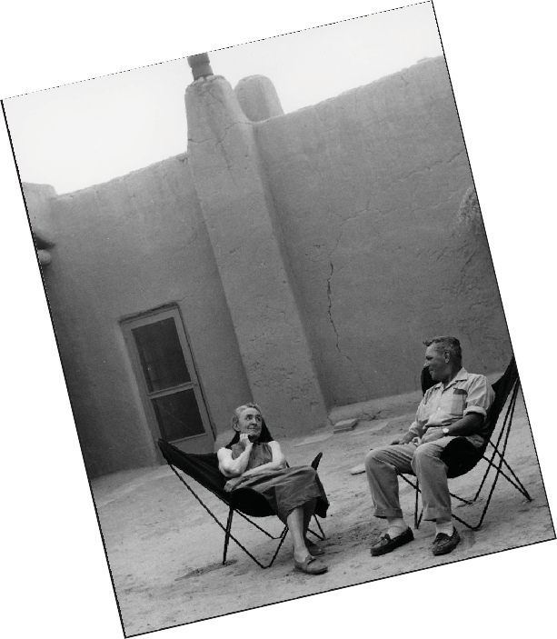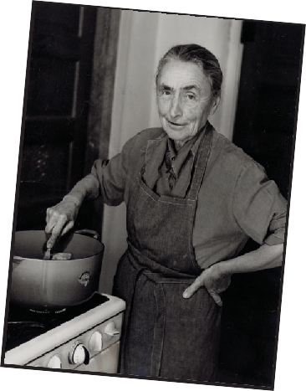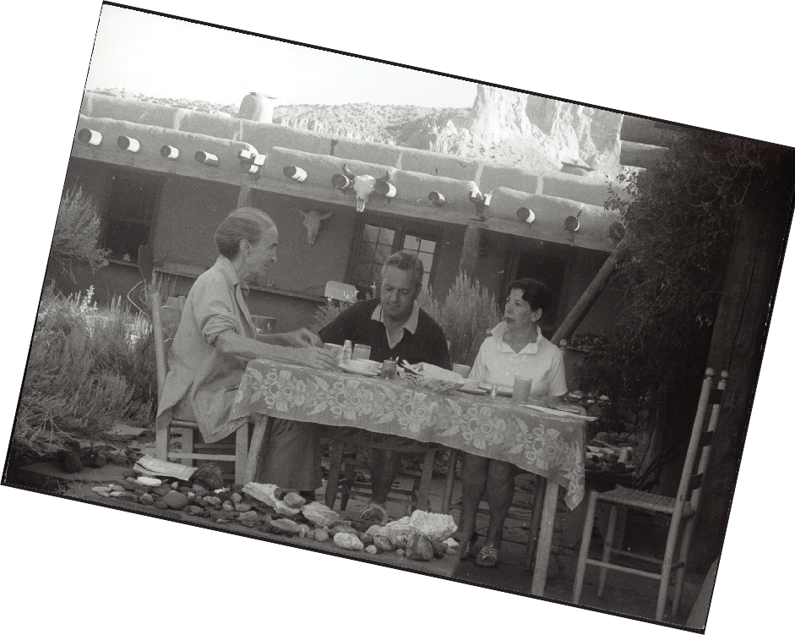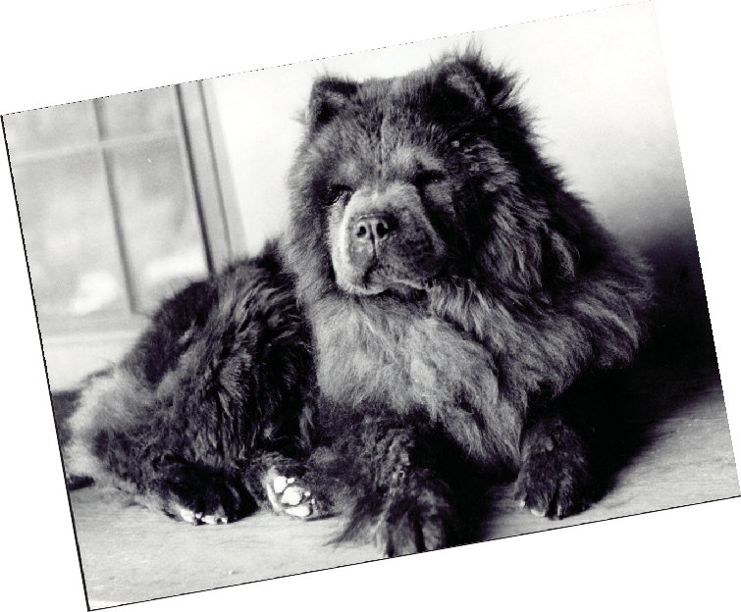Creative Activity
PHOTOGRAPHY
Hundreds of photographs of Georgia O’Keeffe were taken throughout her life, and each one reveals something of her character. Her husband, Alfred Stieglitz, was a pioneer of photography, and their friends included many famous photographers, such as Ansel Adams and Todd Webb.

Think of someone you are close to, and try to capture their personality in five photographs. Get creative with your photos—think of all the different things or places that might characterize the person.
Assemble your photographs on a background of your choice. Collage them together to create a unified collection of images. The finished project might reveal much about the person portrayed, and may even include things that will surprise you!

TOP TO BOTTOM: Todd Webb, Georgia Making Stew, Ghost Ranch, 1962. Gelatin silver print. Gift of The Georgia O’Keeffe Foundation. © Todd Webb Estate, Portland, Maine. Todd Webb, Georgia O’Keeffe with Todd Webb, circa 1955–1956. Gelatin silver print. Gift of The Georgia O’Keeffe Foundation.
© Todd Webb Estate, Portland, Maine. Todd Webb, Georgia O’Keeffe, Todd Webb and Lucille Webb on Ghost Ranch Patio, undated. Gelatin silver print. Gift of The Georgia O’Keeffe Foundation. © Todd Webb Estate, Portland, Maine. Todd Webb, Georgia O’Keeffe’s Chow, undated. Gelatin silver print. Gift of The Georgia O’Keeffe Foundation. Georgia O’Keeffe Museum.

