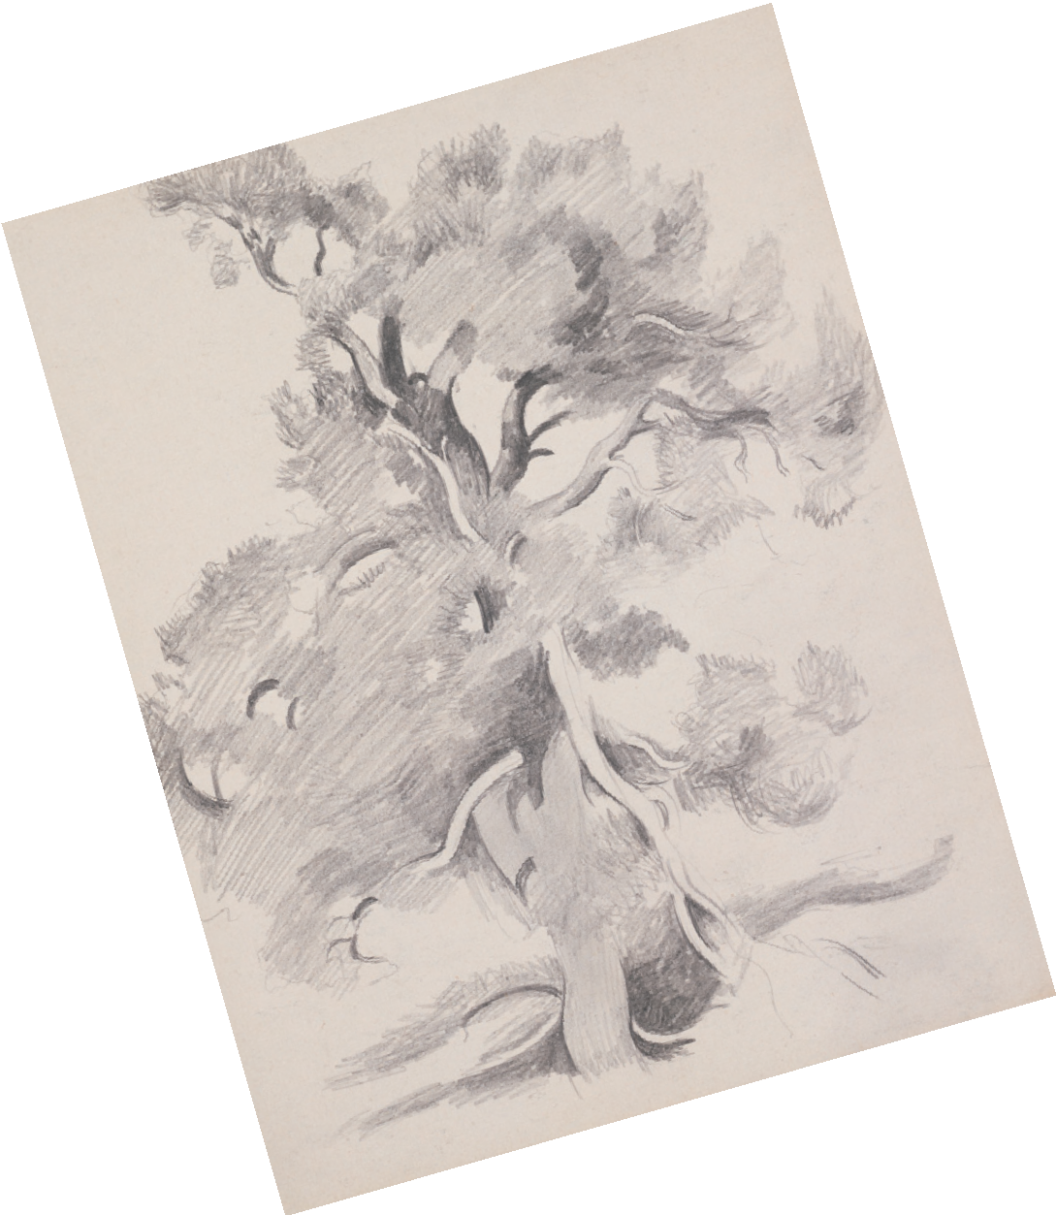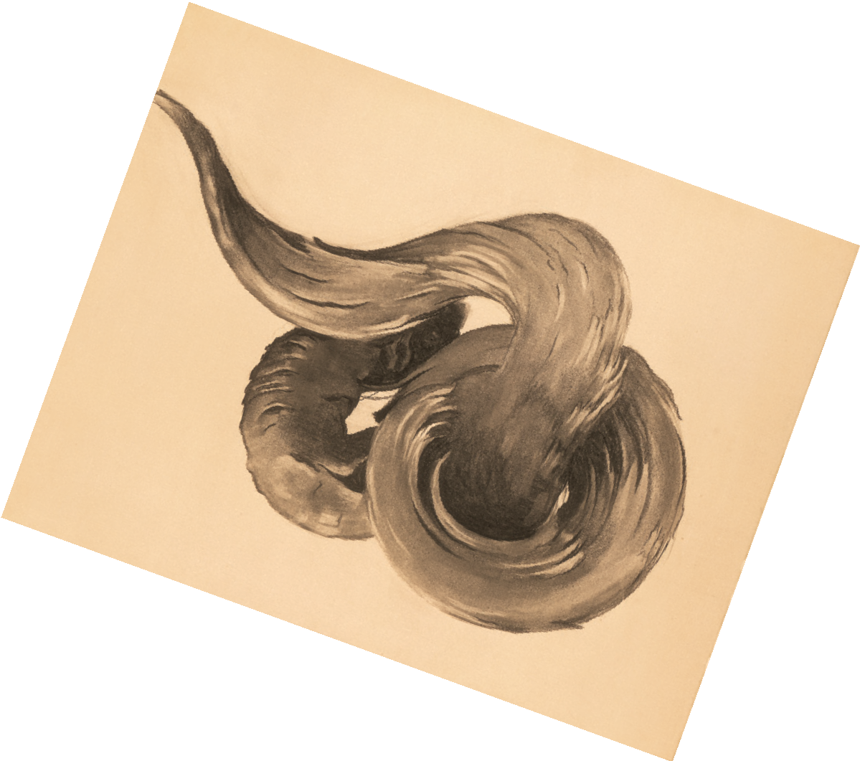

Creative Activity
NOTAN is a Japanese word meaning the balance between dark and light. It is the design or pattern of a work of art as seen in flat areas of dark and light values only. Georgia O’Keeffe utilized the principles of notan in her compositions, which can be especially understood when looking at her drawings.
Did you know? The Georgia O’Keeffe Museum owns approximately 700 drawings by O’Keeffe.
To practice notan, grab a sketchbook and choose a subject to focus on. You might choose something in nature, as O’Keeffe often did. Keep in mind the bal- ance of light and dark while drawing, and see if you can create a harmonious composition.
Notan is not limited to drawing— try looking up “notan paper cuts” for more inspiration!

LEFT: Georgia O’Keeffe. Untitled (Tree), 1940s-1950s. Graphite on paper, 101/4 x 8 in. Georgia O’Keeffe Museum. Gift of The Georgia O’Keeffe Foundation. © Georgia O’Keeffe Museum. RIGHT: Georgia O’Keeffe. Ram’s Horns I, ca. 1949. Charcoal on paper, 185/8 x 247/8 in. Georgia O’Keeffe Museum. Gift of The Georgia O’Keeffe Foundation. © Georgia O’Keeffe Museum.

