Creative Activity
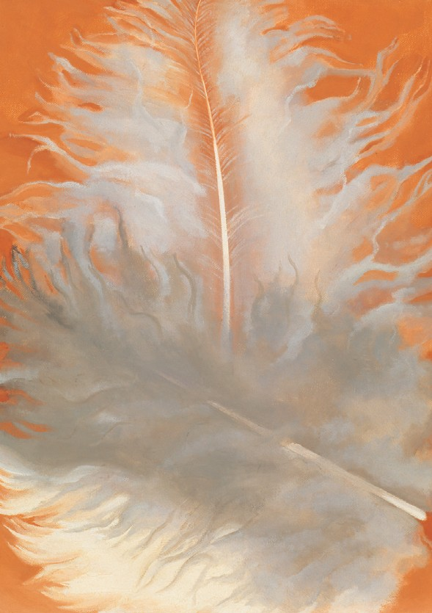
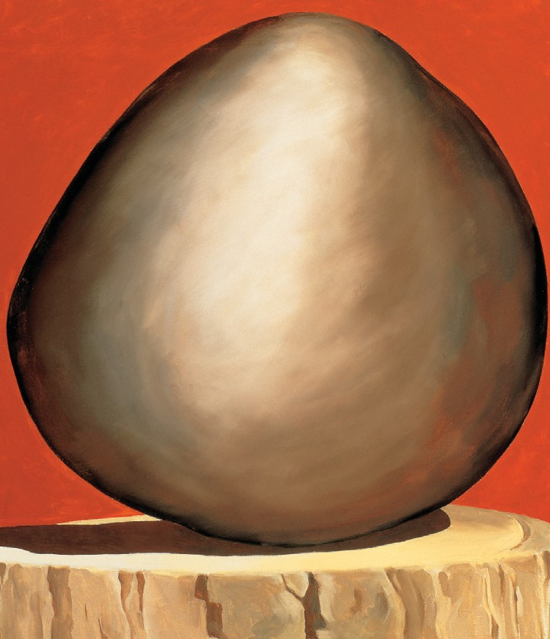
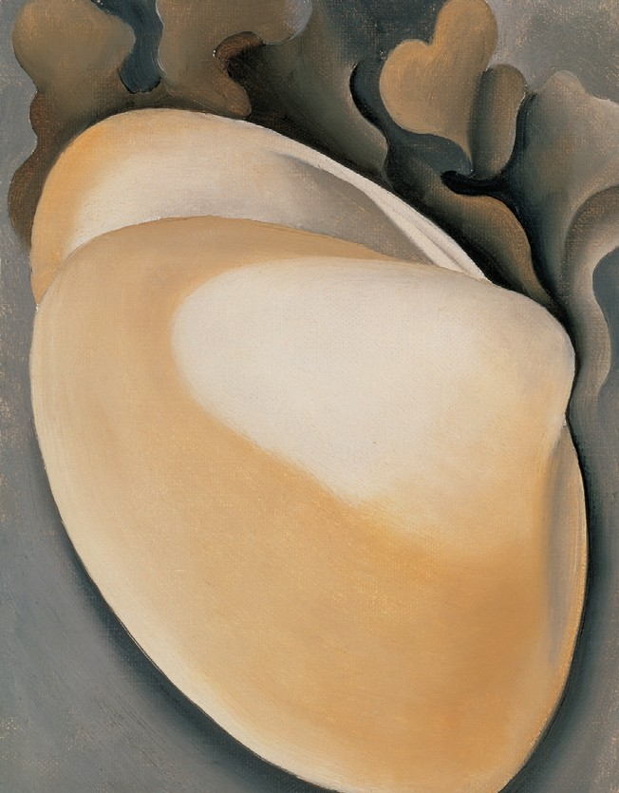

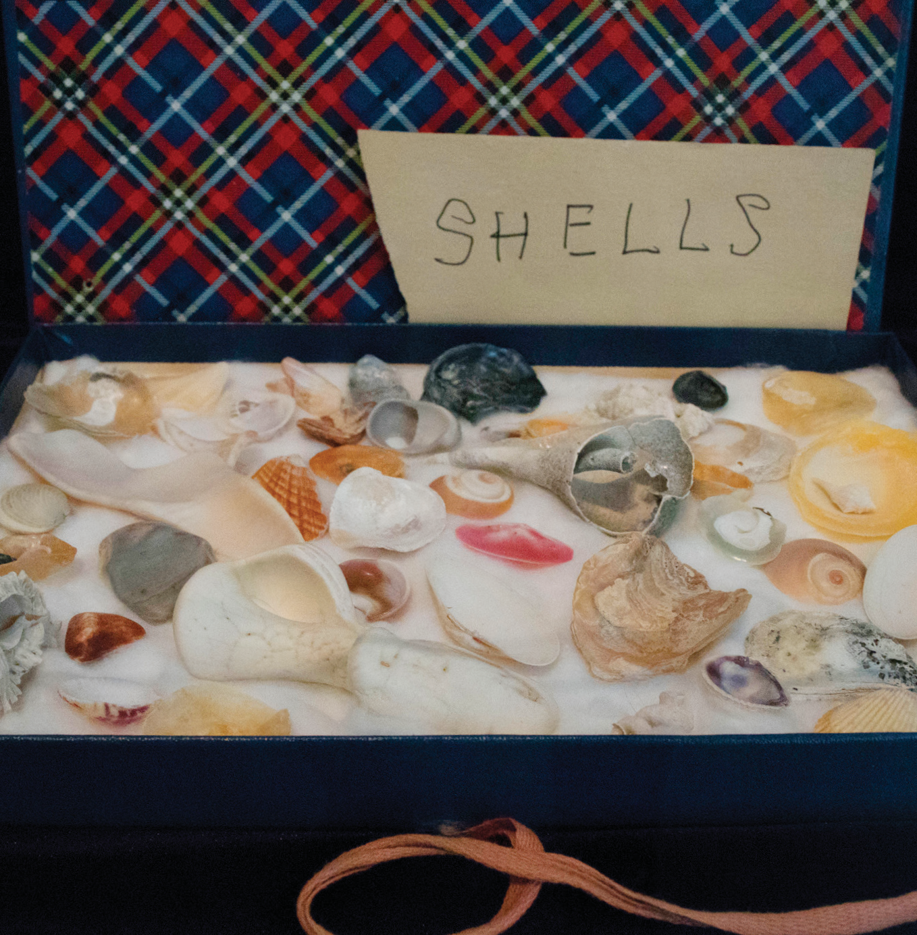
NATURE
SOUVENIRS
Georgia O’Keeffe loved nature and she loved to travel! She collected many different natural objects from her adventures. Rocks, bones, feathers, and shells were some of her favorite things to collect and be inspired by.
Take a look at some of these works O’Keeffe created and how she kept them. How do you store your treasures? What are some things that you have collected on walks or trips?

TOP, LEFT TO RIGHT: Georgia O’Keeffe. Feathers, White and Grey, 1942. Oil on canvas, 16 x 12 in. Georgia O’Keeffe Museum. Gift of The Georgia O’Keeffe Foundation. 2006.5.174. Georgia O’Keeffe. Black Rock on Red, 1971.
Oil on canvas, 30 1/16 x 26 1/8 in. Georgia O’Keeffe Museum. Gift of The Burnett Foundation and The Georgia O’Keeffe Foundation. 1997.5.4. Georgia O’Keeffe. Tan Clam Shell
with Seaweed, 1926. Oil on canvas, 9 x 7 in. Georgia O’Keeffe Museum. Gift of The Georgia O’Keeffe Foundation. 2006.5.108. Photo of current installation.

