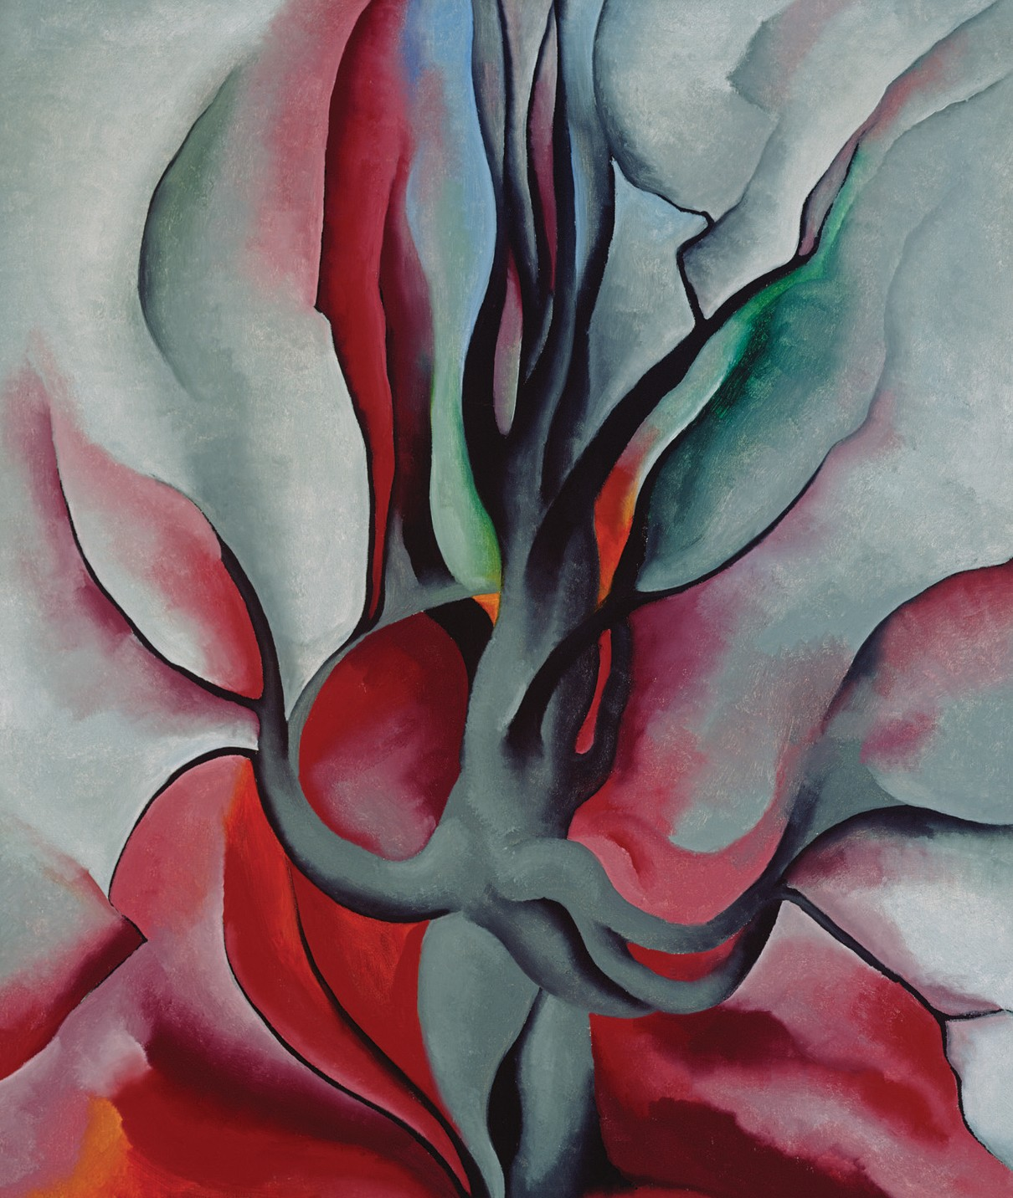

FRIENDS AND FAMILY TREE
Georgia O’Keeffe, Autumn Trees – The Maple, 1924. Oil on canvas, 36 x 30 in. Gift of The Burnett Foundation and Gerald and Kathleen Peters. © Georgia O’Keeffe Museum.
After looking at O’Keeffe’s painting, use collage techniques to create your own tree of your friends and family. Create your own base tree—or use O’Keeffe’s painted tree, above, or family tree, below, for inspiration. Use colored pencils, magazine images, or your own images. Glue or draw on to the tree things that best represent your family and friends!

IDA TEN EYCK TOTTO

GEORGIA TOTTO
OKEEFFEMUSEUM.ORG 19
Creative Activity

ANITA NATALIE

