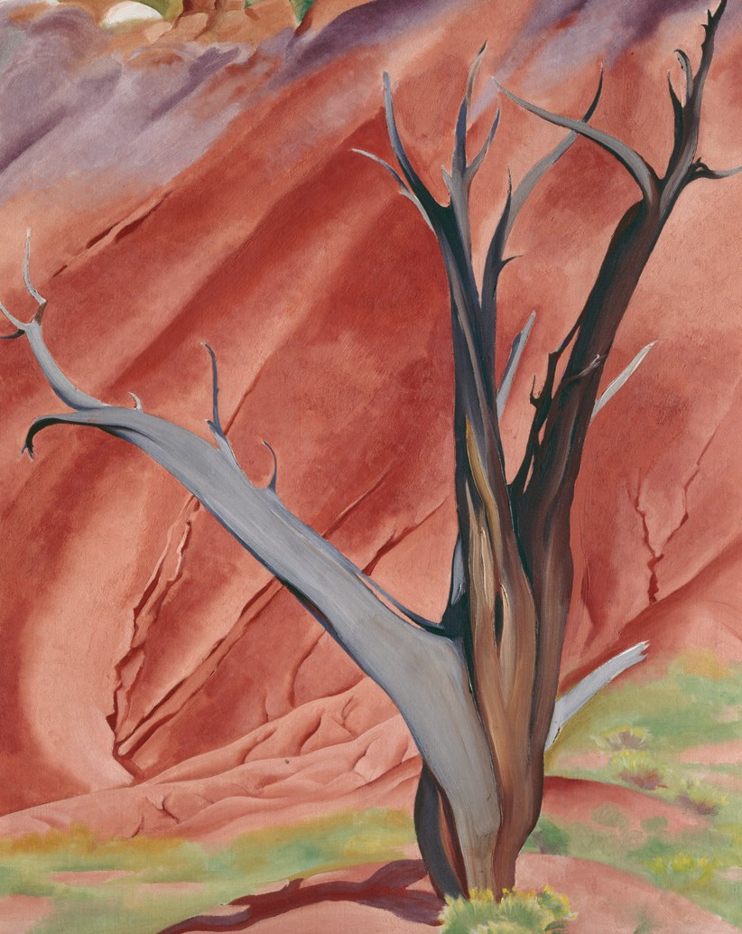 Creative Activity

“I wish people were all trees and then I think I could enjoy them.”
—GEORGIA O’KEEFFE

DRAWING TREES
- Focus on the basic shape of a tree. Using a pencil, draw the general shape.
- Add in more of the tree’s structure. Taper the smaller branches growing out of the tree’s main trunk. Add darker strokes to some of the branches and trunk.
- If your tree has leaves, begin shading the leaves, using short strokes to create texture. Make some areas darker, to create texture and depth. If your drawing also includes shrubs,
use the same techniques to depict them.
- If you like, add some grass around the base of your tree.
- You can name your tree after yourself or a friend.

Stand back and admire your creation!

Georgia O’Keeffe, Gerald’s Tree I, 1937. Oil on canvas, 40 x 301⁄8 in. Gift of The Burnett Foundation. Copyright Georgia O’Keeffe Museum.

