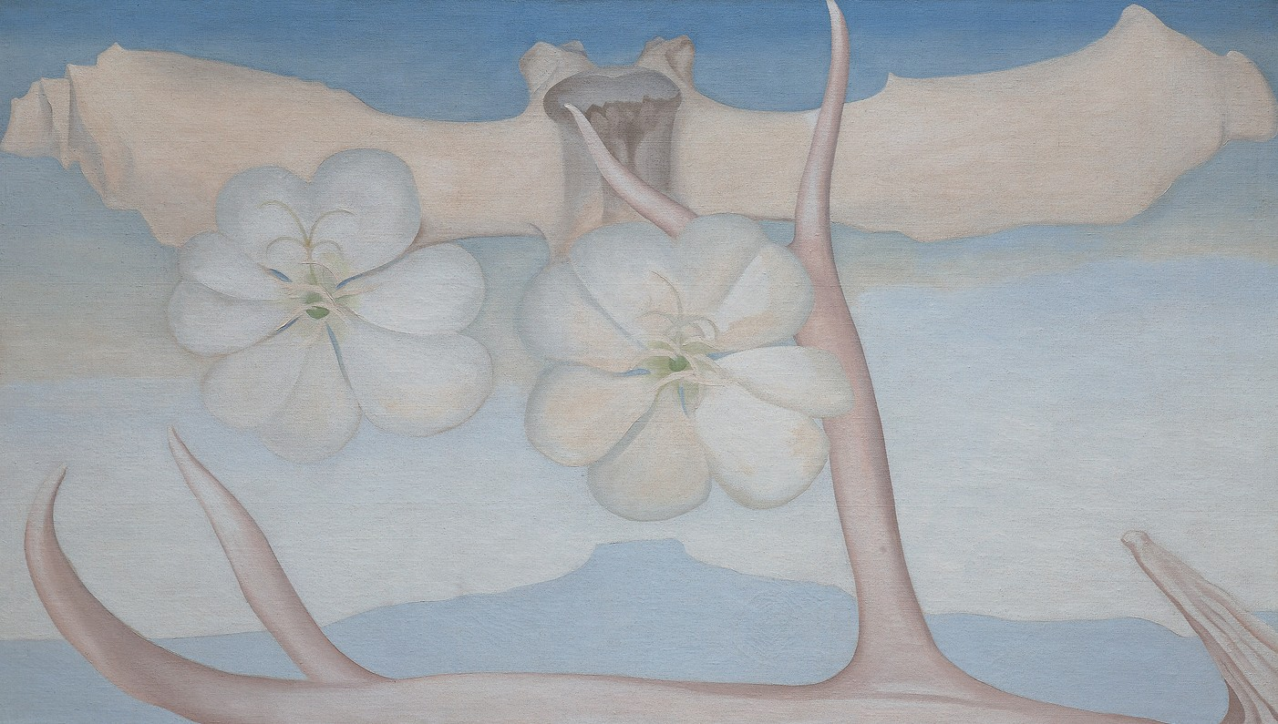Creative Activity

Georgia O’Keeffe, Spring, 1948. Oil on canvas, 481/4 x 841/4 in. Gift of The Burnett Foundation. © Georgia O’Keeffe Museum.

Drawing Exercises
Let’s try three different drawing techniques to experiment with composition and perspective! All you need is three sheets of paper, a drawing tool, and the image above.

Look at the painting above very carefully and pay close attention
1
to the details. Now close your eyes, and draw on your paper the scene you remember. Be sure to keep your eyes closed while you’re drawing!

Now try to draw this same painting while using the hand you don’t normally use. If you’re right-handed, use your left! If you’re left-handed, use your right!
2

Rotate the magazine so that you’re looking at the painting upside down. On your last sheet of paper, draw what you see.
3

You can try this with other images of your choice, and have fun with different ways of drawing and seeing!

