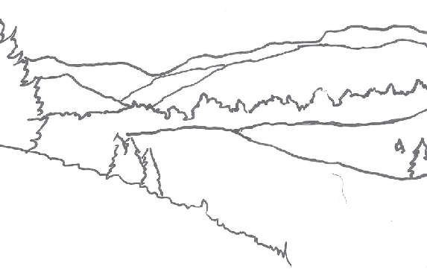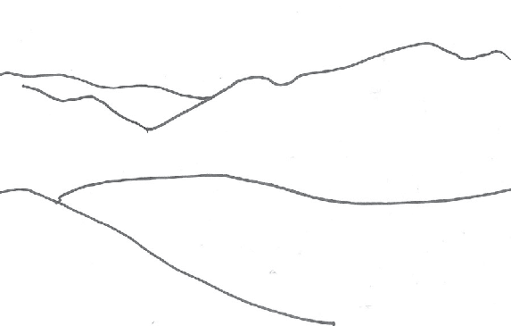
Creative Activity

DRAWING
In 1912, Georgia O’Keeffe was introduced to an important book of exercises titled Composition, by Arthur Wesley Dow. She was a student at the University of Virginia at this time, and used Dow’s ideas of art structure to form her own style of art. O’Keeffe remained dedicated to drawing throughout her life, creating hundreds of drawings. Let’s be inspired by the art exercises O’Keeffe would have practiced, and have some fun with landscapes!

- First, draw a landscape that you’ve seen or imagined— be sure to include lots of details!

- Second, draw this landscape again, but leave out some details. Think of this drawing as a simplified version
of your original thought.

- Now make a third drawing of your landscape, this time changing how
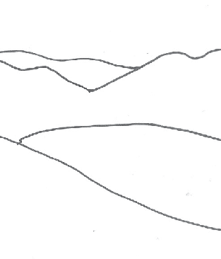

it’s arranged on the paper. If you first did a horizontal landscape, switch to a vertical one. If you began
with a vertical drawing, now make it more horizontal.

The final landscape drawing should be based on what you decide will make this drawing look best. Details or no details? Horizontal or vertical? Perhaps you’ll choose to make this drawing smaller—or bigger.

Congratulations! You are officially an artist making compositional choices in the creation of your own original work of art!

