LOR
CO
“I found I could say things with color and shapes that
I couldn’t say any other way—things I had no words for.”
—GEORGIA O’KEEFFE

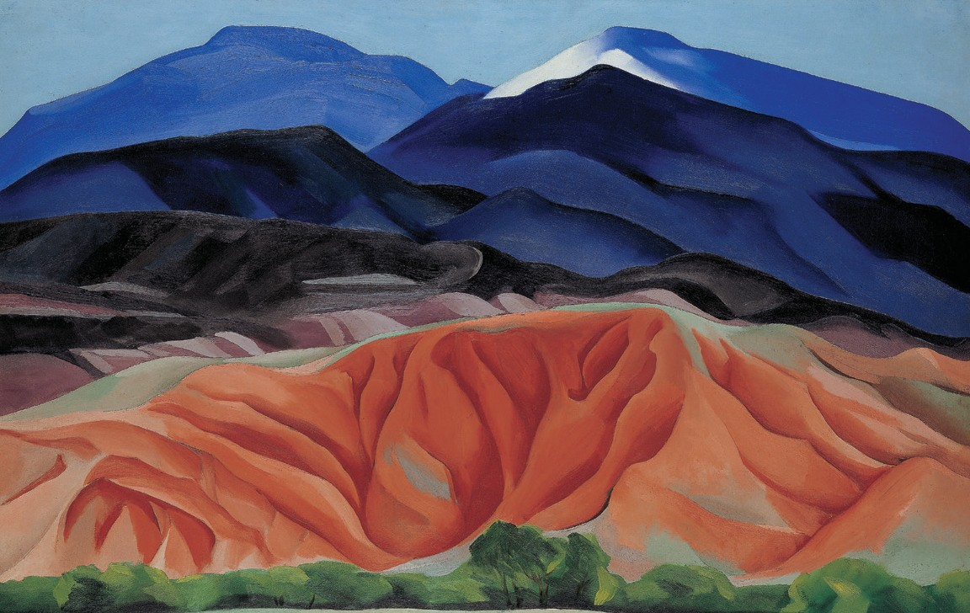

The primary colors are:

red
yellow
blue
Secondary colors are made by mixing together two primary colors:

+ =
red
yellow
orange

+ =
blue
red
violet

+ =
blue
yellow
green

Colors convey meanings—for example, there are both warm colors and cool colors:

warm
cool

red yellow orange
blue violet green


Look at the Georgia O’Keeffe painting above. Make a list of the primary colors you see, then a list of the secondary colors you can find. Now, make lists of the warm
Creative Activity
GEORGIA O’KEEFFE. BLACK MESA LANDSCAPE, NEW MEXICO / OUT BACK OF MARIE’S II, 1930. OIL ON CANVAS, 241/4 X 361/4 IN. GEORGIA O’KEEFFE MUSEUM. GIFT OF THE BURNETT FOUNDATION. © GEORGIA O’KEEFFE MUSEUM. [1997.06.15].
and cool colors you see in this painting.
Using colored pencils or markers, make your own sketch of whatever you like, then list the different types of colors you’ve chosen: primary, secondary, warm, and cool.

