
Creative Activity

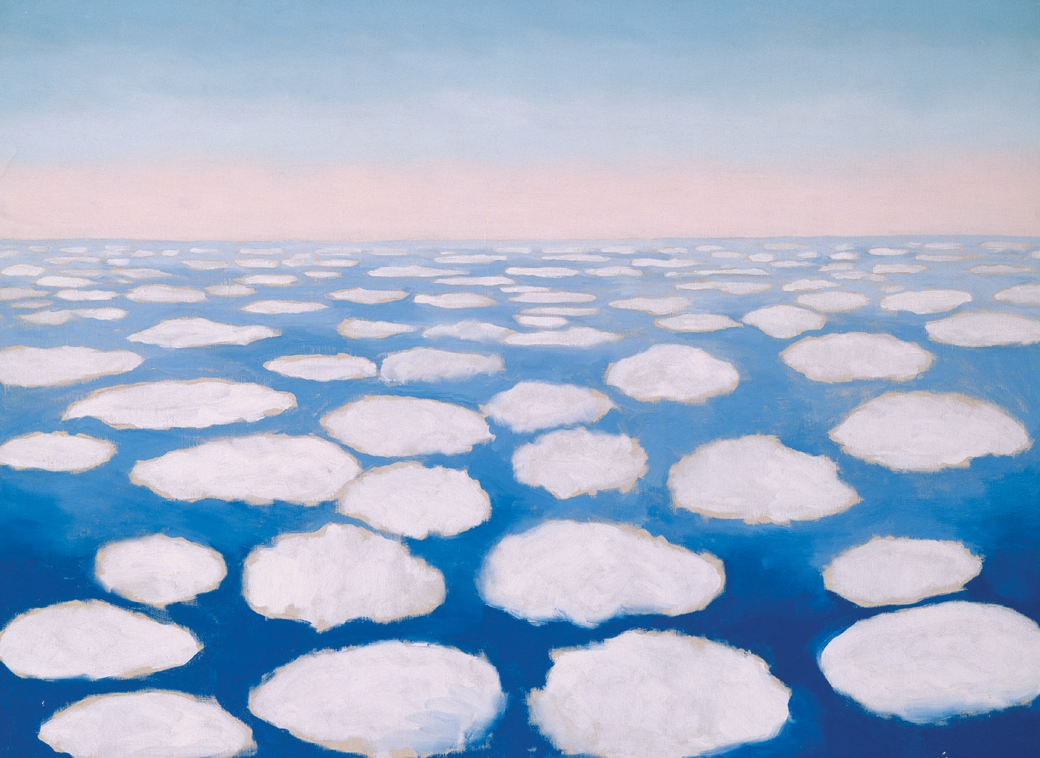

Georgia O’Keeffe. Above the Clouds I, 1962/1963. Oil on canvas, 361/8 x 481/4 in. Georgia O’Keeffe Museum. Gift of The Burnett Foundation and The Georgia O’Keeffe Foundation. © Georgia O'Keeffe Museum. 1997.5.14 [2006.05.460].

CLOUD PAINTING
“A little rain—much sun—tremendous clouds” —GEORGIA O’KEEFFE

Georgia O’Keeffe once described the changing patterns and colors of clouds as “breathtaking.” She loved looking down at clouds from airplane windows, and looking up at them while standing on the ground.
O’Keeffe made several paintings of clouds. Use your own creative eye to try a cloud painting, keeping in mind the following:

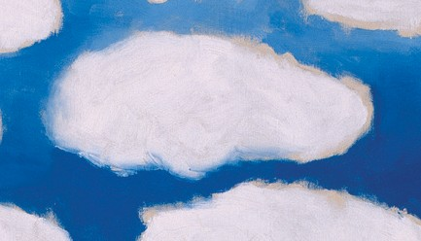Shape—Some clouds look like towers, some are feathery, some are fluffy, some wispy. Some people see animals or other shapes in clouds. Some clouds are uniform, and others are irregular—some are even layered.


Color—Many clouds are white, but some have subtle variations of gray in different areas. Morning and evening clouds reflect the colors of sunrises and sunsets. Use your imagination and paint multicolored clouds.

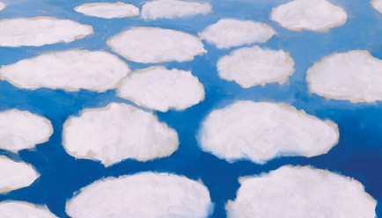Perspective—In your painting, are you looking up from the ground at clouds, or looking down at them from an airplane window or a mountaintop? Be creative, and have fun with your cloud painting!

