Creative Activity

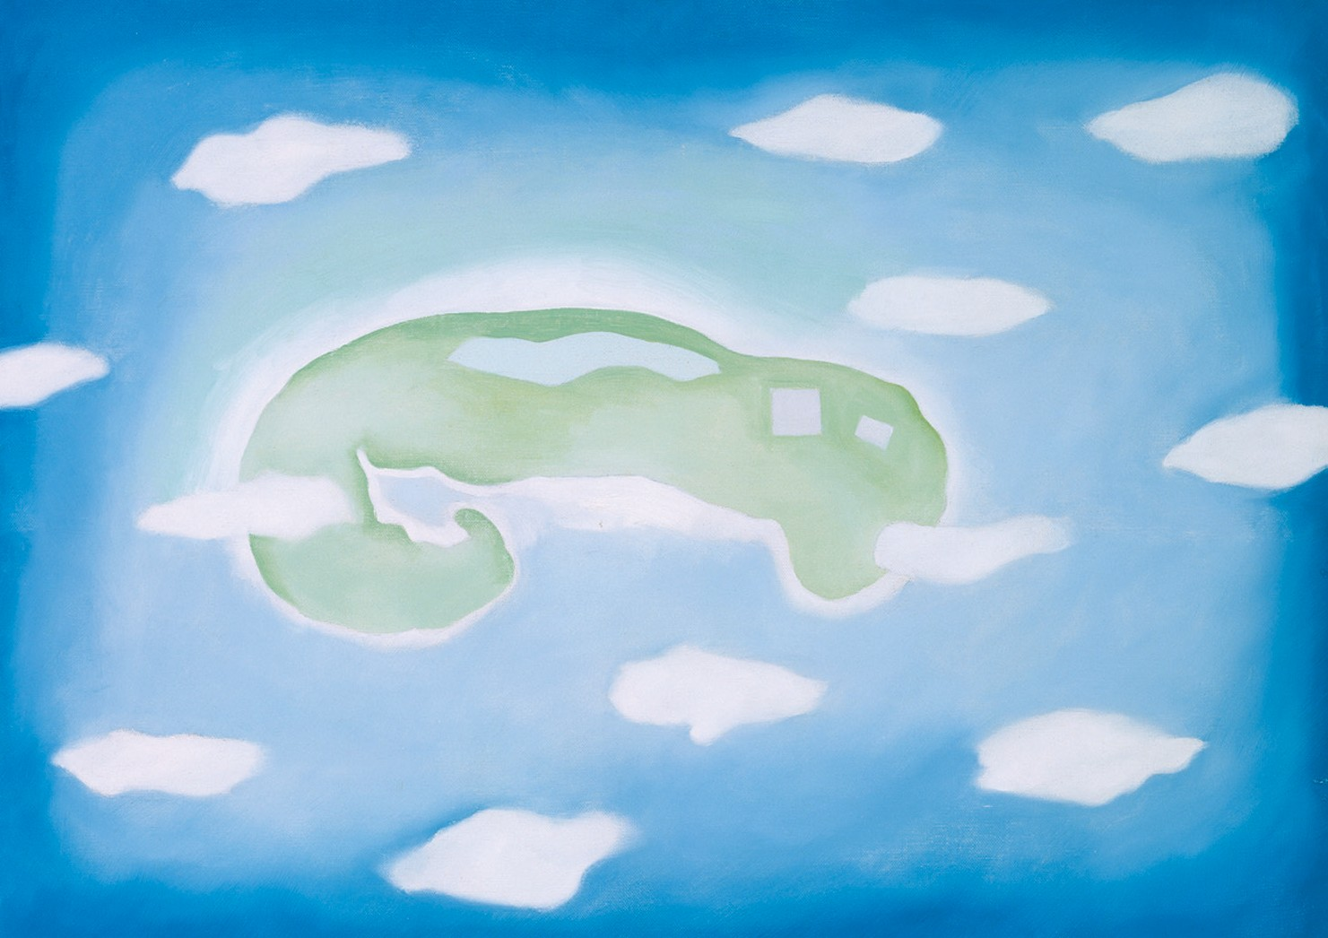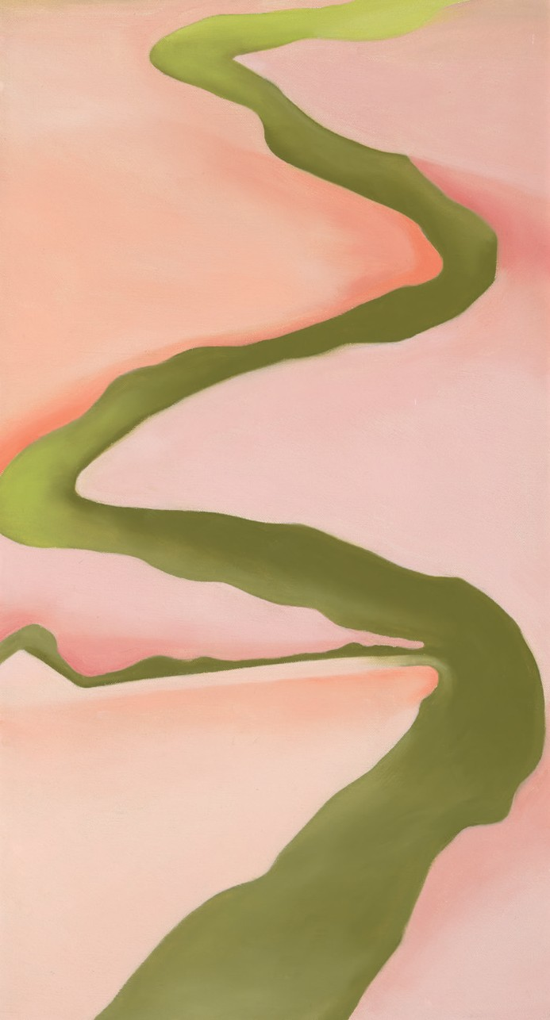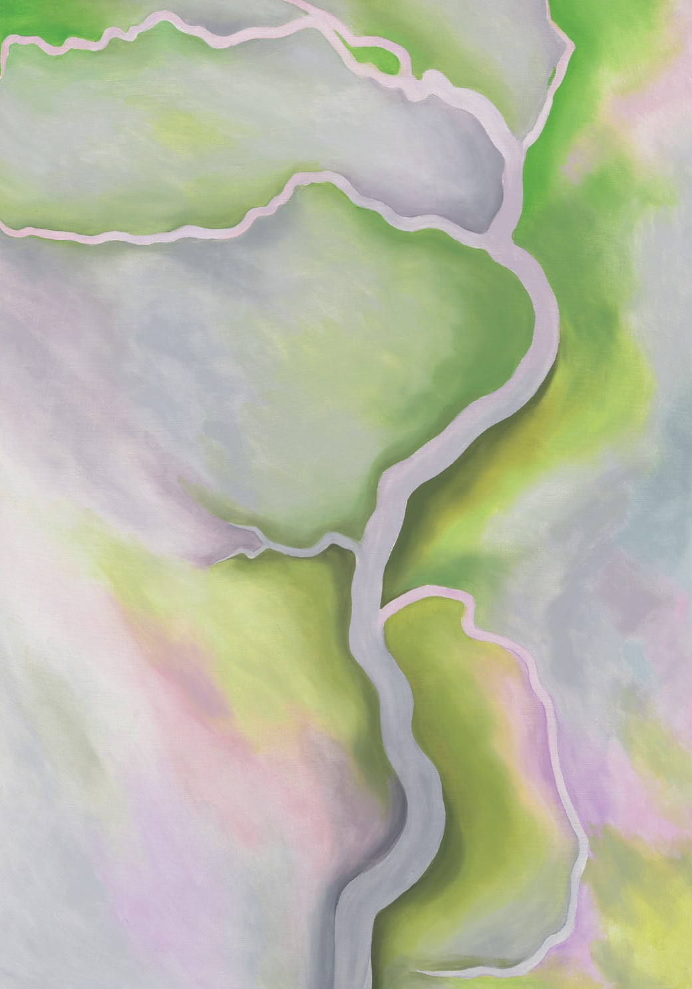

COUNTER CLOCKWISE FROM TOP RIGHT: Georgia O’Keeffe. Pink and Green, 1960. Oil on canvas, 30 x 16 in. Georgia O’Keeffe Museum. Gift of The Burnett Foundation. © Georgia O’Keeffe Museum. [1997.6.18]. Georgia O’Keeffe. An Island with Clouds, 1962. Oil on canvas, 23 x 32 in. Georgia O’Keeffe Museum. Gift of The Georgia O’Keeffe Foundation. © Georgia O’Keeffe Museum. [2006.5.374]. Georgia O’Keeffe. From the River – Pale, 1959. Oil on canvas, 411⁄2 x 313⁄8 in.
Georgia O’Keeffe Museum. Gift of The Georgia O’Keeffe Foundation. © Georgia O’Keeffe Museum. [2006.5.280].
BIRD’S-EYE VIEW
A bird’s-eye view is an aerial perspective on an object or landscape, as if observed from above by a bird.
Georgia O’Keeffe made several paintings as bird’s-eye views, based on scenes she’d seen from airplane windows. On this page are three examples of her aerial artworks.
Let’s try our hand at making art as seen from above! First, think of a real or imagined landscape, and draw
it as if looking at it from the ground.
Now picture yourself floating high above your landscape—try to draw this very different view of it.
You have now mastered a Bird’s-Eye View through your own original art!

