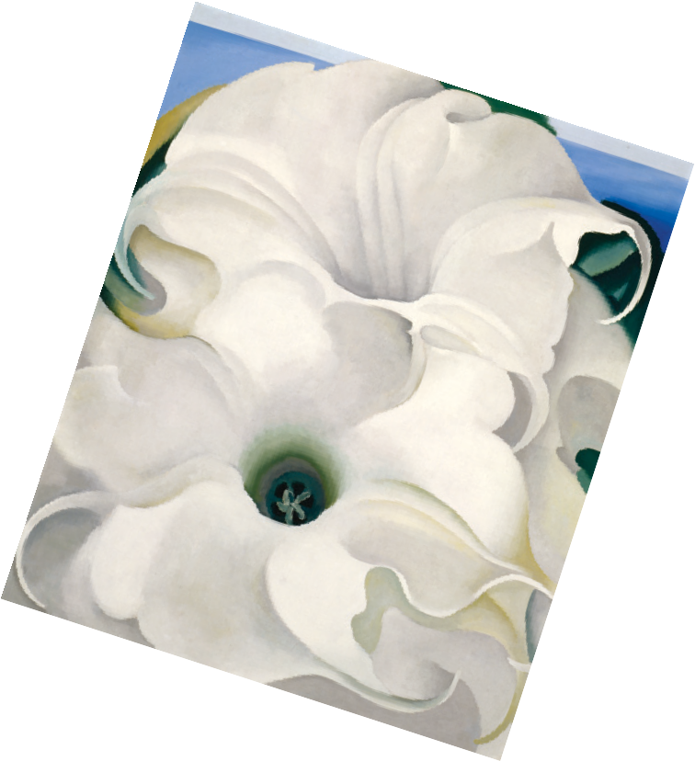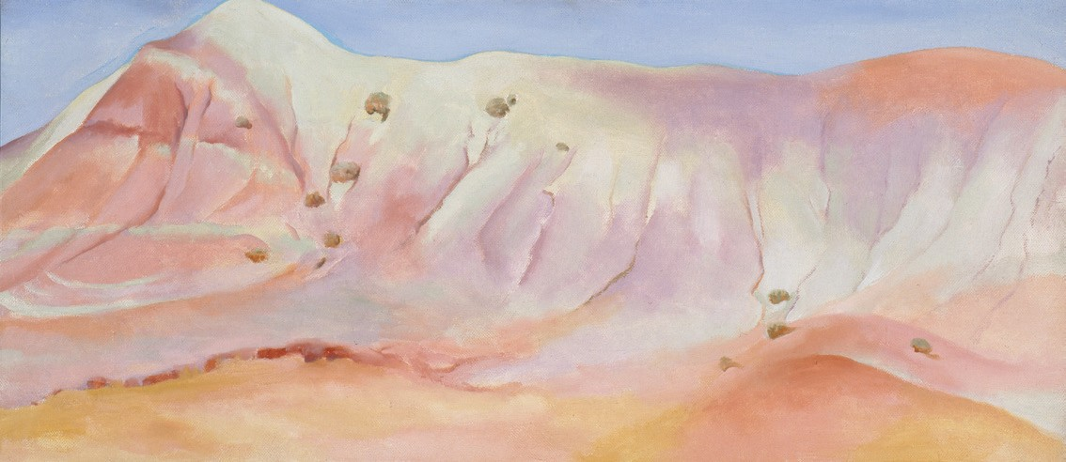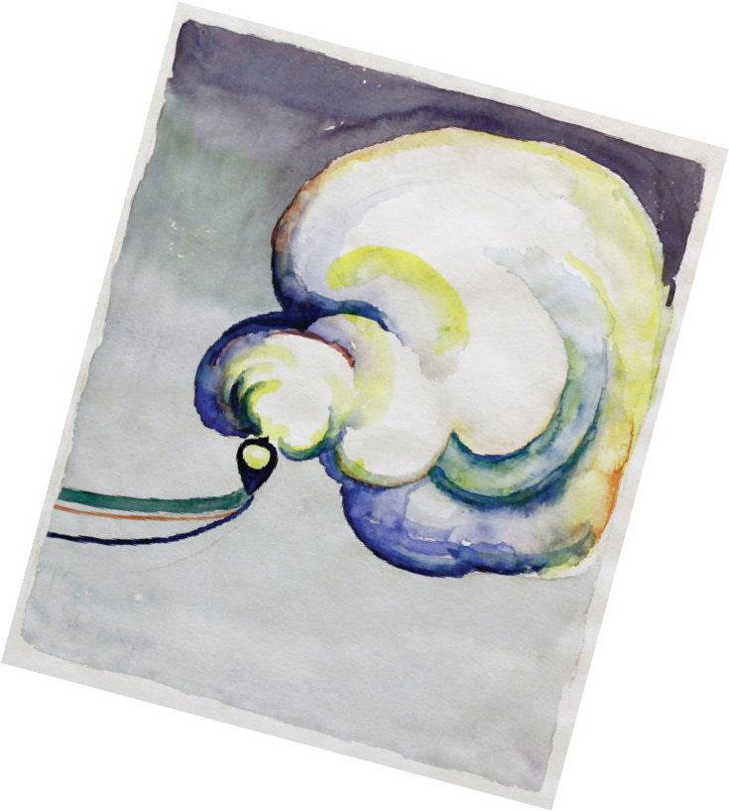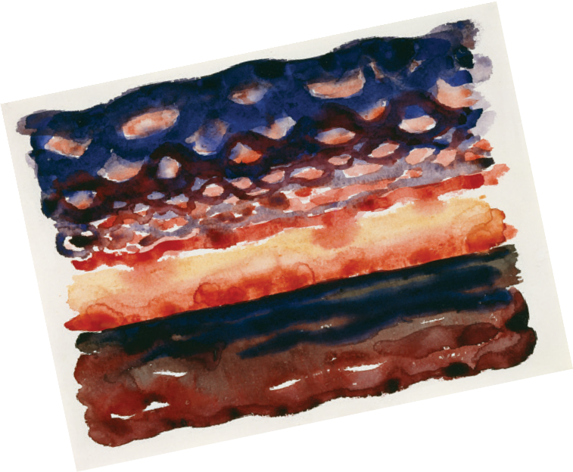
Creative Activity

ABSTRACT WATERCOLORS
The watercolors that Georgia O’Keeffe created while living and teaching in Texas show her dedication to abstraction. As you can see from these paintings, abstraction explores the relationships be- tween forms and colors, while more traditional art represents the world in recognizable images.

If you didn’t know the titles of these paintings, what would you have guessed they are about?

Now let’s look at a couple of O’Keeffe’s later works, created using oil paints.
In watercolors, create your own abstract interpretations of these
oil paintings. Think of shapes and colors that represent how each O’Keeffe painting feels to you.
Complete this activity on a separate sheet of paper and have fun!

Georgia O’Keeffe, Sunrise and Little Clouds No. II, 1916. Watercolor on paper, 8 7/8 x 12 in.
Georgia O’Keeffe Museum. Gift of The Burnett Foundation (1997.18.001). © Georgia O’Keeffe Museum.
Georgia O’Keeffe, Train at Night in the Desert, 1916. Watercolor on paper, 11 7/8 x 8 7/8 in. Amarillo Museum
of Art. Purchased with funds from the National Endowment for the Arts, the Amarillo Area Foundation, the Amarillo Art Alliance, The Mary Ann Weymouth Campbell Foundation, Santa Fe Industries Foundation, and Mary Fain (AM.1982.1.4).
© Amarillo Museum of Art. Georgia O’Keeffe, Lavender Hill with Green, 1952. Oil on canvas, 12 x 27 1/8 in. Gift of The Burnett Foundation and The Georgia O’Keeffe Foundation. © Georgia O’Keeffe Museum. Georgia O’Keeffe, Bella Donna, 1939. Oil on canvas, 36 1/4 x 30 1/8. Extended loan, private collection. © Georgia O’Keeffe Museum.

