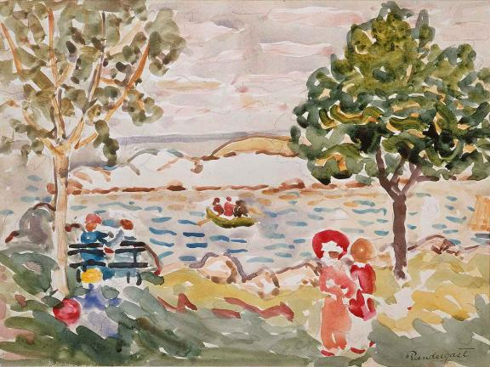
Watercolours

Learn how to “paint” with watercolour pencils using materials from home
Watercolour paint is a translucent or partially see-through art medium made up of colourful pigments that are easily spread when mixed with water.
Artists use watercolours to paint directly on top of wet paper or mix colours with water to add paint to dry paper.
Special effects such as starbursts and spots that keep the paint away can also be achieved when other materials like salt, oil, and wax crayons are used in the art-making process.
Today watercolours can be found in many different forms, such as tubes, hard cake-like discs in a tray, watercolour pencils, and even crayons! The painting above, Cape Ann by Maurice Brazil Prendergast, was made using watercolour paints and graphite pencils to sketch the design.
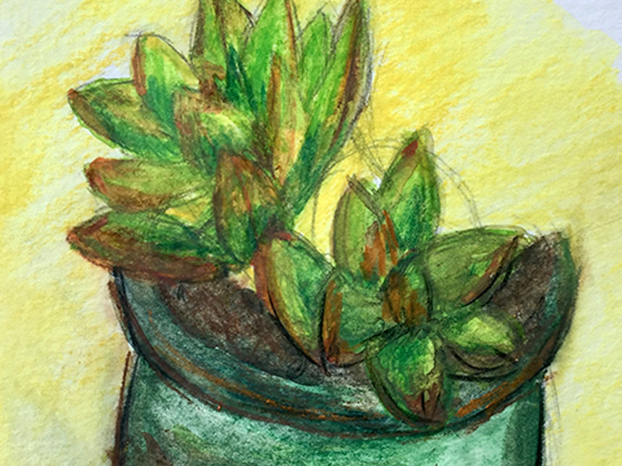

Materials
You will need:
- watercolour pencils
- watercolour paper
- a pencil
- a cup or bowl of water
- a paintbrush, cotton swabs, or paper towels
Step One
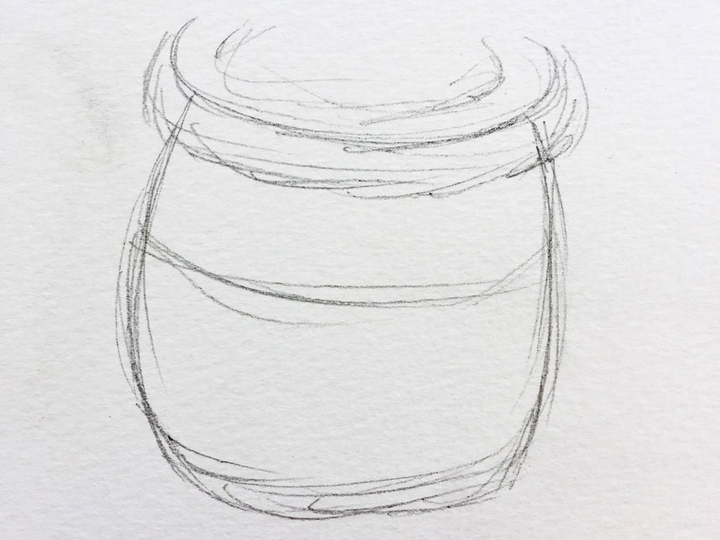
Start by lightly sketching a design with your pencil. Don’t worry if it isn’t perfect!

Step Two
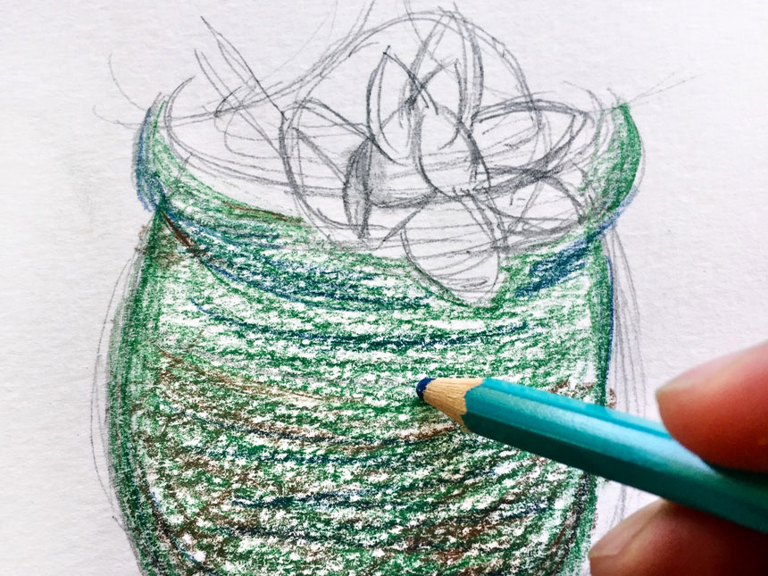
Use watercolour pencils to add some colour. Tip: use lighter colours first!

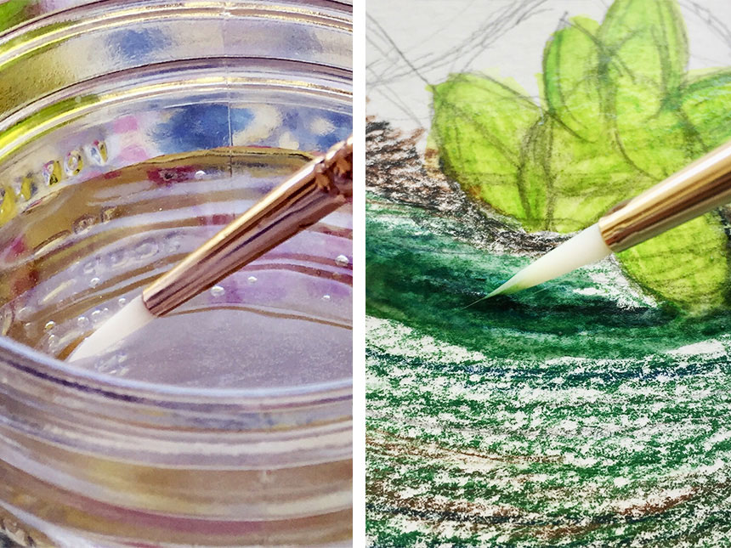
Step Three

Blend the colours by adding water on top of the watercolour pencils using a brush, a cotton swab, a piece of paper towel, or even your fingers!

Step Four
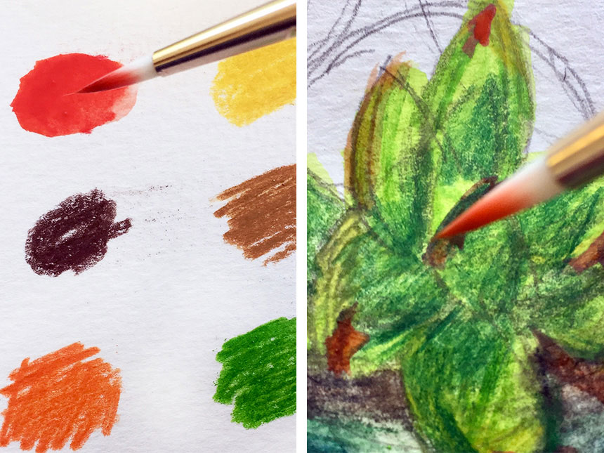

To paint, use the watercolour pencils to draw circles on a different piece of paper. Add a tiny bit of water to each circle when you are ready to use it. You have made a palette! Now, you can add paint to your picture with a brush or a cotton swab.

Step Five
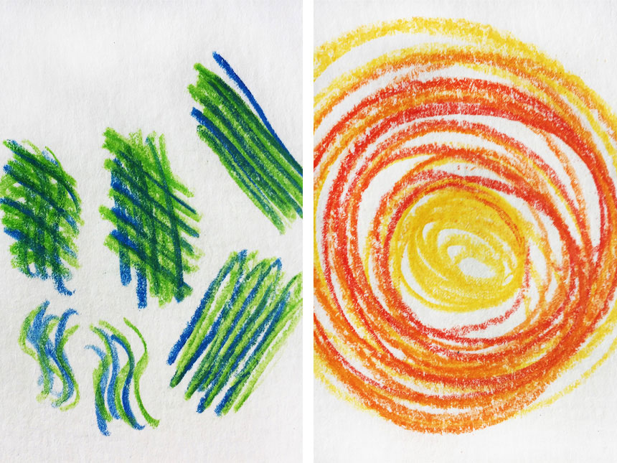

Add some textural details like dots, swirls, or lines.

Step Six

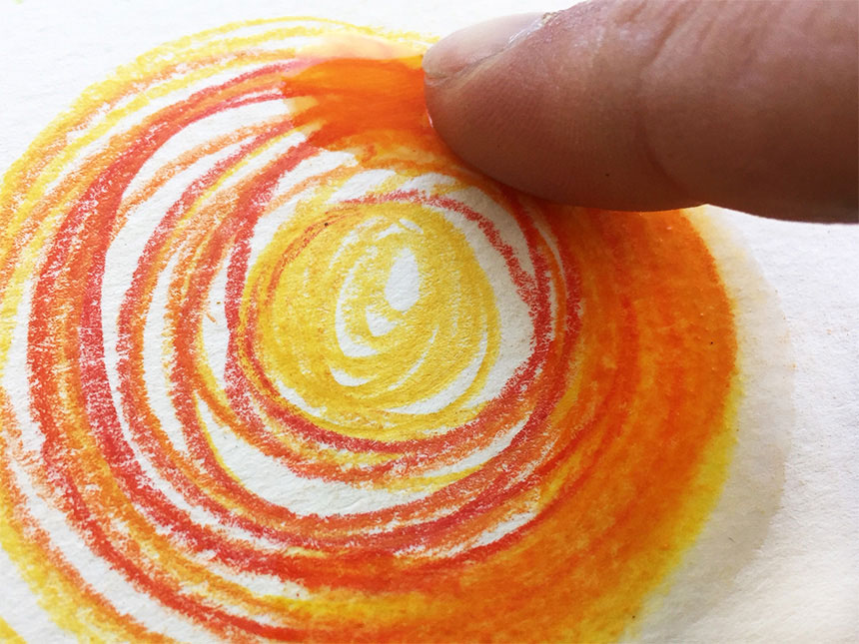

If you like, blend the colours by adding water.
#

Step Seven
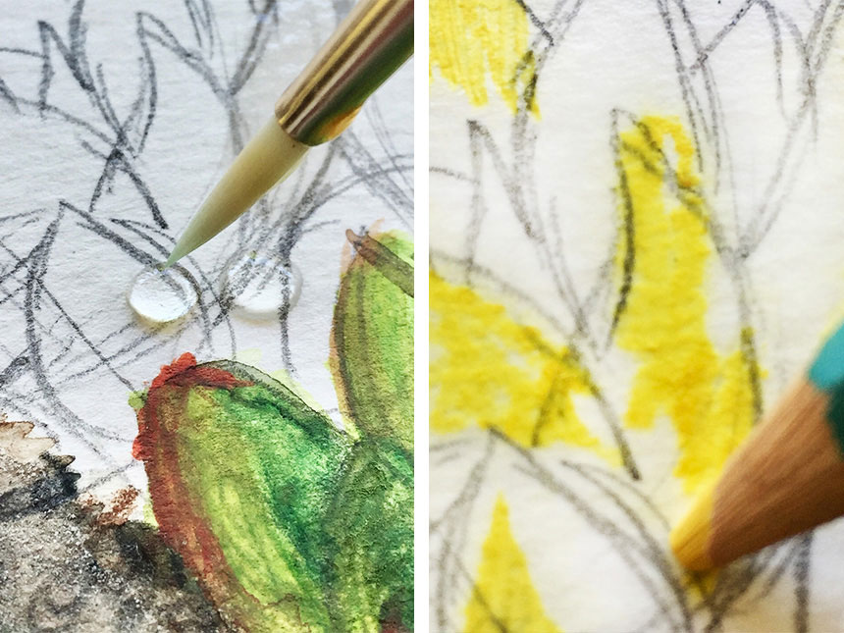
Keep adding colour to your picture. You can get the paper wet first and draw with the watercolour pencils, or quickly dip the tip of your pencil in water and “paint!”

Step Eight

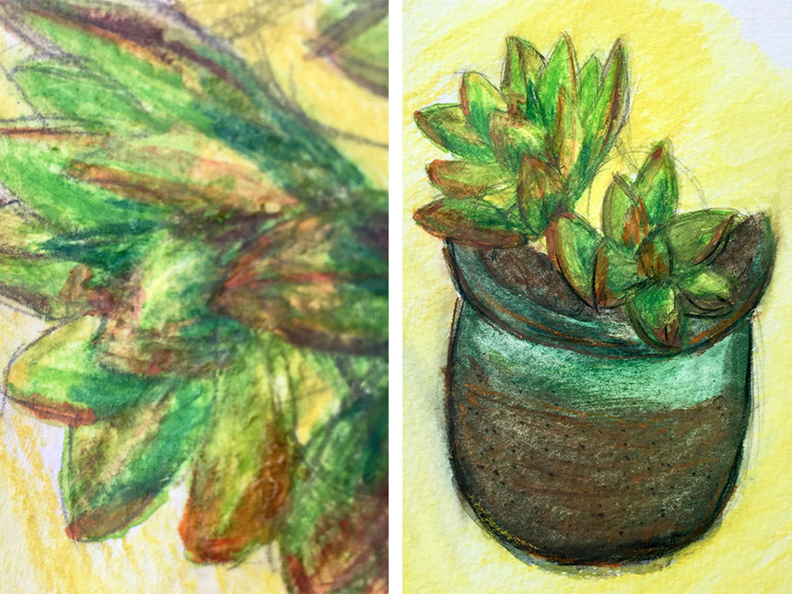

Add colours until you are happy with your picture. What will you make?

