Museum Of Fine Arts, Boston

For all things fashion and all things art, the 16 virtual exhibits by the Museum of Fine Arts are definitely worth a look.
This is another interactive tour that guides you through the museum without ever needing to leave your couch.
www.mfa.org

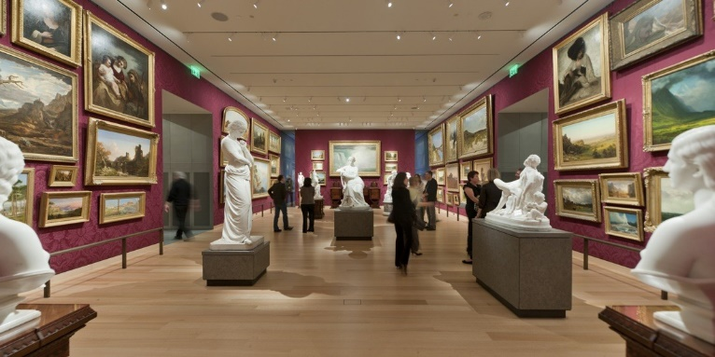


The Museum of Fine Arts, Boston, is one of the most comprehensive art museums in the world with a collection that exemplifies the breadth, richness, and diversity of artistic expression, from prehistoric times to modern day.

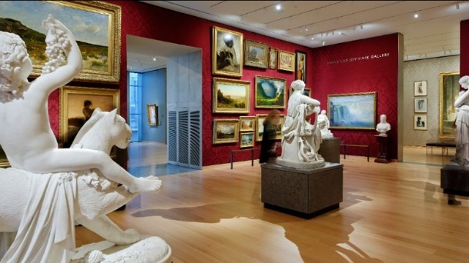

Studio Art Classes: Tutorials at Home
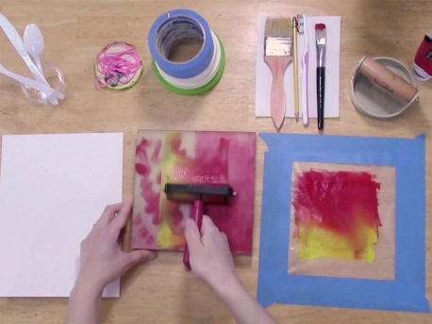


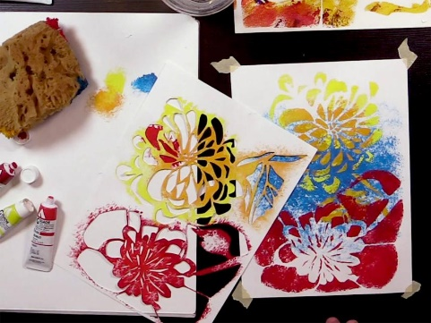
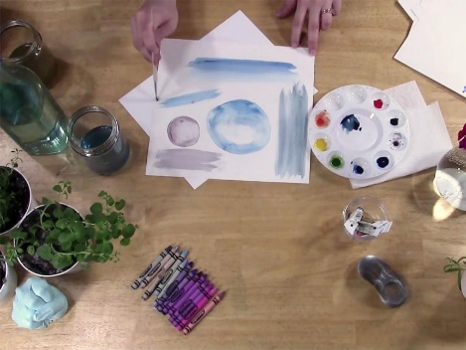
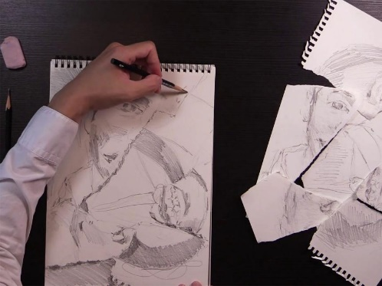
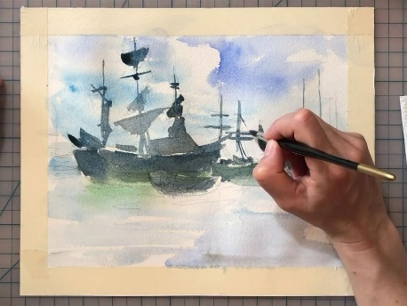
Watch the Videos and have a try at the different techniques. There are many videos to choose from such as…

PORTRAIT DRAWING FROM SCULPTURE.

EXPERIMENTAL DRAWING.

WATERCOLOR LANDSCAPES.

MONOPRINTS AND THE ELEMENTS OF ART.

Now you can enjoy Studio Art Classes from home! Featuring experienced educators and professional artists, each video looks at an object from our collection for inspiration. They walk you through the basics of a different techniques and offers ideas and suggestions for studio exploration on your own.
www.mfa.org/programs/studio-art-classes/videos

