Dragon Puppets
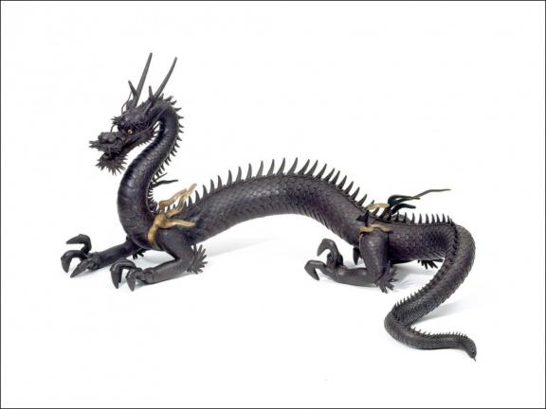

Learn how to make a dragon puppet with materials from home

In Japan, people traditionally believe that dragons are powerful and protective. Japanese dragons are thought to live in the mountains, lakes, rivers and the sky. They are made of parts from other powerful creatures. Take a look at the dragon in the picture above. Can you find a body like a snake? Claws like an eagle? Horns like a deer?

Materials
You will need:
- Dragon Puppet Template
- markers, crayons, or coloured pencils
- scissors
- tape, a glue stick, or liquid glue
- decorative materials such as pom-poms, cellophane, googly eyes, foam shapes, and colourful paper
- popsicle sticks or small sticks
- hole punch
- metal brads

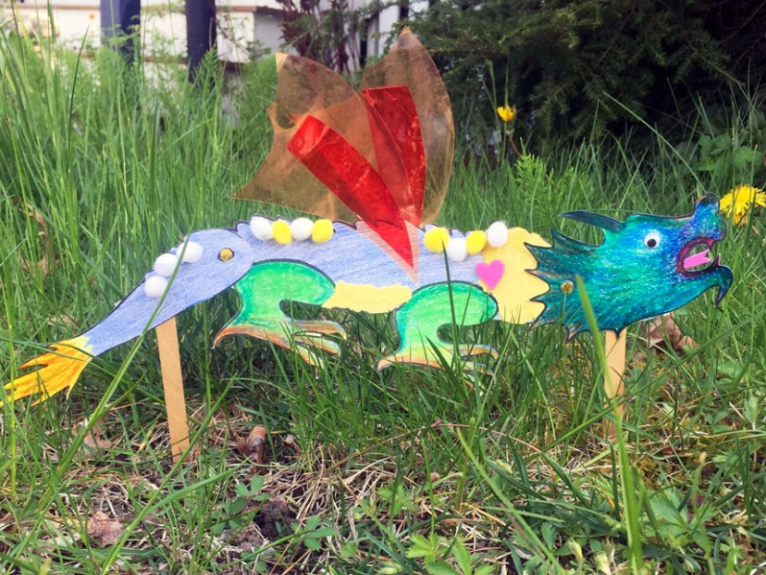

Step One
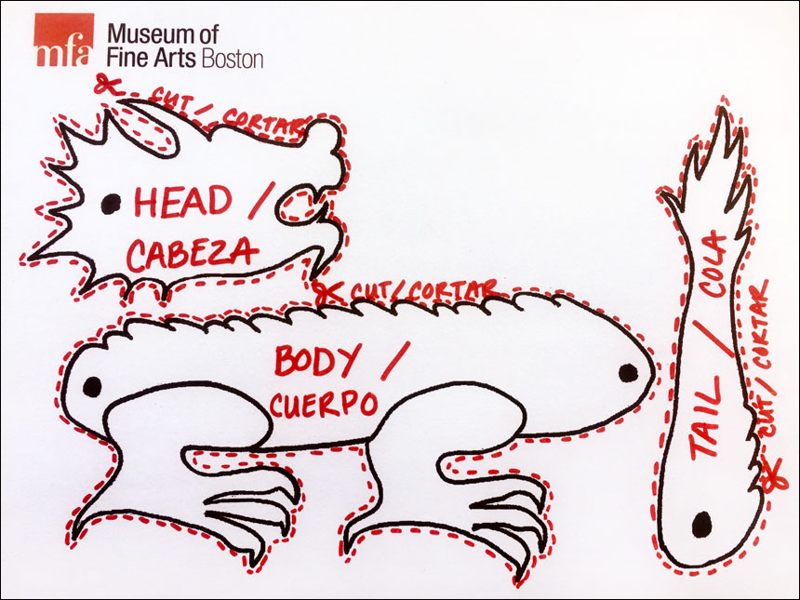
Download, print, and cut out the
Dragon Puppet Template.

Step Two
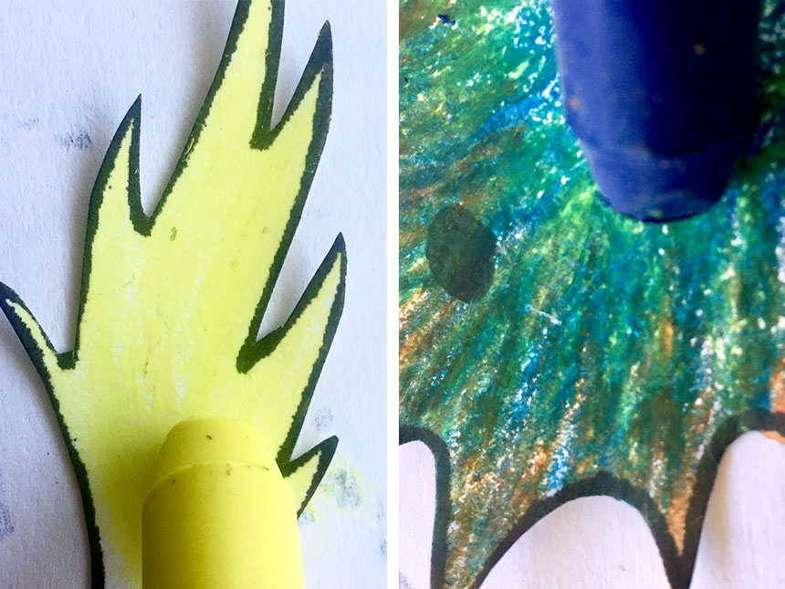
Colour in your dragon with pencils, crayons, or markers in as many different colours as you’d like.

Step Three


If you have coloured paper, tear or cut your paper into different shapes and then glue it onto your dragon. Glue some foam shapes, too, if you have them!

Step Four
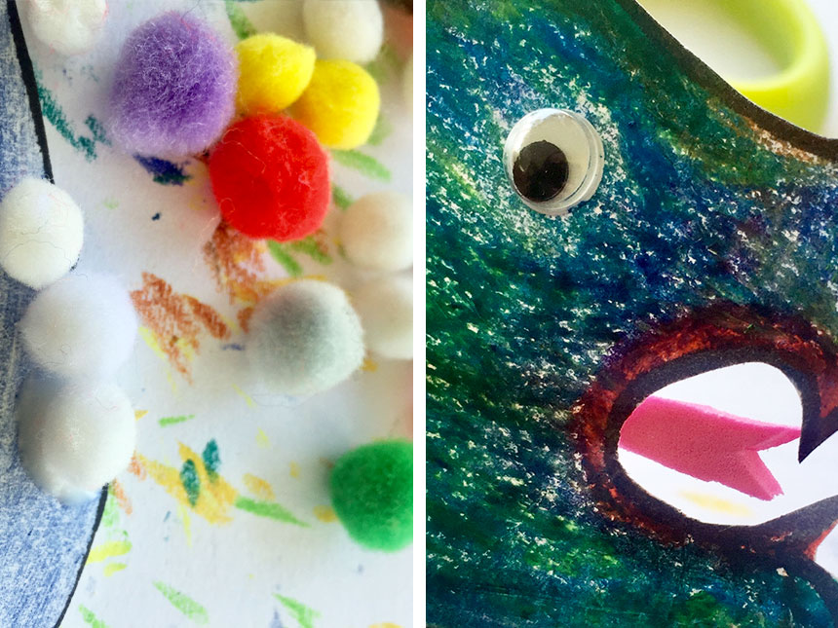

If you have googly eyes or pom-poms, glue these onto your dragon. Get creative with decorating your dragon!

Step Five
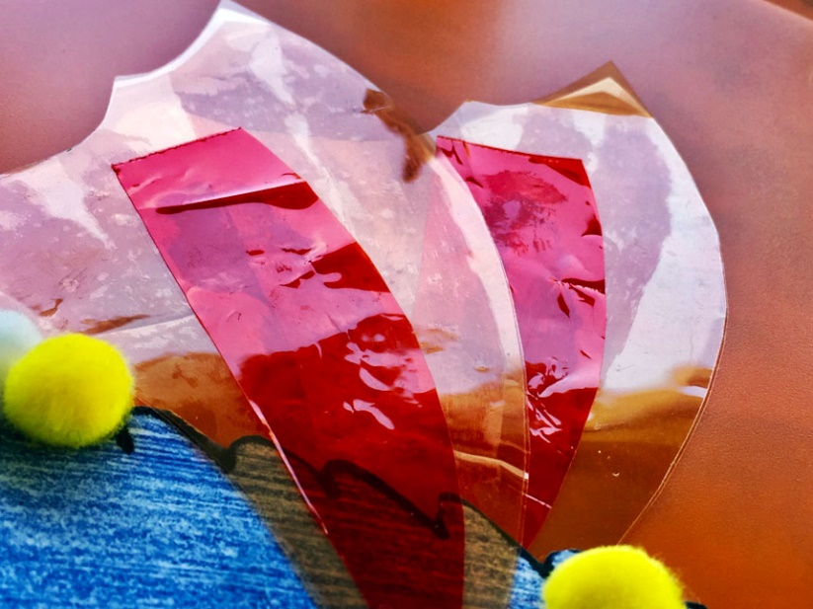
Your dragon might need some wings. Use scissors to carefully cut cellophane, coloured paper, or regular paper in the shape of wings and tape or glue them to your dragon’s body.

Step Six
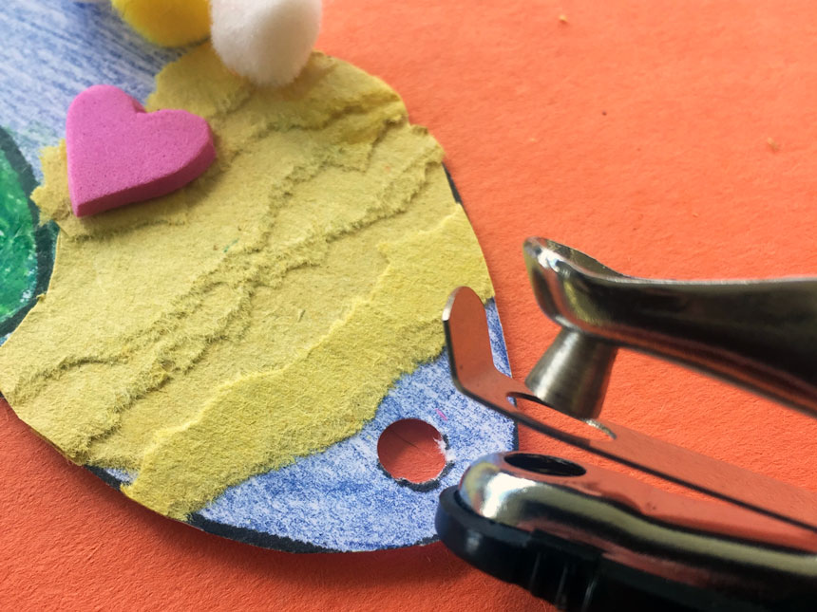
When you are done decorating, use a hole punch, sharp pencil, or the tip of a pen to carefully make a hole through each of the four black circles on the template.

Step Seven

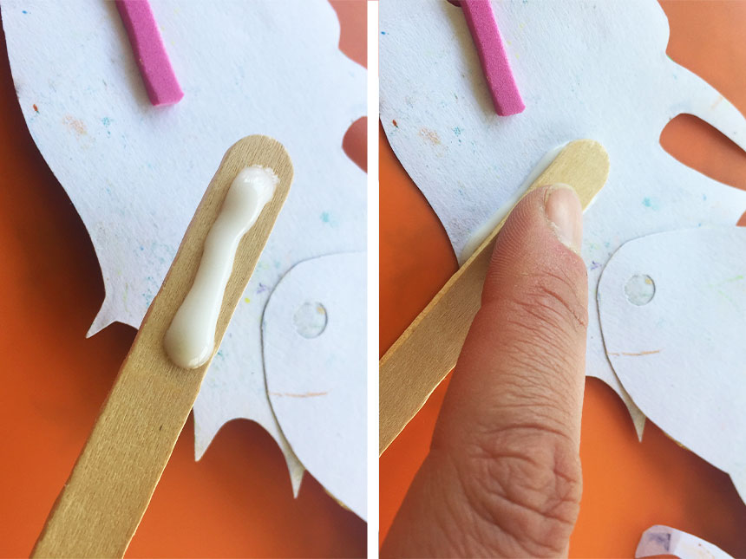
Attach one popsicle stick behind the head and one popsicle stick behind the tail. You can use liquid glue or tape.

Step Eight
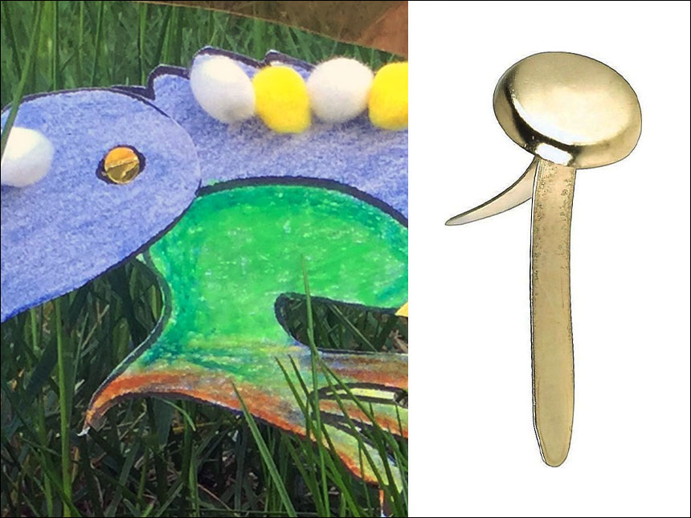

Place the tail on top of the body so the holes line up. Attach the tail and body using a metal brad: stick the brad through both holes and press the two pieces of the brad apart in the back. Do the same thing to attach the head and body. Now your dragon puppet can move!

