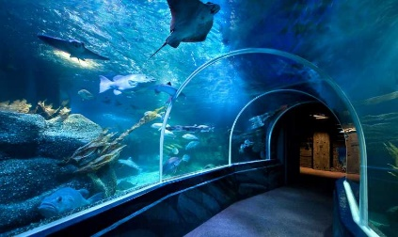
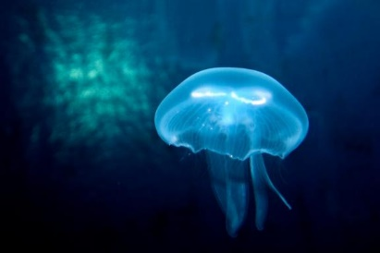
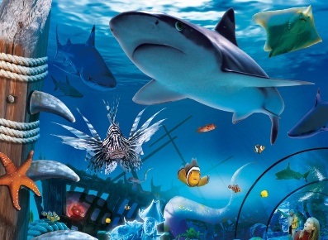
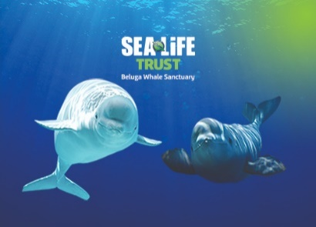
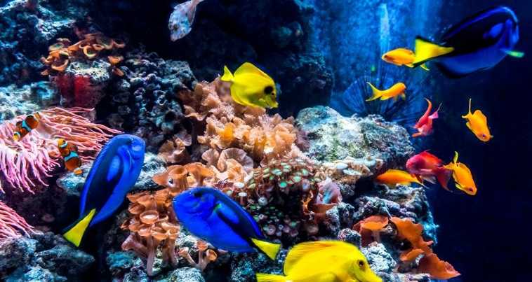
Discover the amazing underwater world
www.visitsealife.com/explore/creatures.
Have a read of the fact files and create a page on your favourite animal and list all the amazing facts.
Have a go at the activities below.

Here at Sea Life you can make up your mind and see them all, from the curious and the rescued to the rare and the enigmatic.
You will be able to get closer to them than ever before.
Many of our creatures are on the endangered list have been rescued and cannot be released into the wild or have been borna and bred as part of our conservation projects. www.visitsealife.com/london

Sea Life

