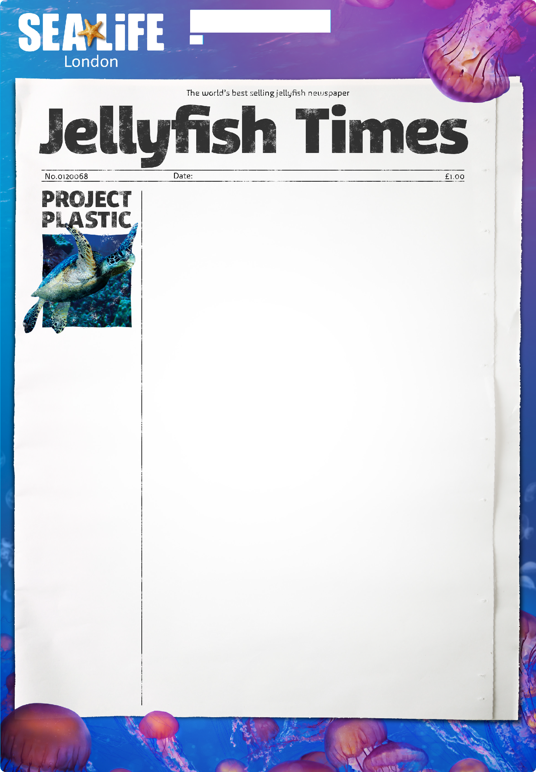Science & English

Write your headline here

Around the world, marine habitats are under threat and more needs to be done to protect them to ensure our oceans are healthy and full of life. Less than 2% of our oceans are currently protected and 26 million tonnes of plastic waste ends up in the ocean each year!

Draw a picture to support your story
But all is not lost you can help. Have a voice
and share these 5 simple ways to reducing plastic
pollution to make a difference.
- Don’t use plastic bags – use a reusable bag for life instead
- Reduce your use of plastics and recycle all of the rubbish you can!
- Look for less packaging
– if you notice an item with too much packaging,
refuse to buy it
- Watch out for toiletries that contain microbeads - these small plastic beads are found in some facial products, soaps, shower gels and toothpastes
- Pick up litter next time you’re at the beach!

NAME CLASS

