







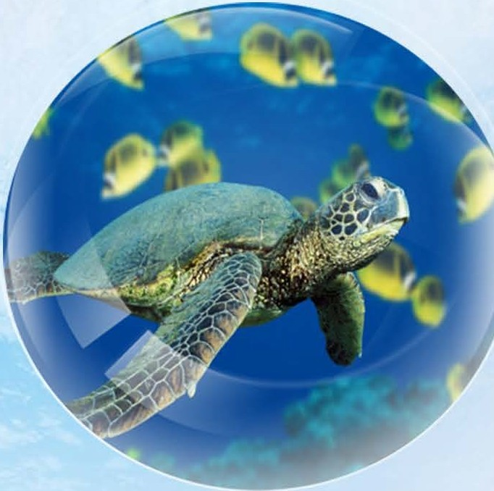

Chelonia mydas

RED
11S1


';\UP,1,11[

alf'\CM\Y' l'.


---
"4T-.WILO

HI 00 U: '" VII
C" tw "'






Threats
Plastic pollution in the water, Turtles mistake this for yummy Jellyfish and accidentally eat it! Global warming also means that more Turtles are born female as the temperature of a Turtle's nest will determine whether babies are male or female.

Habitat (where they liue)
Turtles migrate all around the world but you will usually find them in shallower costal regions where they can graze on Sea Grass. Green Sea Turtle babies will stay in shallower waters until their shells are hard enough to survive in the great big Ocean.

Diet (what they eat)
Leafy greens like lettuce and cucumber. They also love Jellyfish!


Life Span (how long they liue for)  


Bo years or more owza-o



Size:
Up to s feet

Breeding:
The female Turtle will go back to the beach it was born on to lay their eggs. She will bury the eggs under the sand and waddle back to the sea. In around 60 days they will hatch and make their way to the Ocean by themselves.

The Green Sea Turtles at SEA LIFE London Aquarium are
called Boris and Dougie!



■

London Aquarium

